**WITHNESSING WITH WINNIE: LIVING FOR LIBERATION**

Friday June 22, 2018, 6:00 pm to 8:00 pm, Peace Lounge 7th Floor, Admission: Free

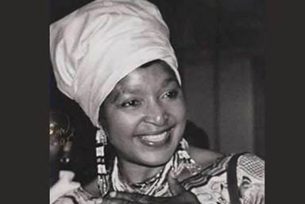

**MAMA WINNIE MADIKIZELA MANDELA**

**1936-2018**

Please join us in a circle of sacred remembering

To live liberation in the spirit of Mama Winnie Madikizela Mandela, with vibrations of joy.

To honour Winnie’s lifelong courage at the heart of the struggle for Black Liberation in her country and the world;

To appreciate her resolute commitment to justice for *all,*unwavering under attacks by those she threatened.

**SPONSORS:**

Adult Education & Community Development, LHAE, OISE/UT;

Oromo Women & Families Association, Toronto;

Saagajiwe Transdisciplinary Indigenous Centre for Research & Creation &

The Anti-Racism Coalition of Ryerson University;

Elder Sar-Ra’s Cosmic Connection.

The 2017 feature documentary film ‘Winnie’ presents a consummate analysis of the personal and political forces of th period.

NETFLIX URL <https://www.netflix.com/ca/title/80170119>

Free Viewing online: <https://www.youtube.com/watch?v=Jc5QyTgmL7Q>