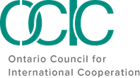

SDG Innovation Lab 2022
Participant Package

February 11 - 12, 2022

Land Acknowledgement

OCIC recognizes that it operates on the traditional and unceded territory of many Indigenous nations, specifically the Haudenosaunee, the Anishnaabe, the Huron-Wendat, and the Mississaugas of the Credit First Nation. We also acknowledge that our membership, staff, and board operate across Turtle Island, on the unceded territory of numerous Indigenous peoples.
As we reflect on our role within a settler-colonial context, we also acknowledge the importance of naming the Indigenous communities on whose lands we live, work and play. We also underscore the importance of framing our involvement and engagement in the sector and beyond through the lens of Reconciliation; recognizing that through our location and operations on unceded land across Turtle Island, we have a responsibility to stand in solidarity with the Indigenous communities who have and continue to fight for social justice on their own lands.
As such, both as part of OCIC's Anti-Oppression Policy and as a holistic approach to our organization's work, we both recognize and encourage our network to reflect on the role each of us, individually, play in Reconciliation. Through our land acknowledgement we orient ourselves within this context to do better, and to intentionally engage in each and every space in a way that will allow us to take back lessons, tools and knowledge to better support and stand in solidarity with Indigenous people.
Land acknowledgements should go beyond simply naming the lands on which we are located; they should push us to recognize that there is no 'neutral' engagement in our work, rather, setting the intention to do better and work towards Reconciliation in each and every moment.

Code of Conduct

OCIC is committed to creating a safe and inclusive space. We ask all participants to commit to the following Code of Conduct, inspired by those of the Inter-Council Network (ICN) and Amnesty Canada, and adapted for OCIC’s content and approach to this event.

1 | RESPECT, I COMMIT to being respectful to all participants regardless of language, race, national or ethnic origin, age, sex, gender, sexual orientation, marital status, ability, and any other identity or belief, throughout this event. I understand that any discrimination or harassment will not be tolerated.
2 | INCLUSION, I COMMIT to creating space for all to contribute and participate, to give prominence to the voices and stories of those who might be systemically excluded, and to make space for those that are more appropriately positioned to contribute.
3 | HUMILITY, I COMMIT to participating with a spirit of openness to learn and a recognition of the broad diversity of participants. I recognize that creating space for lived experiences to inform this space is necessary and that hearing others’ stories is a privilege.
4 | SAFETY, I COMMIT to ensuring the physical, emotional, mental, sexual and spiritual safety of all participants in the sessions,and reporting any incidents of harassment and discrimiation to the organizers.
5 | SOLIDARITY, I COMMIT to seeking common ground and inspiration to support collective action.
6 | PATIENCE, I COMMIT to being patient with technology, organizers, and each other. I recognize that everyone is on their own journey of learning.
7 | OPENNESS, I COMMIT to bringing an open heart and an open mind to my involvement in this event. I commit to being open to caring for others and myself, including taking space to decompress and realign my energy if needed.

Full Program & Speakers

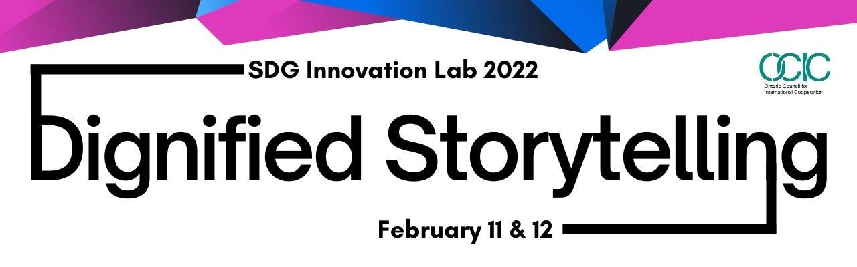

OCIC SDG Innovation Lab: Dignified Storytelling - February 11-12
OCIC’s SDG Innovation Lab 2022 seeks to unpack the power and principles of dignified storytelling with insights from storytellers around the world. Join us to learn about the foundations of dignified approaches to storytelling, pledge to embrace dignified storytelling in your engagement with local communities, and apply learnings to a storytelling project.
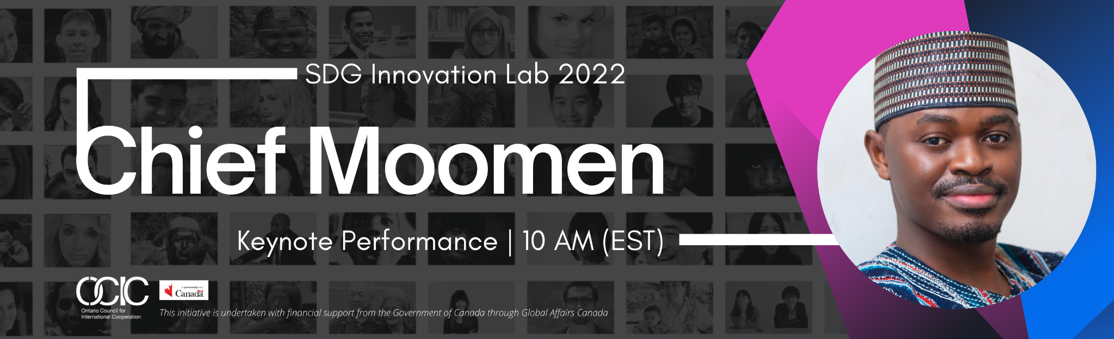

Day 1: Welcome, Keynote Performance by Poet and Playwright Chief Moomen & Dignified Storytelling Panel - February 11 | 10:00 am - 12:30 pm EST
Chief Moomen, Ghanaian performance poet, playwright and creator of theatrical spectacles, shook the stage during his performance at the Dignified Storytelling Forum at Expo2020 Dubai in December 2021. We are honored to have him join OCIC as our keynote performer during International Development Week 2022. Chief Moomen has over 15 years of experience in the performing arts and has been featured on various stages in Ghana, Singapore, Nairobi, Dubai, Lagos, Germany and London.

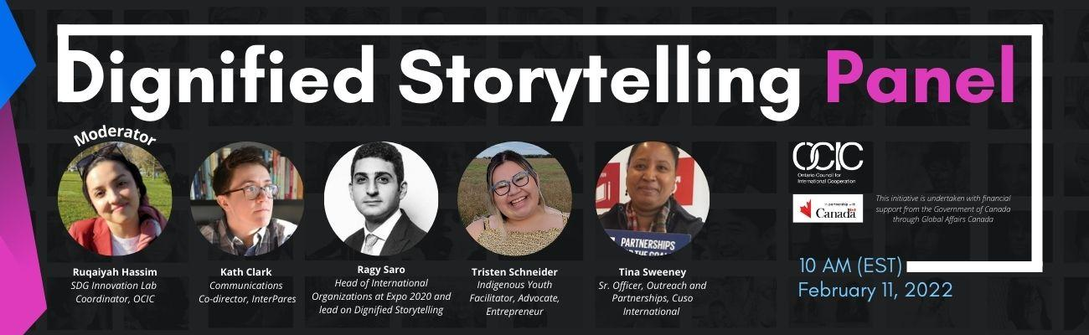

Following his performance and presentation we’re thrilled to welcome Ragy Saro, Head of International Organizations at Expo 2020 and lead on Dignified Storytelling, Dubai; Tina Sweeney, Sr. Officer, Outreach and Partnerships, Cuso International; Tristen Schneider, Indigenous Youth Facilitator, Advocate, Entrepreneur and Kath Clark, Communications Co-director, InterPares, to learn more about the 10 Principles of Dignified Storytelling and insight on how we can apply them to shape and reshape the way we tell stories within the international cooperation sector and beyond.
Contributors:
Shaelyn Wabegijig – Program and Outreach Coordinator, Kawartha World Issues Centre
Shaelyn Wabegijig (kwe/she/her) is Algonquin from Timiskaming First Nation, Caribou Clan, also Irish and German, and she grew up in Rama First Nation. Shaelyn is passionate about learning more of her Anishinaabe culture and language. She is currently the Program and Outreach Coordinator for the Kawartha World Issues Centre (KWIC) and is the project coordinator for Advancing Gender Equality in Nogojiwanong/Peterborough. From March 2020-2021, she coordinated the partnership project with KWIC and GreenUP: Advancing the SDGs 2030 Agenda in Nogojiwanong/Peterborough. She graduated from Trent University with a BAH in Indigenous Studies and Philosophy. You can reach her at shaelyn@kwic.info

Stéphane Levesque – Associate Deputy Minister, Public Affairs, Global Affairs Canada
Stéphane Levesque was appointed as ADM Public Affairs at the start of December 2018. Prior to his appointment he was Director General Communications, International and Defence at the Privy Council Office (PCO). He has filled a number of other senior roles at PCO, namely Director General, Communications Advertising and Marketing (2016 - 2017); Executive Director for Social and Economic (2015 to 2016); and Director, New Media (2013 to 2015). He also worked at Transport Canada as the Director, Web, Creative and Internal Communications (2010-2013). Mr. Levesque has provided communications advice and support to ministers and deputy ministers on high-priority files including the management of communications for the downing of flight PS752; Canada’s international response to the COVID-19 pandemic; communications advice in the management of sensitive consular case files; and most recently Canada’s response to the Afghanistan crisis. Mr. Levesque has also taken on a number of high-profile leadership roles in support of modernizing the federal government communications community including co-leading the implementation of the Web Renewal project (2012-2015); supporting the development of the updated Government of Canada Policy on Communications and the Federal Identity; and provided important contributions to the Open and Accountable Government document — “Personal and Partisan Use of Social Media by Ministers and Parliamentary Secretaries.” Mr. Levesque holds an MA in Business Administration from the University of Ottawa.
Chief Moomen - Poet and Playwright
Chief Moomen is a Ghanaian performance poet, playwright and creator of theatrical spectacles. He has over 15 years of experience in the performing arts. He has featured on various stages in Ghana, Singapore, Nairobi, Dubai, Lagos, Germany and London. Chief Moomen believes in the power of the arts to heal, inspire and transform people and nations. His works often draw from history and heritage to highlight the interconnectedness of the human experience. In 2017, he was awarded as one of Coca Cola Ghana’s Big Six Young Achievers in the category Media and Entertainment.
Ruqaiyah Hassim - SDG Innovation Lab Coordinator, OCIC
Ruqaiyah Hassim (she/her) is a creative, and ambitious young professional who is extremely passionate about international outreach and community empowerment efforts. Ruqaiyah joins OCIC as our Customer Service Assistant and works closely with our Communications and Content Specialist to develop and implement new and compelling content and maintain key stakeholder relationships. Major OCIC projects and initiatives that she supports include: the Global Citizen’s Forum, monthly e-bulletins, social media publication, and Youth Policy Hub blog pages. Outside of OCIC, Ruqaiyah enjoys facilitating activities for youth, coaching, and mentoring students, enhancing her digital communication skills, and volunteering at community events and programs. Ruqaiyah holds an Honours B.A. in International Studies from York University, and a Diploma with President’s Honours in Social Service Work from Seneca College. When she’s not working or volunteering, she’s most likely learning a new language, playing an instrument, or spending time outdoors.
Kath Clark - Communications Co-Director, Inter Pares
Kath Clark (they/them) is Communications Co-Director at Inter Pares. Kath has more than a decade of writing, communications, design and fundraising experience across the non-profit and journalism sectors. Most recently, their work has focused on food justice and small-scale farming. They have a Bachelor of Journalism from Carleton University and have written for publications including the Ottawa Citizen, the Welland Tribune and Canadian Geographic magazine. They also volunteer with the Ten Oaks Project in Ottawa, supporting their fundraising. In their free time they can be found gardening, playing guitar badly and taking photos of bees.
Ragy Saro - Head of International Organizations at Expo 2020 and lead on Dignified Storytelling, Dubai
Ragy Saro is currently the Head of International Organisations at Expo 2020 Dubai. He oversees the engagement of international and regional organisations and leads on diverse programs, such as Dignified Storytelling. Prior to Expo 2020, Ragy was External Relations Officer at the UN Office for Disaster Risk Reduction (UNDRR), managing partnerships, resource mobilization and communication. He led several advocacy campaigns, including the Making Cities Resilient Campaign. Ragy holds a Master’s Degree in management with a focus on international organisations. His love for biodiversity goes beyond spending most of his free time diving and exploring the oceans; he is an adamant advocate for the conservation of sharks – one of the most valuable and vulnerable species today. He has a passion for storytelling and film.
Tristen Schneider - Indigenous Youth Facilitator, Advocate, Entrepreneur
Tristen is an Anishinaabe-Dene facilitator, advocate, and entrepreneur from Shawanaga First Nation Ojibway Territory. She is a forthcoming young woman distinct in various trilateral political advocacy work for First Nations Youth through previous networks throughout Canada; the
Independent First Nations, Ontario First Nations Young People’s Council, Feathers of Hope: Justice & Juries Youth Advisory, Chiefs of Ontario, Thunderbird Partnership Foundation, and recently the Canadian Council for Youth Prosperity. Tristen carries curiosity within her work to diversify her experiences within different sectors, in navigating spaces where youth voices were not present. Tristen is passionate about youth empowerment, as she acknowledges the very start in her own career began as being a youth representative within her own community.

Tina Sweeney - Senior Officer, Outreach and Partnerships, Cuso International
After volunteer trips to Tanzania East Africa and Dharamsala North India, working in child development services, Tina found meaning in proximity and that closeness voiced a new narrative and a career transition from the private sector into community engagement and international development. “I am passionate about engaging Canadian's to better understand how they can contribute their knowledge and talents to help our most vulnerable.” For the past 7 years Tina has been part of Cuso International’s communications and marketing team. She creates spaces to strengthen global citizenship and social inclusion while amplifying the voices and stories of those around the world. Tina is an executive board member of the Canadian International Council (CIC) Toronto branch and a member of The Program Advisory Committee for the International Development program at Centennial College. In 2019 Tina was awarded Canada's 100 Black Women to Watch by the Canada International Black Women Event.
____________________________________________________________________________
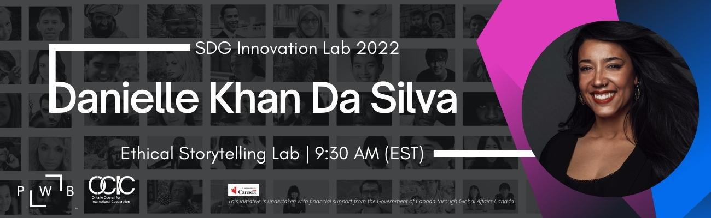

Day 2: Ethical Storytelling Lab & Creative Storytelling ColLaboration - February 12 | 9:30 am 4:00 pm EST
Join OCIC and Danielle Khan Da Silva, Executive Director, Photographers Without Borders, for a free ‘Ethical Storytelling Lab’ with the opportunity for Creative Storytelling ColLaboration and reflection with your peers!
Facilitator:
Danielle Khan Da Silva - Founder and Executive Director, Photographers Without Borders
Dani (she/her or they/them) is a queer South-Asian/Portuguese woman residing in northern Ontario, Canada where she enjoys life in the forest on the mighty Magnetewan river. She is the Founder and Executive Director of Photographers Without Borders, a non-profit organization that supports grassroots community initiatives with storytelling media. Dani is also an award-winning documentary photographer/director/storyteller. She has an academic and practical background in conservation and international development and holds an MSc. in Sustainable Development from the London School of Economics. She is a captivating speaker, educator, and mentor to many.

THANK YOU

This initiative was undertaken with the financial support of the
Government of Canada through Global Affairs Canada.

