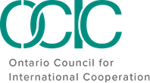

OCIC
Global Citizens Forum 2022 ‘Localization’ Matters
Participant Package

February 2 - 3, 2022

Land Acknowledgement

OCIC recognizes that it operates on the traditional and unceded territory of many Indigenous nations, specifically the Haudenosaunee, the Anishnaabe, the Huron-Wendat, and the Mississaugas of the Credit First Nation. We also acknowledge that our membership, staff, and board operate across Turtle Island, on the unceded territory of numerous Indigenous peoples.
As we reflect on our role within a settler-colonial context, we also acknowledge the importance of naming the Indigenous communities on whose lands we live, work and play. We also underscore the importance of framing our involvement and engagement in the sector and beyond through the lens of Reconciliation; recognizing that through our location and operations on unceded land across Turtle Island, we have a responsibility to stand in solidarity with the Indigenous communities who have and continue to fight for social justice on their own lands.
As such, both as part of OCIC's Anti-Oppression Policy and as a holistic approach to our organization's work, we both recognize and encourage our network to reflect on the role each of us, individually, play in Reconciliation. Through our land acknowledgement we orient ourselves within this context to do better, and to intentionally engage in each and every space in a way that will allow us to take back lessons, tools and knowledge to better support and stand in solidarity with Indigenous people.
Land acknowledgements should go beyond simply naming the lands on which we are located; they should push us to recognize that there is no 'neutral' engagement in our work, rather, setting the intention to do better and work towards Reconciliation in each and every moment.

Code of Conduct

OCIC is committed to creating a safe and inclusive space. We ask all participants to commit to the following Code of Conduct, inspired by those of the Inter-Council Network (ICN) and Amnesty Canada, and adapted for OCIC’s content and approach to this event.

1 | RESPECT, I COMMIT to being respectful to all participants regardless of language, race, national or ethnic origin, age, sex, gender, sexual orientation, marital status, ability, and any other identity or belief, throughout this event. I understand that any discrimination or harassment will not be tolerated.
2 | INCLUSION, I COMMIT to creating space for all to contribute and participate, to give prominence to the voices and stories of those who might be systemically excluded, and to make space for those that are more appropriately positioned to contribute.
3 | HUMILITY, I COMMIT to participating with a spirit of openness to learn and a recognition of the broad diversity of participants. I recognize that creating space for lived experiences to inform this space is necessary and that hearing others’ stories is a privilege.
4 | SAFETY, I COMMIT to ensuring the physical, emotional, mental, sexual and spiritual safety of all participants in the sessions,and reporting any incidents of harassment and discrimiation to the organizers.
5 | SOLIDARITY, I COMMIT to seeking common ground and inspiration to support collective action.
6 | PATIENCE, I COMMIT to being patient with technology, organizers, and each other. I recognize that everyone is on their own journey of learning.
7 | OPENNESS, I COMMIT to bringing an open heart and an open mind to my involvement in this event. I commit to being open to caring for others and myself, including taking space to decompress and realign my energy if needed.

Full Program & Speakers

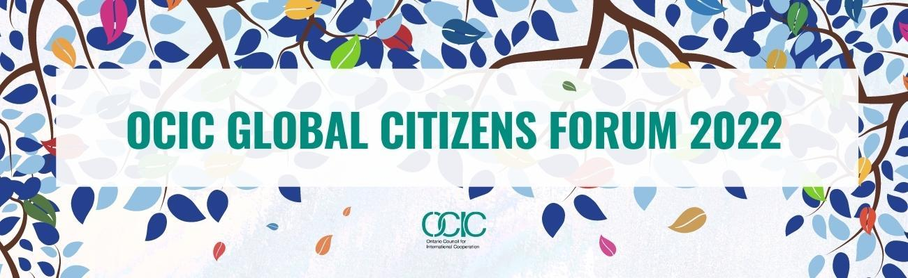

February 2, 2022

Global Citizens Forum 2022 Welcome | 10:00 AM – 10:15 AM EST | English/French
Kimberly Gibbons - Executive Director, Ontario Council for International Cooperation
Kimberly Gibbons (she/her) has been the Executive Director of OCIC since 2005. Kimberly believes in supporting community-led development and an enabling environment for civil society organizations, and in mobilizing Canadians to achieve universal sustainable development. As an active contributor to the Inter-Council Network of Provincial and Regional Councils for International Cooperation (ICN) and Cooperation Canada (formerly CCIC), a member of the Humber College International Programs Advisory Committee, Ontario Institute for Studies in Education (OISE) Programs Advisory Committee, Knowledge for Change Toronto Hub, and Global Affairs Canada Civil Society Partnerships Policy Advisory Group (CPAG), Kimberly is a vocal advocate for small and medium-sized organizations (SMOs) and their potential to strengthen local to global connections, transformative partnerships, and solidarity.
Kimberly has worked in many formal and non-formal education settings with youth and adults of diverse backgrounds in Asia, Central America, Europe and Canada. She holds a Masters of Education in Adult Education and Transformative Learning from OISE, University of Toronto, and studied human rights at the graduate level at the Commonwealth Institute, University of London, England. Kimberly also has a Bachelor of Arts in International Development and Rural Extension Studies from the University of Guelph and completed her final undergraduate year of study at SNDT Women’s University, Mumbai, India. Throughout the pandemic period, Kimberly’s love of plants and community gardening have grown as she has spent countless hours with her hands in the dirt in her balcony pots, and while connecting with neighbours and passers-by the Hopewell Community Garden.
____________________________________________________________________________
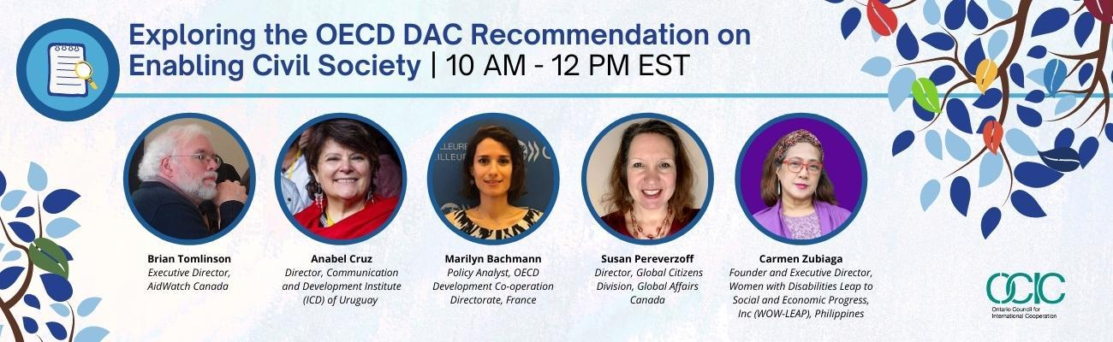

Exploring the OECD DAC Recommendation on Enabling Civil Society | 10:15 AM – 12:00 PM EST | English/French
This panel brings together high-level experts, policy makers, policy analysts and other professionals for a conversation around the OECD DAC Recommendation on Enabling Civil Society, approved by OECD Development Assistance Committee members, including Canada, in July 2021. The panel intends to share the nature and content of this Recommendation, its significance for small and medium-sized organizations (SMOs), how SMOs can advocate for changes in Global Affairs Canada (GAC)’s support for civil society through the Recommendation, and the opportunities for improving conditions facing civil society from a global south perspective.
Moderator:

Brian Tomlinson - Executive Director, AidWatch Canada

Brian Tomlinson is the Executive Director of AidWatch Canada, which focuses on issues related to Canadian and global aid priorities as well as global trends in the development effectiveness of civil society organizations (CSOs). Brian is also an adjunct professor in the Department of International Development Studies at Dalhousie University. He has had a long career working with international civil society organizations in international development. He retired in June 2011 as Senior Policy Analyst (Aid Policy) at the Canadian Council for International Co-operation (CCIC), where he worked for 16 years. He is widely published on Canadian development cooperation. He closely follows trends and issues relating to Canadian international climate finance.

At the global level, in 2015/16 he chaired the Monitoring Advisory Group, a 12-person experts group mandated to review the monitoring framework of the Global Partnership for Effective Development Cooperation, which includes the elaboration of an indicator on CSO enabling environments. He was a founding Co-chair for the multi-stakeholder Task Team on CSO Development Effectiveness and the Enabling Environment, for five years, until June 2015, and closely follows issues related to enabling legal and policy environments for CSOs around the world. He worked with CSO colleagues globally in 2019 to elaborate and launch the Belgrade Call to Action on closing civic space in April 2019.

Contributors:

Anabel Cruz - Director, Communication and Development Institute (ICD) of Uruguay

Anabel Cruz is originally from Uruguay and has a long experience in civil society promotion, research and training in various countries in Latin America, the regional and in the global context. She is the Founder Director of the Institute for Communication and Development (ICD) in Uruguay and has worked with local, national, regional, and global CSO networks and platforms. She has extensively promoted civil society transparency and accountability, leading international research and coordinating efforts to implement common standards as well as spaces for reflection, exchange of information and training.

Anabel has been the Board Chair of CIVICUS, the World Alliance for Citizen Participation in two different periods (2007-2010 and 2016-2019). She led the creation and is the co-coordinator of Rendir Cuentas, a Regional Civil Society Accountability Initiative gathering active CSO members and partners in 12 countries in Latin America and the Caribbean. She is also leading on the design and implementation of the Global Standard for CSO Accountability. Since January 2022 Anabel is the incoming Civil Society Co-Chair of the Open Government Partnership (OGP).

Marilyn Bachmann - Policy Analyst, OECD Development Co-operation Directorate, France

Marilyn is an international development specialist with a decade of experience in the areas of development co-operation, democratic governance and civil society. Marilyn currently works as a Policy Analyst in the Foresight Outreach and Policy Reform Unit in the OECD Development Co-operation Directorate. She supports the civil society work stream which aims to assist Development Assistance Committee members to develop more effective development co-operation policies and practices on civil society. Prior to joining the OECD, she worked for UNDP in New York, in the Inclusive Political Processes team of the Bureau for Policy and Programme Support, and the UNDP Country Office in Lao PDR, as interim Head of Governance. Marilyn is a French and Lebanese national. She holds a Master’s Degree in International Relations from the School of International and Strategic Relations in Paris.

Susan Pereverzoff - Director, Global Citizens Division, Global Affairs Canada

Susan Pereverzoff is Director of the Global Citizens and Engagement Division at Global Affairs Canada. She has spent her career in international development, on strategic policy, bilateral programs in Africa and the Americas as well as programs to foster partnerships on climate change and indigenous peoples. She has been posted to Canadian missions in Mozambique, Senegal and Brazil and has lived, studied and volunteered in the United States, the United Kingdom and Indonesia. She has a Master’s of Arts in Political Science (Environmental Studies) from the University of Toronto and a Bachelor’s of Arts in International Relations from the University of British Columbia. Susan was born in Prince Albert, Saskatchewan and currently lives in Ottawa, Ontario with her two lively children.

Carmen Zubiaga - Founder and Executive Director, Women with Disabilities Leap to Social and Economic Progress, Inc (WOW-LEAP), Philippines

Carmen Zubiaga, a disability rights advocate, is currently the Executive Director of Women with Disabilities Leap to Social and Economic Progress (WOW-LEAP) Inc., an organization of and for women with disabilities. She holds a Bachelor of Arts in Mass Communication from the Trinity University of Asia and a Masters in Development Management from the Asian Institute of Management. She has worked as a Public Relations and Fund-raising officer at the House With No Steps in the Philippines for nine years, prior to joining the UNDP Cambodia, as a technical advisor to the Ministry of Social Affairs, Labor, Veterans and Youth in Phnom Pehn. After her contract, she returned to the Philippines and worked as Public Information Officer in her hometown, Taytay Rizal, under the Office of the Mayor. In 2012, she was appointed by the Philippine President as Executive Director on the National Council on Disability Affairs.until 2019 Currently, she is a subject matter expert/content developer for online courses; and a freelance consultant on gender equality, disability, and social inclusion. Carmen filed her candidacy for senator in the upcoming Philippine elections in May 2022. With this platform, Carmen hopes to amplify the voice of millions of disabled Filipinos.

____________________________________________________________________________
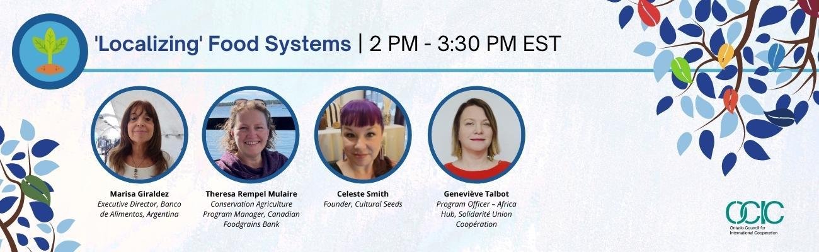

‘Localizing’ Food Systems | 2:00 PM – 3:30 PM EST | English/French/Spanish
This panel brings together different perspectives around the ‘localization’ of food systems, food justice, and ending hunger. We will explore grassroots initiatives from an Indigenous perspective, what it might mean to ‘decolonize aid’, and how community-led approaches are used by organizations working to end hunger in Argentina, Canada and internationally.
Moderator:
Elizabeth Tuck - Special Events Coordinator, Ontario Council for International Cooperation
Elizabeth Tuck (she/her) is a Rhodes Scholar (Maritimes & Linacre College, 2020) who recently completed her MSc in Comparative Social Policy from the University of Oxford. She received her undergraduate degree from St. Thomas University in Fredericton, New Brunswick where she honoured in Human Rights and completed double majors in Political Science and Great Books. An advocate for gender justice, Elizabeth has held various volunteer and other leadership positions with YWCA Canada, Plan International Canada, Girls Guides of Canada, the Canadian Council for Youth Prosperity, and Fora: Network for Change (formerly G(irls)20). Elizabeth enjoys cross-stitching, hiking, cooking, and baking in her spare time and has recently started learning the sport of curling. She currently resides in Mi’kma’ki, known colonially as Nova Scotia, and has been working at OCIC since October 2021 on the coordination of our Global Citizens Forum 2022 and ‘Tapestry 2030’ Season 2 podcast and illustration series.

Contributors:
Marisa Giraldez – Executive Director, Banco de Alimentos, Argentina
Marisa Giraldez is an Argentinean Industrial Engineer who began her professional career in the private sector until 2005, when she decided to accept a new challenge to work in the Department of Projects for Development at the Agency for Cooperation and International Affairs of the Province of Buenos Aires. During those years she also began to carry out volunteer activities for the Banco de Alimentos Foundation, contributing with his experience in the area of quality and leading the team that led the organization to achieve ISO 9000 Certification in 2007, a certification that was important because there was a legal vacuum regarding food donation and donor responsibility.
In 2008, once again working in the private sector, she became part of the Board of Directors of the Banco de Alimentos Foundation. In 2010, faced with the Board's proposal, she decided to accept the position of General Director of this institution, resigning from her role in the Board and definitively abandoning activity in the private sector. She is currently also part of the Executive Committee of RACI, the Argentine Network for International Cooperation.
Theresa Rempel Mulaire – Conservation Agriculture Program Manager, Canadian Foodgrains Bank
Theresa Rempel Mulaire currently works as the Conservation Agriculture Program Manager with Canadian Foodgrains Bank. Theresa’s career has focused on facilitating economic and agricultural programming together with local partners in Asia and East Africa. Theresa is currently based in Winnipeg and has lived and worked internationally in Taiwan, China, Kenya, India and Colombia.
Celeste Smith – Founder, Cultural Seeds
Celeste Smith (she/her) is Oneida from Six Nations of the Grand River Territory. As an intergenerational trauma survivor, she has made it her life's mission to help Women/Gender Diverse People rebuild their connections to the land and their lifeways. Celeste is a seed steward, traditional agriculturalist and former professor of Traditional Ecological Knowledge (TEK) at Niagara College. Her TEK comes from a strong connection to her family's agricultural traditions and 30 years of personal/community gardening, and she continues to educate herself through ceremony and mentorship with traditional healers and agricultural Knowledge Holders from around the world.
Her current work centres around Indigenous Food Sovereignty, Land Justice and Indigenous Human Rights. She is the Founder/Director of Cultural Seeds (culturalseeds.com) an Indigenous seed store/rematriation project and Ga Gitigemi Gamik (wewillplantlodge.com) an ecological centre on a permanent Indigenous stewarded site, where women and 2SLGBTTQQIA+ persons can (RE)learn ancestral agricultural methods lost to colonization. Ga Gitigemi Gamik recently won the i3 Indigenous Innovation Challenge at the Desjardins Cooperathon which is the world's largest Social Innovation Challenge. The project has also been chosen as a Pow Wow Pitch Finalist and as a future funding recipient from the Grand Challenges Canada - Indigenous Innovations Initiative. Celeste is the current Chair of the Peel Food Action Council and is active on several National and Provincial Boards. Celeste's academic experience was at Niagara College (Social Sciences), Brock University (Poli Sci/Sociology/Indigenous Education) and she was invited to Columbia University NYC (ISHR: Institute for the Study of Human Rights) to study Indigenous Rights and Policy. She is involved with work on Land Rights issues globally
Geneviève Talbot – Program Officer - Africa Hub, Solidarité Union Coopération
Avant d’assumer des fonctions comme chargée de Programme Pôle Afrique à SUCO, Geneviève Talbot a travaillé de nombreuses années dans le milieu des ONG au développement et la gestion de projets et programmes, de même qu’à la recherche et au plaidoyer sur les changements climatiques et les systèmes alimentaires.
Elle a vécu et travailler en Équateur et aux Philippines .Forte d’une dizaine d’année d’expériences comme chargée de programmes à l’international pour diverses organisations, Geneviève possède une vaste expérience en gestion et développement de programmation en Afrique de l’Ouest et Asie du Sud Est. De plus Geneviève contribue régulièrement à diverses publications portant sur divers enjeux internationaux, mais surtout sur les changements climatiques et les systèmes alimentaires.
Elle possède une formation universitaire en science politique, sa maîtrise portant sur l’impact du mouvement zapatiste dans les processus de démocratisation au Mexique.

February 3, 2022

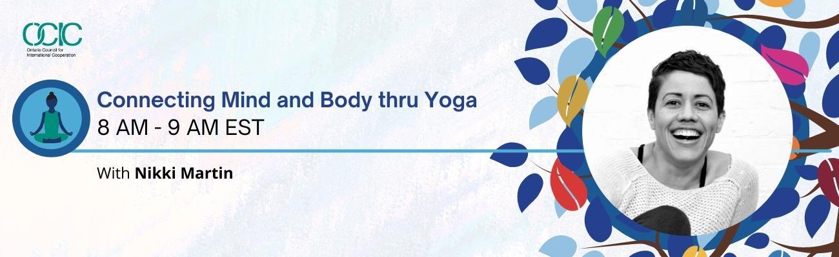

Connecting Mind and Body thru Yoga | 8:00 AM – 9:00 AM EST
Join OCIC for an interactive yoga session with the aim of re-centering our mind and our bodies. This hour-long guided session is inclusive to varying abilities, body types, ages, and yoga experiences and participants may turn their cameras off. This space allows us to reflect on the many learnings from throughout day one of the forum and to prepare ourselves for a second day of learning and collaborating.

Instructor:

Nikki Martin

Nikki Martin is an inspired and creative teacher with a passion for learning and a desire to offer her students the time and space to land, experience their breath and be present in their bodies despite the distractions of the mind. She is an E-RYT 200hr with more than 3000 hours of in room and studio teaching experience including assisting a 200hr YTT with one of her teachers, Leslie Bishop. She is in the midst of completing her 300hr YTT and is also a committed student of ParaYoga, a lineage of Tantra Yoga, which honours tradition in a way that's relevant to the modern world and that she has felt called to pursue. With more than 700 hours of training with some amazing teachers she is just at the beginning of her learning and teaching journey and feels humbled by the opportunity to offer what she knows and is passionate about. She has been a lululemon ambassador since 2016 and continues to be a leader in her local community in various ways.

As a writer and storyteller, she loves the idea that a yoga class can lead you somewhere, that you can tell a story with body and breath and she believes the same well of inspiration she draws her stories and words from help her to craft meaningful classes and hold space for transformation. Whether it’s a couple of people or a crowded room, she tries to pass along the greatest gift this practice has given her, “Ultimately this is a practice of connectivity. It connects us with the world. It connects us with ourselves. And it connects us with each other.

____________________________________________________________________________
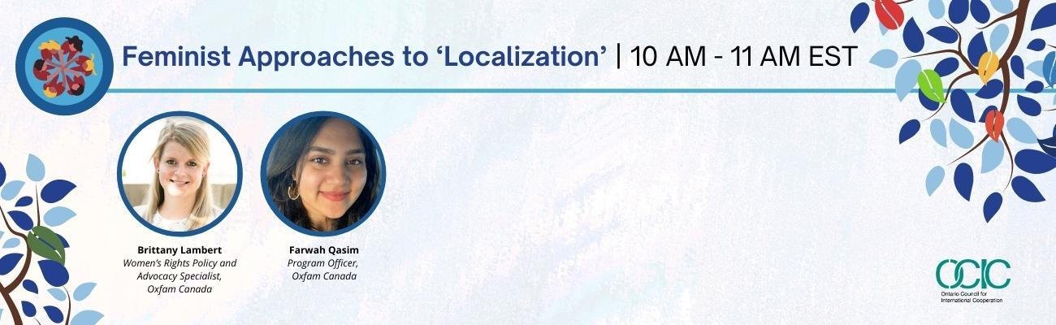

Feminist Approaches to ‘Localization’ | 10:00 AM – 11:00 AM EST | English/French

Oxfam Canada is on a journey to apply a feminist approach to all its work – both in terms of outcomes and ways of working. Applying feminist principles requires us to rethink current ways of working in the international aid sector. This session will unpack how ‘localization’ is part and parcel of an intersectional feminist approach. Drawing on its interviews with local women’s rights actors working across the humanitarian-development-peace nexus, and on its experience supporting the leadership of local women’s rights organizations in its international programming, Oxfam will share reflections and lessons learned on this crucial topic.

Moderator:

Aniqah Zowmi - Community Engagement & Gender Equality Specialist, Ontario Council for International Cooperation

Aniqah Zowmi (she/her) works from an intersectional, anti-oppressive operational framework. As a Muslim woman of colour with multiple other intersectional identities, she brings her lived experience authentically into her work. Some of her recent efforts have included supporting humanitarian projects in Jordan focused on mental health, psychosocial awareness, and economic empowerment, for the Italian NGO Un Ponte Per… (UPP) and for the Canadian NGO Menonnite Economic Development Associates (MEDA). Aniqah has also served as a Youth Representative to the United Nations’ Department of Global Communications’ Steering Committee, the Canadian Youth Delegate to the Youth20 (the official youth engagement arm of the G20) in 2018, and a member of the Joint Youth Delegation to the Commonwealth Youth Forum in 2015. She is currently the Director of Diversity, Equity, and Inclusion for Leading Change Canada, a Youth Advisor to the Canadian Commission for UNESCO, and the incoming Chair of Girls Action Foundation. Aniqah holds a Master of Arts in Social Justice and Equity Studies from Brock University, where she looked at feminist and anti-colonialist perspectives on social enterprise. Prior to her Masters, she completed her Honours Bachelors of Science in Neurobiology, specializing in learning, memory, and neurobiophysics.

Contributors:

Brittany Lambert – Women’s Rights Policy and Advocacy Specialist, Oxfam Canada

Brittany Lambert is a Women’s Rights Policy and Advocacy specialist at Oxfam Canada. She leads Oxfam Canada’s policy and advocacy on humanitarian and refugee issues, bringing a strong gender lens to this work. She has been an advocate for the role of local women's rights actors in humanitarian action - authoring A Feminist Approach to Localization, Protected and Powerful and Making Gender Transformative Humanitarian Action a Reality. Women’s rights and human rights are at the heart of her vision for social change. Prior to working for Oxfam, she worked at the Canadian Council for International Cooperation and the McGill Institute for Health and Social Policy. She has a Master’s degree from McGill University.
Farwah Qasim – Program Officer, Oxfam Canada

Farwah Qasim is a Program Officer for Ending Violence Against Women and Girls (EVAWG) unit at Oxfam Canada. She manages implementation of the Creating Spaces Project in Philippines, Nepal and Pakistan. Farwah specializes in Gender Based Violence (GBV) prevention and response and Women’s Economic Empowerment (WEE) programming using community driven development approaches. Farwah is a Muslim Feminist who has advocated for women’s rights from a young age. Prior to working for Oxfam, she worked at the World Bank Group and other international development organizations as a gender specialist and researcher. She is born and raised in Pakistan and has a Master’s degree from George Washington University in Washington, DC.

____________________________________________________________________________
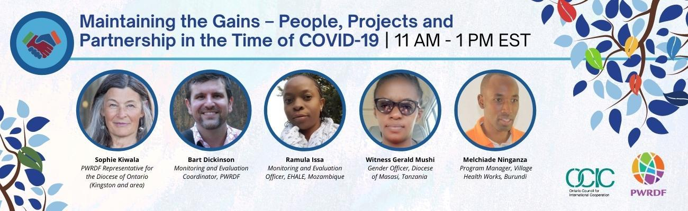

Maintaining the Gains - People, Projects and Partnership in the Time of COVID-19 | 11:00 AM – 1:00 PM EST | English/French

This session is organized and led by the Primate’s World Development and Relief Fund.

For the past two years, PWRDF, together with its partners in Burundi, Mozambique, Rwanda, and Tanzania, and with support from Global Affairs Canada (GAC), has carried out two one-year projects that have responded to the COVID-19 global pandemic. Designed to maintain the gains achieved through the four-year GAC-funded, ‘All Mothers and Children Count’ (AMCC) program, these projects have supported vital COVID-19-related work. In this panel PWRDF’s Planning, Monitoring and Evaluation Coordinator, Bart Dickinson, together with partners from Village Health Works, Burundi; the Diocese of Masasi, Tanzania; and EHALE, Mozambique, will explore the impacts of COVID-19 through the data they have gathered and through real-life experiences on the ground. They will discuss how this has both made possible new work, and challenged existing ways of working. And they will explore how COVID has changed the ways it has impacted how we live out our partnerships.

Moderator:

Sophie Kiwala – PWRDF Representative for the Diocese of Ontario (Kingston and area)

Sophie was appointed PWRDF Diocesan Representative for the Diocese of Ontario in 2020. From 2014 to 2018, she served as Member of Provincial Parliament for Kingston and the Islands. Prior to that, she worked for seven years in federal constituency offices as a manager and chief of staff. Sophie lived in Turkey and France for five years and studied politics at Athabasca and Queen’s University. She is currently working on her Professional Masters of Public Administration degree. Sophie is a tireless community advocate and is passionate about supporting vulnerable sectors of society and Indigenous reconciliation.

Contributors:

Bart Dickinson – Monitoring and Evaluation Coordinator, PWRDF

Bart has been working in international development for more than a decade, the last six with PWRDF. He specializes in project management, applied social research, evaluation and learning, curriculum development, field training and capacity building. Bart works closely with partner organization staff to maintain and strengthen monitoring mechanisms and help develop, define and refine indicators to measure and learn from PWRDF’s intended beneficiaries. Before COVID-19 he frequently visited PWRDF’s partners in the field to observe and learn from them. Bart is fluent in three languages and has an M.A. in International Affairs from the Norman Paterson School at Carleton University.

Ramula Issa – Monitoring and Evaluation Officer, EHALE, Mozambique

Ramula is a university lecturer and Researcher in the areas of Nutrition and sexual and reproductive health. She has a Masters in Clinical Nutrition (2014), and a Degree in Nutrition Sciences (2012). She works as a Consultant for various organizations where she conducts baseline and endline project evaluations, as well as situational analysis of project implementation in the area of Sexual and Reproductive Health Rights, Children’s Education, Nutrition and Early Childhood Development.

Witness Gerald Mushi – Gender Officer, Diocese of Masasi, Tanzania

Witness has worked closely on the All Mothers and Children Count program implemented by the Anglican Church of Tanzania, Diocese of Masasi and the Gender focal person for Diocesan operations. She has six years experience in the field of supporting mothers’ and children’s health with a focus on gender sensitivity and special needs.

Melchiade Ninganza – Program Manager, Village Health Works, Burundi

Melchiade worked as the Project Coordinator for the All Mothers and Children Count program, which focused on increasing access to maternal and child healthcare both through activities at VHW’s clinic, as well as within the community through Community Health Workers. Previously, he worked with Village Health Works in communication and community organization, where his responsibilities included producing radio shows, conducting sensitization campaigns and organizing community members. Melchiade has a B.A. in History with a specialization in political science from Burundi University, as well as certificates in global health from the John Hopkins Bloomberg School of Public Health and the University of Washington.

____________________________________________________________________________
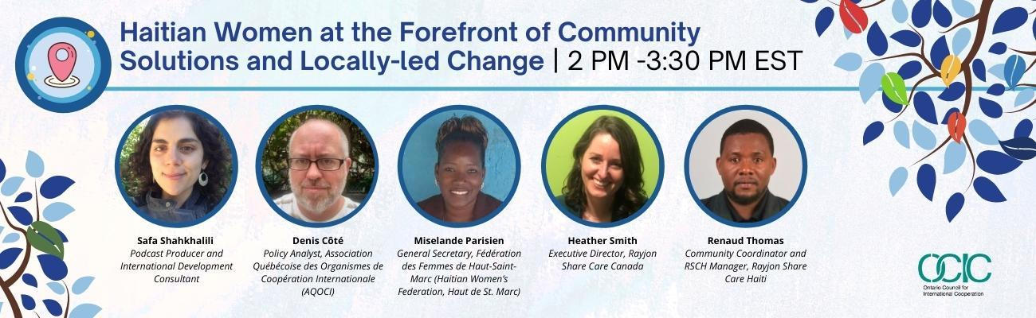

Haitian Women at the Forefront of Community Solutions and Locally-led Change | 2:00 PM – 3:30 PM EST | English/Haitian Creole

In this panel speakers will share insights on how community-led and grassroots solutions are transforming communities in Haiti. It will build upon the conversation between leaders from Rayjon Share Care Canada, Rayjon Share Care Haiti, and the Haitian Women’s Federation in OCIC’s ‘Tapestry 2030’ podcast and illustration series, Season 1 (available here), focusing on how grassroots actors, particularly women, are the drivers of sustainable change.

Moderator:

Safa Shahkhalili – Producer, OCIC ‘Tapestry 2030’ Season 1

Safa is a podcast producer and international development consultant based in Toronto. She recently facilitated a "Podcasting for Public Engagement" training for OCIC members and was the producer for OCIC's Tapestry 2030 podcast.

Contributors:

Denis Côté – Policy Analyst, Association Québécoise des Organismes de Coopération Internationale (AQOCI)

Denis Côté has been a Policy Analyst with the Association québécoise des organismes de coopération internationale (AQOCI) since 2016. In this role, he works on a number of issues related to international cooperation and solidarity, and he facilitates the network's community of practice on the environment. He participates on behalf of AQOCI in various provincial and national alliances on topics such as corporate accountability, climate change, and trade agreements. He also participates and supports the organization of civil society delegations to international events like the World Social Forum and the COP. Before joining AQOCI, Denis was the coordinator of the Asia-Pacific Working Group with the Canadian Council for International Cooperation (CCIC) from 2009 to 2016. He has also been working as a freelance translator since 2015 and has recently become the co-owner of a small farm in Quebec.

Miselande Parisien – General Secretary, Fédération des Femmes de Haut-Saint-Marc (Haitian Women’s Federation, Haut de St. Marc)

Miselande Parisien is a well-respected leader in her rural community of Barbes, where she serves as the Vice-President of the local women’s association l’Organisation des Femmes Actives pour le Développment de Saint-Marc (OFACDES). Miselande completed her university education in 2019, and currently teaches at the Jean Calvin School in Saint-Marc. She is also the elected General Secretary of the la Fédération des Femmes de Haut-Saint-Marc (Haitian Women’s Federation), and a passionate promoter of Adult Literacy programs throughout the region. As an executive member, Miselande is deeply involved with the Haitian Women’s Federation’s ongoing initiative to operate a cooperative breadfruit processing factory and sustainable tree nursery.

Heather Smith – Executive Director, Rayjon Share Care Canada

Heather Smith has been Executive Director and Project Manager for Rayjon Share Care (based in Sarnia, Ontario) since 2016. Her education and work history have allowed her to explore grassroots approaches to intercultural communication and community-centric fundraising, and best practices in international cooperation. In her role with Rayjon Share Care Heather facilitates dialogue and collaboration between Rayjon Share Care and their partners in Haiti and the Dominican Republic. Together they support local solutions to sustainable community development through health care, education, microcredit and the empowerment of women.

Renaud Thomas – Community Coordinator and RSCH Manager, Rayjon Share Care Haiti

Renaud Thomas was born in Jacmel, Southern Haiti, to a large family with 5 sisters and 3 brothers. In 2011 he graduated from the State University of Haiti (Faculty of Agronomy and Veterinarian Medicine) with an advance degree as an Engineer-Agronomist. Additional training both in Haiti and abroad has earned him specializations in permaculture design and breadfruit propagation.

Renaud has co-founded several local Haitian organizations (Fond Paysans de Fond’Oies (FPF), Association Haïtienne de Permaculture (HPC), Inisyativ Sante Peyizan (ISAP), and Zanmi Lagrikilti (ZL). He has been the Community Coordinator and Manager of Rayjon Share Haiti (RSCH) at Saint-Marc since 2018. He also provides independent consultation in permaculture design at different levels from local farms to universities. Renaud has worked with numerous NGOs in Haiti and has a particular interest in community development with a focus on sustainability, and a passion for mobilizing local communities. Renaud and his wife (who is a nurse and midwife) recently welcomed their first child.

‘Localization’ Resources

OCIC has compiled the following resources to support participant engagement in the Global Citizens Forum and in understanding the broader ‘localization’ agenda, recognising that there are different perspectives and understandings of what ‘localization’ means, and questions regarding the relevance of the ‘localization’ agenda to diverse stakeholders in our sector and work.
Articles and Reports:
‘Catalysing locally-led development in the UK aid system’ – Bond
‘Fostering Equitable North-South Civil Society Partnerships’- RINGO
‘Localization in Practice: Emerging Indicators & Practical Recommendations’- Global Mentoring Initiative
‘Localizing the 2030 Agenda’- BCCIC
‘Localize or Perish: What you Need To Know About Localization” – Cooperation Canada
‘Roadmap for Localizing the SDGs: Implementation and Monitoring at Subnational Level’- United Nations
‘Time to Decolonise Aid’- Peace Direct
Unpacking Localization’- International Council of Voluntary Agencies (ICVA)
Recommandation du CAD sur le renforcement de la société civile
Short Summary on the Recommendation
OECD Brochure on the Recommendation
Standards and Principles:
DAC Recommendations on Enabling Civil Society
Doing Development Differently Principles
Podcasts and Videos:
‘Disrupt Development’ podcast series – particularly the episode on the localization agenda
‘Localising the SDGs in Your Community’ (Youtube Video) – Together Ensemble
‘Rethinking Development’ podcast series

THANK YOU

This initiative was undertaken with the financial support of the
Government of Canada through Global Affairs Canada.

