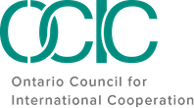

Career Journeys in the International Cooperation Sector
Participant Package

February 10, 2022

Land Acknowledgement

OCIC recognizes that it operates on the traditional and unceded territory of many Indigenous nations, specifically the Haudenosaunee, the Anishnaabe, the Huron-Wendat, and the Mississaugas of the Credit First Nation. We also acknowledge that our membership, staff, and board operate across Turtle Island, on the unceded territory of numerous Indigenous peoples.
As we reflect on our role within a settler-colonial context, we also acknowledge the importance of naming the Indigenous communities on whose lands we live, work and play. We also underscore the importance of framing our involvement and engagement in the sector and beyond through the lens of Reconciliation; recognizing that through our location and operations on unceded land across Turtle Island, we have a responsibility to stand in solidarity with the Indigenous communities who have and continue to fight for social justice on their own lands.
As such, both as part of OCIC's Anti-Oppression Policy and as a holistic approach to our organization's work, we both recognize and encourage our network to reflect on the role each of us, individually, play in Reconciliation. Through our land acknowledgement we orient ourselves within this context to do better, and to intentionally engage in each and every space in a way that will allow us to take back lessons, tools and knowledge to better support and stand in solidarity with Indigenous people.
Land acknowledgements should go beyond simply naming the lands on which we are located; they should push us to recognize that there is no 'neutral' engagement in our work, rather, setting the intention to do better and work towards Reconciliation in each and every moment.

Code of Conduct

OCIC is committed to creating a safe and inclusive space. We ask all participants to commit to the following Code of Conduct, inspired by those of the Inter-Council Network (ICN) and Amnesty Canada, and adapted for OCIC’s content and approach to this event.

1 | RESPECT, I COMMIT to being respectful to all participants regardless of language, race, national or ethnic origin, age, sex, gender, sexual orientation, marital status, ability, and any other identity or belief, throughout this event. I understand that any discrimination or harassment will not be tolerated.
2 | INCLUSION, I COMMIT to creating space for all to contribute and participate, to give prominence to the voices and stories of those who might be systemically excluded, and to make space for those that are more appropriately positioned to contribute.
3 | HUMILITY, I COMMIT to participating with a spirit of openness to learn and a recognition of the broad diversity of participants. I recognize that creating space for lived experiences to inform this space is necessary and that hearing others’ stories is a privilege.
4 | SAFETY, I COMMIT to ensuring the physical, emotional, mental, sexual and spiritual safety of all participants in the sessions,and reporting any incidents of harassment and discrimiation to the organizers.
5 | SOLIDARITY, I COMMIT to seeking common ground and inspiration to support collective action.
6 | PATIENCE, I COMMIT to being patient with technology, organizers, and each other. I recognize that everyone is on their own journey of learning.
7 | OPENNESS, I COMMIT to bringing an open heart and an open mind to my involvement in this event. I commit to being open to caring for others and myself, including taking space to decompress and realign my energy if needed.

Full Agenda & Speakers

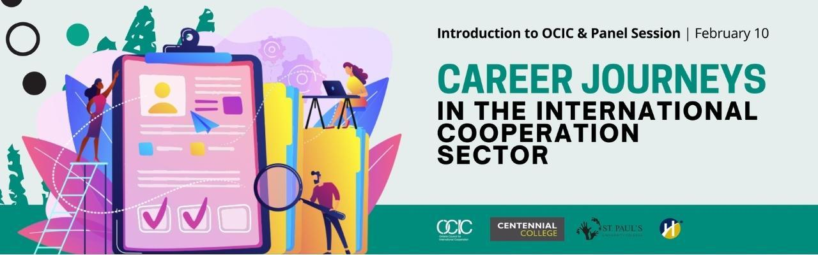

Part 1 – Introduction to OCIC & How to Get Involved | 2:00 PM - 2:45 PM (EST)
Interested in learning about what the Ontario Council for International Cooperation (OCIC) does? Join OCIC staff to learn more about the work of the Council, how to become a member, and some of the steps in their journeys leading to where they are now.
Facilitators:
Marilyn Bastedo – Membership & Administration Coordinator, OCIC
Marilyn Bastedo joined OCIC in July 2019 and is responsible for supporting membership, logistics and administration for OCIC programs. She brings her passion for women’s empowerment, connecting with communities, and knowledge sharing to her work. Marilyn majored in Community Development at Brescia University College through Western University and in 2017 completed her postgraduate certificate in International Development with a partnering certificate in Global Citizenship from Humber College. Marilyn’s experience in the non-profit sector spans from volunteering locally with the United Way, Heart and Stroke Foundation, Culture Link and Progress Toronto. She has also worked internationally with CARE Canada in Zambia, with rural indigenous women weavers in Guatemala, and on social justice movements through the use of information and communication technologies in South Africa. Through her work she has specialized in community and public engagement, strategic partnerships, and gender equality. Marilyn currently volunteers for TEDxToronto supporting community partnership outreach and relationships. She is continually learning and is currently focusing on expanding her knowledge of local policy research and corporate social responsibility. She can most often be found out for a run or a bike in the city.
Aniqah Zowmi – Community Engagement & Gender Equality Specialist, OCIC
Aniqah Zowmi (she/her) works from an intersectional, anti-oppressive operational framework. As a Muslim woman of colour with multiple other intersectional identities, she brings her lived experience authentically into her work. Some of her recent efforts have included supporting humanitarian projects in Jordan focused on mental health, psychosocial awareness, and economic empowerment, for the Italian NGO Un Ponte Per… (UPP) and for the Canadian NGO Menonnite Economic Development Associates (MEDA). Aniqah has also served as a Youth Representative to the United Nations’ Department of Global Communications’ Steering Committee, the Canadian Youth Delegate to the Youth20 (the official youth engagement arm of the G20) in 2018, and a member of the Joint Youth Delegation to the Commonwealth Youth Forum in 2015. She is currently the Director of Diversity, Equity, and Inclusion for Leading Change Canada, a Youth Advisor to the Canadian Commission for UNESCO, and the incoming Chair of Girls Action Foundation. Aniqah holds a Master of Arts in Social Justice and Equity Studies from Brock University, where she looked at feminist and anti-colonialist perspectives on social enterprise. Prior to her Masters, she completed her Honours Bachelors of Science in Neurobiology, specializing in learning, memory, and neurobiophysics.

____________________________________________________________
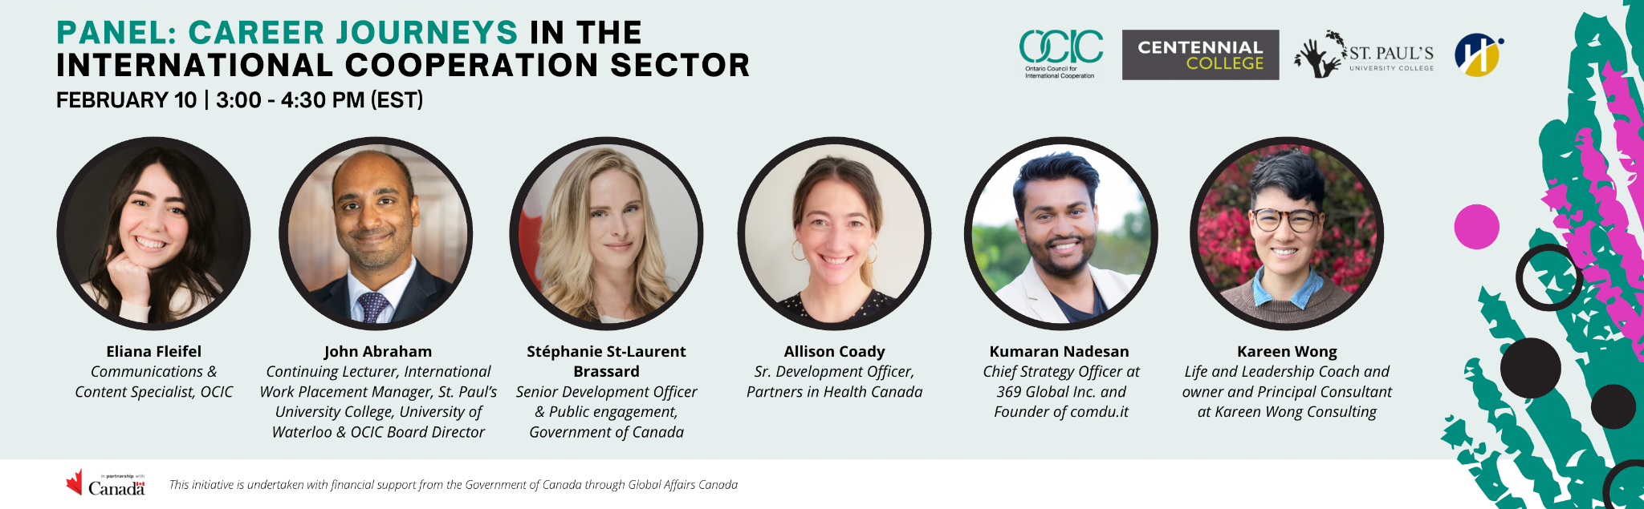

Part 2 – Panel Discussion: Career Journeys in the International Cooperation Sector | 3:00 PM – 4:30 PM EST
OCIC, Centennial College, Humber College and St. Paul’s University College at the University of Waterloo are pleased to present a conversation between panelists, sharing insights on their career journeys in academia, civil society, government, non-profit leadership and entrepreneurship. They will offer experience and advice on navigating the job market and will share perspectives on the many disruptions and shifts underway in the international cooperation sector and work at large, particularly in the context of an ongoing global pandemic, and what that means for students pursuing careers in the sector.
Moderator:

Eliana Fleifel - Communications & Content Specialist, OCIC

Eliana Fleifel (she/her) leads communication efforts at OCIC and facilitates the multi-sectoral exchange of ideas, opportunities and knowledge in support of FIAP and the Global Goals. She holds an undergraduate degree in Business Administration from the American University in Cairo and a Master’s in Development Practice from the University of Waterloo. Eliana specializes in communications for network based organizations in the international cooperation sector, and has held leadership and advocacy roles in organizations like SDSN Canada, the Global Schools Program and the British Columbia Council for International Cooperation (BCCIC). For her, working with networks on a daily basis is a reminder of how much we need each other to create a better world, and how our diverse lived experiences can fuel this process with creativity, innovation and empathy. She feels grateful to serve a small role in a big, collective effort to make positive change.

Contributors:

John Abraham – Continuing Lecturer, International Work Placement Manager, INDEV, Masters of Development Practice, St. Paul’s University College, University of Waterloo & OCIC Board Director
John Abraham has worked in the higher education and civil society sectors for over twenty years. He currently teaches in the International Development program at the University of Waterloo through the School of Environment, Enterprise and Development and St. Paul's University College where he also manages the undergraduate capstone year international placements and the masters degree internship programs. He is passionate about connecting young people with opportunities in the Development sector.
Stéphanie St-Laurent Brassard – Senior Development Officer & Public engagement, Government of Canada
Stéphanie St-Laurent Brassard is a Senior International Development Officer in the Engaging Canadians Bureau at Global Affairs Canada (GAC) since June 2021. She previously was an analyst in the Afghanistan and Pakistan Program for three years. She worked, initially as an intern before being recruited, as an international consultant in human rights and gender equality at the United Nations Development Program (UNDP) in Ukraine in 2017. She also gained work experience in the strategic communications division at Global Affairs Canada in 2016. In 2014, through the volunteer cooperation program, she actively contributed to capacity-building projects in the field of ecological agriculture in Peru within a Canadian non-profit international cooperation and solidarity organization, SUCO. Stéphanie obtained her Masters in International Public Administration from the National School of Public Administration (ENAP) in 2016. She holds a Bachelor of Social Sciences in International Development and Globalization from the University of Ottawa. She is fluent in English, French and Spanish and is currently learning Russian.
Allison Coady – Sr. Development Officer, Partners in Health Canada
An accomplished fundraising, international development and human rights professional, Allison Coady is PIH Canada’s Senior Development Officer. She joined PIH Canada in May 2021 after seven years with Doctors Without Borders/Médecins Sans Frontières USA, serving in the positions of Interim Director of Major Gifts and Development Officer for Foundations. Prior to working at Doctors Without Borders, Allison was based in South Africa representing Canada’s International Centre for Human Rights and Democratic Development (Rights & Democracy) and served as Programs Manager for the Denis Hurley Peace Institute (DHPI) in Pretoria. A 2021 Hilton Humanitarian Prize Virtual Leadership Institute Scholar, Allison also serves on the Board+ of ALIMA (the Alliance for International Medical Action). She holds a Master’s degree in Political Science from the University of Pretoria and a Bachelor of Arts from Mount Allison University in Sackville, New Brunswick.
Kumaran Nadesan – Chief Strategy Officer at 369 Global Inc. and Founder of comdu.it
Kumaran Nadesan is an experienced public sector professional who has held progressively senior roles at the Ontario Ministries of Government and Consumer Services, the Solicitor General, and the Attorney General. Currently on leave from the OPS, he's the Chief Strategy Officer of 369 Global Inc.,a rapidly growing business conglomerate with interests in education and training, financial services, creative industries, philanthropy, and more. An active community animator for over two decades, Kumaran founded comdu.it in 2014. He was named a 2018 DiverseCity Fellow by the CivicAction Leadership Foundation and was awarded the 2020 Established Professional of the Year by the Canadian Tamil Professionals Association.
Kareen Wong – Life and Leadership Coach and owner and Principal Consultant at Kareen Wong Consulting
Kareen Wong is a human committed to the pursuit of self-actualization. She has had a wandering path over the last 15 years that led her to work with civil society organizations across Canada and Central America. Kareen’s career journey has forked several times as she moved from being an English major to studying international development, moved from local community-based programming to working in outdoor retail, left a job and went to Guatemala on a one-way plane ticket to work with local NGOs, moved from international development work to local dialogue-based public engagement, and moved recently from working in communications and marketing to a private leadership coaching and consulting practice. These shifts were challenging yet necessary for where I was in my life. Some happened quickly, others were many years in the making. Each one is beautiful and I continue to reap ongoing value and learning from them. Kareen is a certified Life and Leadership Coach and owner and Principal Consultant at Kareen Wong Consulting where she specializes in facilitation and strategic communications.

THANK YOU

This initiative was undertaken with the financial support of the
Government of Canada through Global Affairs Canada.

