Global Citizens Forum 2013

FULL PROGRAM
November 7 - 8, 2013

November 7, 2021

Full Schedule
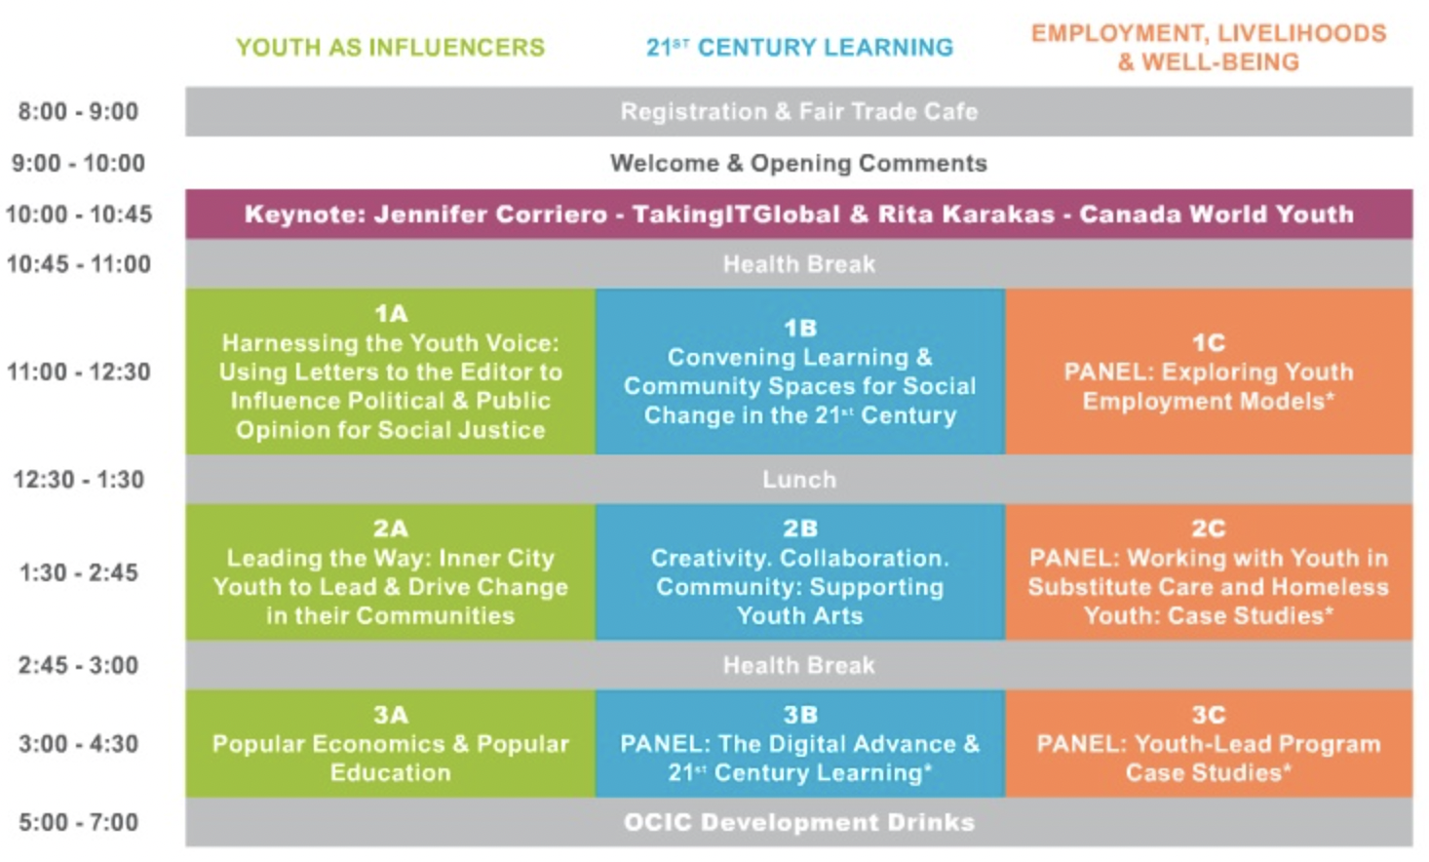

November 8, 2021

Full Schedule
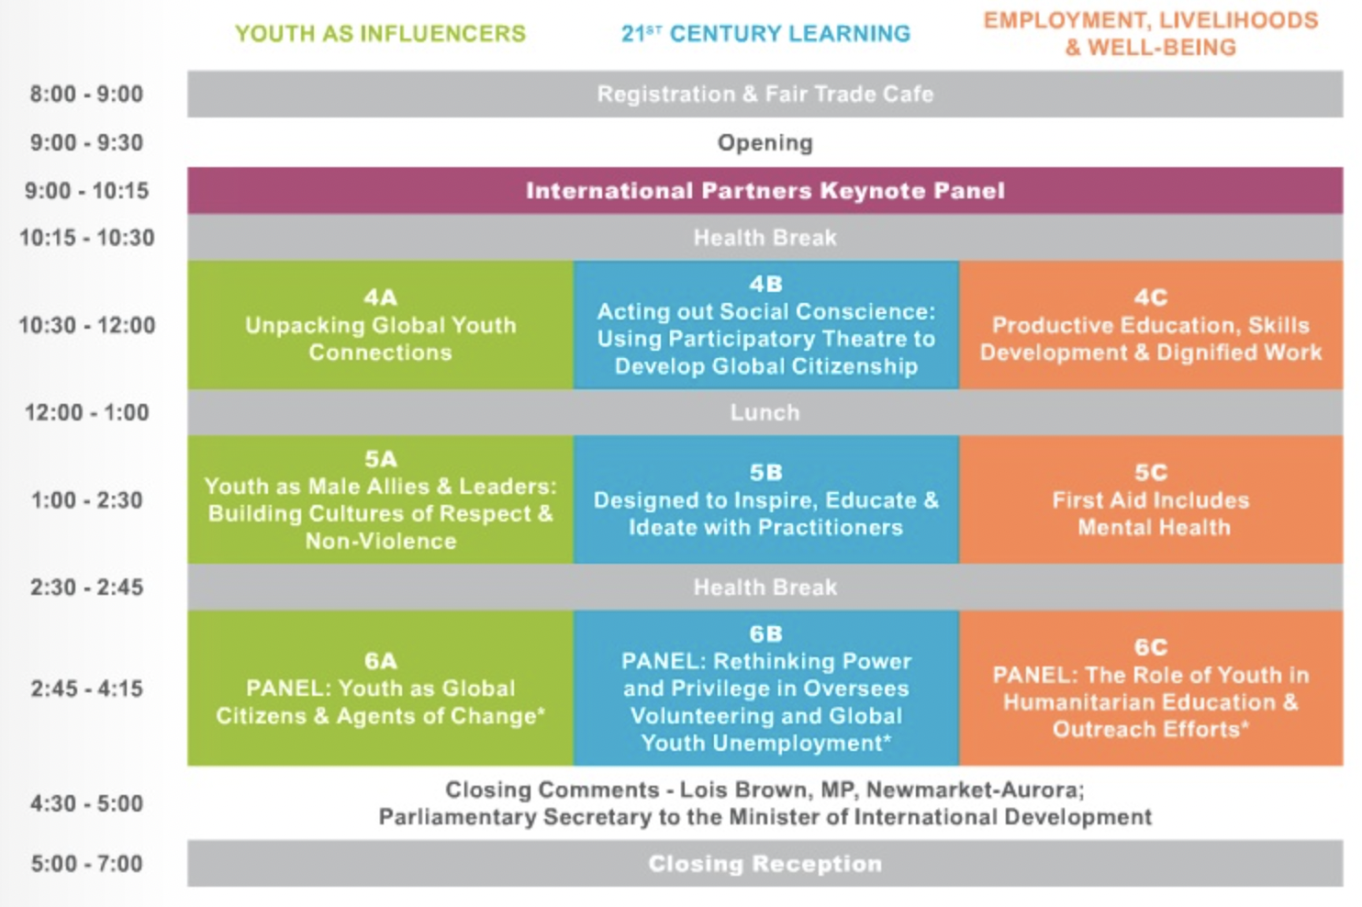

KEYNOTE PRESENTERS

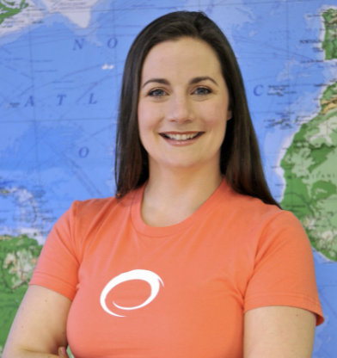

Jennifer Corriero
Named by the World Economic Forum as a ‘Young Global Leader’, Jennifer Corriero is a Canadian innovator, bringing tremendous insight into understanding, reaching and engaging youth. Jennifer is co-founder and Executive Director of TakingITGlobal, a non-profit organization that has thrived for over a decade. She has her Masters in Environmental Studies and serves as Adjunct Professor with the Faculty of Health at York University where she helped to design a course titled Agents of Change in a Global World. Jennifer has been a judge for a range of awards including the World Summit Youth Award, 2011 TD Scholarship for Community Leadership Award and 2010 Buckminister Fuller Challenge. In 2003, Jennifer was a member of the Official Canadian Government Delegation to the World Summit on the Information Society. She has traveled to over 30 countries, presenting at conferences and supporting civil society engagement. In 2011, Jennifer served as a member of the World Economic Forum Global Agenda Council on Youth Unemployment.

Rita Karakas

Ms. Karakas has over 30 years of global experience in both the government and non-government sector. Over the years, Ms. Karakas has specialized in developing solid strategies for policy development, advocacy, international program development and communications. She has a substantive track record as a determined and conscientious senior executive and has demonstrated her ability to bring about continual and recognizable transformation at Centennial College, Save the Children Canada, the YWCA of/du Canada, TVOntario, and other non-governmental organizations such as Oxfam International and Oxfam Great Britain. Ms. Karakas was also the principal and managing partner of RSK Associates Inc., an international organizational development practice specializing in non-governmental organizations. She has worked extensively with global clients such as the International Federation of Red Cross and Red Crescent Societies, the Australian Government’s Aboriginal and Torres Strait Island Council, Oxfam Australia and Oxfam Quebec. She has served as an independent Director for Green Shield Canada from 1988 to 2007.

INTERNATIONAL PARTNERS

The following international partners join us as special guests of the Global Citizens Forum 2013, nominated by OCIC member organizations and selected by our Steering Committee through a competitive and inclusive review process. Please join us in welcoming:

Sarah Wambui Itambo
As a young urban farmer and a small-scale agri-entrepreneur, Sarah passion for farming began as a young girl. After completing her studies in Hospitality at Kenyan training institutes and Urban Agriculture at Mazingira Institute, she went on to participate in an internship with the Kenya Private Sector Alliance (KEPSA). There, she gained the knowledge she would put into practice developing her own urban farming plan, which is currently flourishing and providing employment for other young adults. To learn more about Sarah's work check out Rooftops Canada video Changing Lives - Urban Farmers of Nairobi.

Madeline Mendoza
With a diverse background in the development sector within Nicaragua, Medeline strongly believes in the importance of participatory methodologies and the need to supporting grass-roots organizations. She has also worked as a researcher on global economic justice issues with a focus on Nicaraguan social movements. Medeline’s other areas of focus include: development aid, the “real life” effects of free trade agreements, climate change, and climate justice.

Dario Merlo
Dario Merlo is the project coordinator for JGI’s community-centered conservation programs in the DRC. These programs are a holistic approach to conservation, where he works closely with community leaders at all levels, and youth leaders to build the community’s capacity for conservation. Before joining the Institute, Dario worked as a project assistant for the North Kivu Farmer’s Association, where he managed rural development programs including the construction of roads and the establishment of a cheese factory. Furthermore, he was a high school history teacher in Brussels, Belgium, before moving back home to the DRC in 2005.

Layton Shaw
Currently a Tavares Gardens Primary School Guidance Counselor and Drama Coordinator, Layton works to bring about positive change in the lives his community through creative self-esteem and behaviour modification programs. Jamaican Self-Help has been proud to support effective models of education for youth in inner-city communities for many years and has worked with Tavares Gardens Primary School since 2007. Layton holds a Bachelor of Science Degree in Guidance and Counseling from the Mico University College in Kingston, Jamaica

WORKSHOP DESCRIPTIONS
Thursday | Friday

THURSDAY

Round One - 11:00am - 12:30pm

1A) Harnessing the youth voice: using Letters to the Editor to influence political and public opinion for social justice.

Speaker:
Roshelle Filart - RESULTS Canada

Despite the surge in popularity in social media and online movements among young people, letters to the editor remain a potent tool of social justice advocates. With numerous publications about proven, cost-effective solutions that address extreme global poverty, participants in this workshop will hone their own persuasive writing skills using a simple EPIC format (Engage audience, state Problem, Inform about a solution, Call to action) to increase their chances for publication.

1B) Convening Learning and Community Spaces for Social Change in the 21st Century.

Speaker:
Anna Smith - Engineers without Borders Canada

The 21st century demands different learning and community spaces, and by consequence, the spaces we convene must reflect a 21st century understanding of how individuals learn, collaborate, and communicate. 21st Century Learning Theory and the Art of Convening provide us with new approaches to challenge our traditional models of education and engagement. This workshop will guide delegates through an exploration of how we traditionally understand learning spaces, and why those can often fall short.

1C) PANEL: Exploring Youth Employment Models

Speakers:
Riaz Nathu - Aga Khan Foundation Canada
Nadine Grant - Plan Canada

Expanding Youth Employability: Lessons and Tools from Northern Pakistan.
This workshop will engage participants in a discussion on the experience of constructing and implementing tools to understand local realities and opportunities for youth employment. The workshop pulls on examples from the Enhancing Employability and Leadership for Youth (EELY) project, supported by the Government of Canada, and implemented by the Aga Khan Foundation in Northern Pakistan. The EELY project seeks to contribute to sustainable improvements for youth in Gilgit-Baltistan and Chitral (GBC) through two complementary components: youth employability and youth participation as leaders. Participants of this workshop can expect to gain an understanding in designing and carrying out a youth-centered LMA and engage in youth employment strategy development.

Livelihood Advancement Business School (LABS) Model
The purpose of this workshop is to share the experience of Livelihood Advancement Business School (LABS) model that Plan has adopted and implemented for youth economic empowerment in Asia. Plan recognizes that in order for children to fulfil their potential they need to be prepared to become economically active adults. LABS was developed to address the needs of youth who are constrained by low income levels, inadequate skills, and lack of access to opportunities for training and development. It was adopted by Plan as a model for Youth Economic Empowerment programs and has piloted the program in a number of countries in Asia (Indonesia, India and Vietnam) with different levels of success. This workshop/presentation will share a model that has been using in the pilot projects as well as some of the current youth employability skills development projects.Participants in this workshop will be provided with a brief description of a village setting (e.g. Ifakara in Tanzania) to help them understand economy, youth profile, challenges, and opportunities. Three groups will be formed and asked to come up with modifications to the LABS model that could be relevant to support youth in rural areas.

Lunch Speaker
Poonam Sandhu - United Nation Environmental Programme

In February 2003, the Governing Council of the United Nations Environment Programme (UNEP) adopted a long-term strategy, entitled Tunza, for engaging young people in environmental activities and in the work of UNEP. The word “Tunza” means “to treat with care or affection” in Kiswahili (a sub-regional language of Eastern Africa). UNEP’s vision for this strategy is to foster a generation of environmentally conscious citizens capable of positive action through capacity building, environmental awareness, and information exchange. Learn more about the Tunza Youth Strategy here.
Join Poonam Sandhu - Youth Fellow for UNEP’s Regional Office for North America (RONA) over lunch to learn more about TunzaNA. TunzaNA is the Tunza network specific to youth in North America. Founded in 2008 by UNEP RONA, TunzaNA highlights the environmental work of North American youth on regional, national and international platforms.

Round Two - 1:30 - 2:45pm

2A) Leading the Way: Inner city youths from Miami and Kingston empowered to lead and drive change in their communities.

Speaker:
Novia M McKay - RISE Life Management Services

Using case studies of individuals and projects which have fuelled positive changes in impoverished communities in Kingston, Jamaica and Miami, Florida, this workshop will highlight the RISE Youth Leadership and Training Program, the Sex Ed: Best Said Project, and the NVP Club Project, highlighting effective youth engagement, youth leadership and an overall community development from the perspective of nonprofit agencies and youth workers.

2B) Creativity. Collaboration. Community.: Supporting Youth Arts.

Speaker:
May El-Abdallah - Arts Reach

When young people are equipped with the skills and resources needed to create change in their communities on their own terms, amazing things can happen. This presentation outlines different models of youth work: unincorporated groups (youth organizers); incorporated nonprofit organizations; charitable organizations; intermediary organizations; and social enterprise. Each model of youth work is defined, followed by steps on how to make it happen, including: the benefits, limits and where to find more information on the particular model. ArtReach’s own model and transformation over the years will be used an illustrative example.

2C) PANEL: Working with Youth in Substitute Care and Homeless Youth: Case Studies

Speakers:
Irwin Elman - Provincial Advocate for Children and Youth
Zahra T. Esmail - Eva's Phoenix
Building Relationships Between Youth In Substitute Care - Global Possibilities.
Children and youth in substitute care – those separated from their parents and often family through no fault of their own but due to the inability of their caregivers and family to care for them – have a commonality of experience the world over. How can this affinity with one another support a reclaiming of voice, provide a source of wisdom for decision makers, and assist others in similar situations? What ways have young people in substitute care used, and been supported to use, to join across borders for change? What are ways forward?

Integrated Support for Homeless Youth - Exploring Overseas Replicability of a Successful Canadian Model.
This workshop provides a detailed overview of Eva’s Phoenix – a non-traditional shelter that offers employment programs and housing to homeless and at-risk youth aged 16-24 – and considers the suitability of the Phoenix model in other settings, both within Canada and in developing countries. Participants will learn about the mandate of Phoenix, the cornerstone of which is providing a holistic web of supports to youth including housing, life skills, and employment training. The unique integration of the Phoenix Print Shop, a successful social enterprise, will be examined, along with lessons that have been learned since the inception of Eva’s Phoenix.

Round Three - 3:00 - 4:30pm

3A) Popular Economics & Popular Education

Speaker:
Mandy Bergman and Deborah Konecny - Catalyst Centre

Youth have untapped resources in the stories they have heard about their communities and how they have flourished through practices like paid jobs, subsistence farming and gift economies. Through personal reflection, group dialogue and the interactive tool “jobology”, this workshop will uncover some patterns in how our families and communities have survived and even flourished. Using these emerging themes we will brainstorm some actions to take immediately and some longer-term actions to bring home.

3B) PANEL: The Digital Advance & 21st Century Learning

Speakers:
Sara Hassan - TakingITGlobal
Aniket Bhushan - North - South Institute
Kate Gatto - International Development and Relief Foundation: IDRF

Building Future Friendly Schools through The Use of Collaborative Technology.
Today's global challenges require that youth develop global awareness, environmental responsibility, and the drive and capacity to take on critical leadership roles. For schools to be future-friendly, each of these areas must occupy a critical space in the classroom. Through this presentation, participants will explore the concept of future friendly schools through the lens of global citizenship, environmental stewardship, and student voice, how to incorporate these into teaching and learning through the use of collaborative online technologies, social networking and digital media tools, and leave with tangible concepts to bring to their practice.

Introducing the Canadian International Development Platform: Leveraging Open Data for Development Impact.
Through this panel presentation and interactive session to follow, Aniket Bhushan, the creator and lead of the CIDP, will introduce the platform and demonstrate how users can interact with, analyze and download data on Canada’s engagement with developing countries, encompassing Canada’s over $5billion a year aid program and other areas such as trade and investment. One of the key motivations behind the CIDP is to engage a new demographic of Canadians in an interactive, technology-enabled dialogue on how they would like to see Canada rise to global challenges such as poverty reduction and sustainable economic development. In this regard the CIDP is a tool that can, and is, being used in universities and classrooms. Through the panel presentation Aniket will discuss how the open data movement in the international development sector in Canada is growing rapidly. He will talk about recent and forthcoming initiatives by NSI and NSI’s partners in the open data space, and suggest ways young Canadians can get more involved in the same.

Licensed to Learn Peer-to-Peer Mentorship Program.
L2L (Licensed to Learn) is a Toronto-based program that trains student tutors to provide support and mentorship to other students at their schools who struggle academically. Tutoring is provided at no cost to students, and is proven to benefit youth by improving academic success among those being tutored, by fostering the development of leadership skills among tutors, and by nurturing positive relationships that make up vibrant and inclusive school communities. During this panel presentation, the topic of 21st Century skill development in the L2L program will be explored. What do these skills look like in peer-to-peer support, and how can we foster further engagement in our schools by tapping into this under-used model?

3C) PANEL: Youth-Led Program Case Studies

Speakers:
Craig Frayne - Horizons of Friendship
Shaunna Burton - Plan Canada
Fostering youth identity and inclusion in Central America.

Youth, the drivers of development and change, are often uprooted from communities. Nowhere is this more evident than rural-urban migration in Latin America, or the route from Central America and Mexico into the U.S. This workshop will outline the socio-political context in Central America and why partners in the field have made youth participation (through skills training and creative arts) a priority in their communities. The presentation will include brief case studies of innovative projects in the field and insight into possible new projects that address the topics of youth and migration.

Empowering Girls for Global Change.
Because I am a Girl clubs are an initiative from Plan Canada, supported by the Because I am a Girl movement. The clubs offer girls across Canada the opportunity to explore issues that matter to girls here and in the developing world. Aiming to empower girls to support one another and stand up for the rights of girls in Canada and around the world, the clubs are designed to be youth-led, youth-driven and adult or educator mentored. Plan Canada will present an overview of our innovative program, provide youth engagement activity ideas, and discuss some club highlights, which have included lobbying the United Nations to formally adopt October 11 as the International Day of the Girl.

FRIDAY
November 8, 2021

Round Four - 10:30 - 12:00pm

4A) Unpacking Global Youth Connections.

Speakers:
Sara Hsiao
Cari Bourrie
Dario Merlo - Jane Goodall Institute

This workshop will share the Jane Goodall Institute’s experience in trying to create a global youth movement with their various partners around the world, through the “Roots & Shoots” youth engagement program, as well as build understanding and unpack the way we currently engage in ‘cultural exchanges’ for youth . We will also identify challenges faced by workshop participants in their experiences with global youth programming, and together apply the information discussed to propose solutions and ways forward to create meaningful exchanges between young people.

4B) Acting out Social Conscience: Using Participatory Theatre to Develop Global Citizenship.

Speaker:
Simon Malbogat - Mixed Company Theatre

This workshop will demonstrate the prospect of using participatory theatre as a pedagogical tool to promote dialogue within organizations and communities and to demonstrate the integral link between creative thought and critical reflection – a skill necessary for global citizenship development and education. This method of facilitation provides participants with a safe space to explore alternatives and critically evaluate global systems and their social, environmental or cultural consequences.

4C) Productive Education, Skills Development and Dignified Work.

Speaker:
Leigh Eagles - Save the Children

This workshop will highlight two case studies in particular: 1) the productive education projects in formal schools in Bolivia and Peru, including ‘Education for Work’ Curriculum, and 2) the Bulgari Jewelry Making project in formal schools in Colombia. This workshop will show the intersectionality of Save the Children’s two main niche areas; children and work, and gender. The presentation will also delve into ways in which young people exercise their right to participation to improve the promotion and protection of girls’ and boys’ rights among civil society, government, child-led groups and the private sector.

Round Five - 1:30 - 2:30pm

5A) Youth as Male Allies and Leaders: Building Cultures of Respect and Non-Violence.
Speaker:
Jeff Perera - White Ribbon Campaign

Ending violence against women and girls requires partnerships among women and men, boys and girls of all walks of life. The workshop will explore concepts of masculinity and the role of fathers and sports as powerful influences over the lives of young men. It will highlight various strategies and the leadership roles that young men can play in promoting gender equality and ending violence against women and girls in their communities and how international organizations can support young men in this role.

5B) Designed to inspire, educate and ideate with practitioners.

Speaker:
Natasha Walji - Google

Learn about and brainstorm innovative ways to to engage and empower youth using technology -- get inspired, learn about freely available technologies to engage youth and have the opportunity to brainstorm your own ideas (prize to be awarded for top idea).

5C) First Aid Includes Mental Health.

Speaker:
Sjors Reijer - Mental Health First Aid Canada

For years, the international development sector has widely provided excellent pre- and post- travel briefings and training to ensure a healthy overseas experience. This workshop will focus on the necessity of mental health training for volunteers and professionals prior to overseas postings to help decrease early returns, ensure effective and early interventions, and enhance the ability of Canadians overseas to be effective partners with their local counterparts.

Round Six - 2:45 - 4:15pm

6A) PANEL: Youth as Global Citizens & Agents of Change

Speakers:
Evans Rubara - York University
Chizoba Mary Imoka - The Ontario Institute for Studies in Education / University of Toronto
Youths in the Global Citizenship Era: Influencers or Influencees.
This workshop will attempt to define “global citizenship” from sociopolitical, developmental and academic perspectives. The heart and focus of the workshop is to help participants discuss the pros and cons of being a youth in the “global citizenship” era. In conclusion, the paper will draw crucial and persuasive points that encourage a more balanced view of “global citizenship”
Equipping Nigerian Teenagers with Social Change Capital for Nigeria’s development.
Making the case for an alternative conceptualization and implementation strategy for youth engagement programs, this workshop will present results/testimonials from a teen driven social change research project in Nigeria. Recorded results include teenagers giving up their lunch money for a week and then raising 20,000 to buy a bus for a home to a teenager living on the street self-facilitating his transition into an internship in a salon to students in a public school writing a letter to the governor of their state demanding for qualified teachers to teenagers organizing community programs that has impacted over 3000 people. At this workshop, program attributes and the lessons learnt will be discussed. Attendants will gain insight on how to engage young people from an assets based approach and how to deepen engagement with young people for social change. Conceptual frameworks about development especially as it relates to Africa will also be challenged.

6B) PANEL: Rethinking Power and Privilege in Oversees Volunteering and Global Youth Unemployment

Speakers:
Mai Ngo - The Ontario Institute for Studies in Education / University of Toronto
Juwaeriah Abdussamad - University of Ottawa
Canadian Youth Volunteering Abroad: Rethinking Issues of Power and Privilege.
Since the 1960s, over 65,000 young Canadians have participated in volunteer abroad programs (Tiessen, 2008), and this number continues to expand each year as young people travel to developing countries to “change the world”. In recent years, researchers and practitioners in the international field have questioned the ethics of volunteering as development, with scrutiny on who actually benefits from volunteering initiatives. The purpose of this workshop will focus on how complex social relations and institutional structures in international development can shape the issues of power and privilege of the young person’s experience in volunteering.

Youth Change Lab; a think tank to tackle Global Youth Unemployment issues.
Global unemployment is on the rise, particularly for youth and as a global economy we seem to be undermining the growing gap between educated youth and their entry into the workforce. Unemployment is a consequence of a large system level failure. A youth change lab aims to address this issue by means of social innovation and technological collaboration. The concept of a Youth change lab sparks a hope to tackle unemployment issues from ground up to the system level. A designed thinking is required to defrost this stagnancy of unemployment and to compel young minds to delve deeper into region specific barriers, issues and their localized solutions. The aim of this discussion is for the youth: 1) To have a holistic understanding of barriers surrounding youth unemployment, and 2) To empower the Youth to design change labs where these issues can be addressed. Why do youth need to take control of this? You are just about to find out.

6C) PANEL: The Role of Youth in Humanitarian Education & Outreach Efforts

Speakers:
Kelly Bowden - Oxfam
Andrea McArthur - Red Cross

Exploring Syria: what needs to be done, and why we must do it now.
More than two million refugees have now fled violence in Syria and are in desperate need of shelter, food and water. Over half of them are children. The scale of the Syria crisis is rapidly deepening, particularly as winter approaches, leaving relief agencies overstretched and struggling to cope with massive numbers of refugees, who are often living in inadequate shelter in neighbouring countries. Ultimately, there needs to be a political solution to this crisis. The humanitarian suffering caused by the crisis is already staggering. More than 100,000 lives have been lost and more than two million people have fled to neighbouring countries. This workshop will look at the case study of Syria to explore how Oxfam provides humanitarian assistance, advocates for lasting and peaceful solution to conflicts, and connects Canadians to the struggles of people living in poverty.

I Don’t Want to Go Back.
Exploring Humanitarian Law (EHL) is an international education program from the International Committee of the Red Cross about humanitarian education, justice and International Humanitarian Law. EHL workshops provided by the Canadian Red Cross offer teachers the ability to learn how to best fit EHL resources into classes while earning professional development at the same time. In this workshop, limits in armed conflict are explored through the issue of the recruitment or other use of children by armed forces or groups. The workshop begins by taking a look at childhood and the needs of children. It then uses photos, a film and readings to communicate to students the experiences of child soldiers and to help them understand the consequences of these experiences for the children themselves and for their societies. Finally, the exploration looks at the recruitment and use of children in armed conflicts around the world in such a way that no one can dismiss this practice as occurring in ‘another part of the world.’

