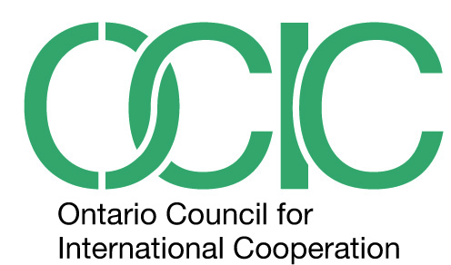
AGM Resolution RE: Changes to OCIC Bylaws

Be it resolved that OCIC’s current Bylaws be amended as follows:

From:

Board of Directors

8. a) The affairs of the Council shall be managed by a Board of Directors. The Board shall be comprised of not less than six directors and not more than twelve. Members of the Board shall include representatives of international and global education organizations. Three associate members may sit on the Board of Directors. In order to reflect the broader community, the Council shall ensure that the Board has equitable gender, racial and regional representation.

To:

Board of Directors

8. a) The affairs of the Council shall be managed by a Board of Directors. The Board shall be comprised of not less than six directors and not more than twelve. Members of the Board shall include representatives of international and global education organizations. Four associate members may sit on the Board of Directors. In order to reflect the broader community, the Council shall ensure that the Board has equitable gender, racial and regional representation.

Rationale

The OCIC Board of Directors has undertaken a review of the Bylaws related to Board structure and composition, and has noted that there are an increasing numbers of associate members in the Council, many of whom express interest, upon application, to serving in a governance function. Given that the Board may currently be comprised of twelve directors, the Board puts forward this resolution as a means to allow up to one third of its Directors to represent this constituency within the Council.

