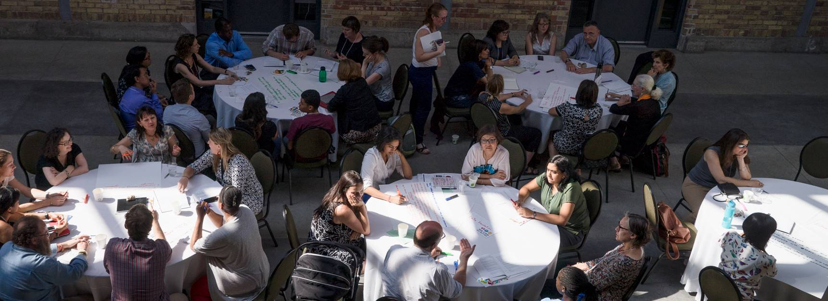

ONTARIANS & THE WORLD: UNIVERSALITY MATTERS
ANNUAL GENERAL MEETING & SYMPOSIUM PROGRAM

M

8:30-9:00 | Registration / Fair Trade Café
9:00-9:30 | Welcome & Introduction  Elder Dr. Bob Phillips  Kimberly Gibbons Executive Director, Ontario Council for International Cooperation  Emily Kere Vice President, Ontario Council for International Cooperation
9:30-11:00 | Annual General Meeting  Approval of the Proposed 2016 AGM Agenda  Approval of the 2015 AGM Minutes  Presidents’ Report  Membership Survey Report  Treasurers’ Report  Approval of 2016-2017 Auditors  Ratification of New Members  Resolution on By Law Amendment  Presentation of Candidates for Board of Directors  Elections  Executive Directors’ Report  Introduction to Consultation Processes  Video Message to Participants: Karina Gould Parliamentary Secretary to the Minister of International development and La Francophonie  Ratification & Election Results  Volunteer Recognition  Adjournment of Business Meeting  Icebreaker
11:00-11:30 | Networking Break / Fair Trade Café
11:30-12:45 | Towards 2030: Building Canada’s Engagement with Global Sustainable Development  Margaret Biggs Skelton-Clark Fellow, School of Policy Studies, Queens University  Helle Bank Jørgensen President, Global Compact Network Canada  Dr. Alexandra Conliffe VP Operations, Engineers Without Borders Canada  Julia Anderson Board Director, Ontario Council for International Cooperation
12:45-1:45 | Lunch

2:00-2:50 | Shared Leadership: Defining Priorities for Collective Action  The Honourable Elizabeth Dowdeswell OC, OOnt, Lieutenant Governor of Ontario  Mitra Manoucherian President, Ontario Council for International Cooperation  Elissa Golberg Assistant Deputy Minister, Partnerships for Development Innovation, Global Affairs Canada  Shannon Kindornay Adjunct Research Professor, Norman Paterson School of International Affairs, Carleton University  Kimberly Gibbons Executive Director, Ontario Council for International Cooperation
3:00-3:40 | Parallel Roundtable Discussions  - the health and rights of women and children (A)  - delivering results by improving effectiveness and transparency, innovation and partnerships (A)  - Ontario municipalities, colleges and universities (B)  - clean economic growth and climate change (C)  - peace and security (D)  - diaspora communities in Ontario (D)
3:50-4:30 | Parallel Roundtable Discussions  - the health and rights of women and children (A)  - delivering results by improving effectiveness and transparency, innovation and partnerships (A)  - Ontario municipalities, colleges and universities (B)  - governance, pluralism, diversity and human rights (C)  - responding to humanitarian crises and the needs of displaced populations (D)  - diaspora communities in Ontario (D)
4:45-5:30 | Roundtable Highlights, Synopsis & Closing Remarks  Jennifer Foulds Amref Health Africa in Canada  Jakub Nemek ADRA Canada  Susan James Associate Member  Isabelle Hachette World Accord  Gavin Charles Canadian Council for International Co-operation  Tina Sweeney Cuso International  Esperanza Monsalve YMCA of Greater Toronto  Luke Stocking Canadian Development & Peace  Shannon Kindornay, Kimberly Gibbons
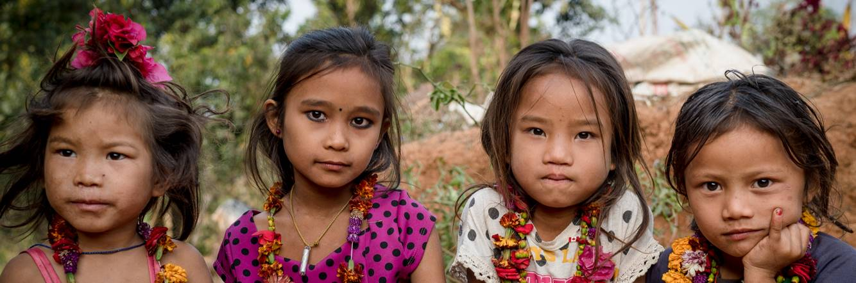  5:30-6:00 | Championing Change in Conflicts and Disasters: Options for Ontarians & Canada  Annie Demirjian Director, Glendon School of Public & International Affairs, York University  Roshelle Filart Board Director, Ontario Council for International Cooperation



MINUTES OF THE 2015 ANNUAL GENERAL MEETING

Held June 18, 2015 at Artscape Wychwood Barns
601 Christie Street, Toronto, ON

1. Welcome & Introductions
- OCIC Executive Director Kimberly Gibbons and Board Director Scott Zoltok welcomed the membership and recognized our presence on the traditional territory of the Anishinaabe First Nation. Kimberly also welcomed the international delegation from the YMCA.
- Kimberly thanked OCIC staff, the many volunteers, moderators and speakers for their contributions to the day’s AGM and Symposium
- Scott gave a brief overview of the day, reviewed AGM objectives, introduced the participant package, highlighted the Agenda, and provided basic housekeeping information.
- Kimberly explained the theme “Universality Matters”.
- Kimberly introduced Vice-President Yin Brown and Treasurer Matthew Legge, who would be leading the Annual General Meeting.
- Yin welcomed members to the AGM, and Matte reminded them that we would be following Roberts Rules of Order.

2. Business Meeting
- Approval of the Proposed 2015 AGM Agenda (Yin Brown)
- Motion to approve the proposed 2015 AGM Agenda moved by Susan James (Presbyterian World Service and Development) and seconded by Caroline Abbots (cbm Canada). All in favour, motion carried.

- Approval of 2014 AGM Minutes (Yin Brown)
- The minutes from the 2014 AGM were presented to the membership by Yin Brown.
- Farrah Ali-Khan from World Accord provided corrections on the details of World Accord’s work overseas.
- Motion to approve the 2014 AGM minutes as amended moved by Kelly Bowden (Oxfam Canada) and seconded by Liane Cerminara (Crossroads International). All in favour, motion carried.

- Presidents’ Report (Yin Brown)
- Yin presented the Presidents’ Report on behalf of Ikem Opara, who could not be present.
- Highlights: OCIC is now two years into our 2013-2018 Strategic Plan and is moving well at meeting new goals. OCIC development principles are now aligned with the Istanbul Principles, the CCIC Code of Ethics, and a new OCIC Anti-Oppression Policy and Monitoring Framework. A new member acquisition drive has been managed by the Membership & Nominations Committee, and we have transitioned from our previous DFATD contribution agreement to a 2014-2019 grant agreement. We have also diversified our funding with new grant for capacity building in monitoring and evaluation from the Ontario government.

- Membership Survey Report (Kevin O’Neill)
- Kevin O’Neill presented information from the membership survey, a tool which OCIC regularly uses to track progress towards meeting strategic goals.
- Highlights: 39 respondents to the survey (67% organizational members, 31% associate members)
- 91% feel current OCIC communications are very effective or effective, 85% are very satisfied or satisfied with OCIC's knowledge sharing opportunities, 82% are very satisfied or satisfied with OCIC programs and member services, 82% are very satisfied or satisfied with OCIC's distribution methods of DFATD information

- Governance Committee Report (Matthew Legge)
- Matthew Legge presented highlights of the work of the Governance Committee and reminded the membership that the Governance Committee was developed three years ago to allow the Board to focus on reviewing and developing policies.
- The Governance Committee reviewed the OCIC Development Principles to determine if they still resonated with the goals of the Council. Through this review the Committee noticed there were significant gaps, and determined that that OCIC’s Anti-Oppression Policy and adherence to other national and international principles was more inclusive and current, and better served the needs of OCIC and our membership.
- The Board of Directors took a decision to strike OCIC’s existing Development Principles, and to instead use the Istanbul Principles for CSO Development Effectiveness, the CCIC Code of Ethics and OCIC’s Anti-Oppression Policy as our collective suite of Principles.

- Treasurer’s Report (Matthew Legge)
- Matthew presented highlights of the Audited Financial Statements.
- OCIC had a clean audit with no misstatements and no adjustments required, ending the year with a deficit of $18,619, as a result of the gap between DFATD funding. The Board has reviewed and approved the audited financial statements.
- OCIC was able to absorb the deficit using unrestricted reserve funds, which have built up over the last 10 years.
- With the move of the Inter-Council Network (ICN) host function to BCCIC, OCIC’s program budget decreased this year.
- OCIC secured a grant from the Ontario government for a monitoring and evaluation capacity building program. As the Ontario government disbursed our first tranche of funding, we have cash on hand (deferred government balance).
- Motion to approve Collins Barrow Toronto LLP as auditors for the 2014-2015 financial year moved by Tina Sweeney (Cuso International) and seconded by Farrah Ali-Khan (World Accord). All in favour, motion carried.

- Ratification of Members (Michelle Manks)
- Michelle Manks introduced Beautiful World Foundation Canada, Casa-Pueblito, World Animal Protection and Anza as new Organizational Members, and the Centre for Critical Development Studies, University of Toronto Scarborough Campus (CCDS as a new Network/Institutional member, to be ratified.
- Krista O’Shaughnessy briefly introduced Beautiful World Foundation Canada, an educational organization that supports higher education for students, especially girls, in Uganda, Rwanda, Sierra Leone and South Africa.
- Katie Daly introduced Casa Canadiense-Pueblito Canada (Casa-Pueblito), a new amalgamation of two OCIC members which is currently focusing on community development in Central America.
- Melissa Matlow introduced World Animal Protection (formerly World Society for the Protection of Animals), an organization that focuses on reducing suffering on animals, and the only organization to focus on animal protection during disasters, working to protect food producing and working animals during disasters.
- Michelle introduced Anza, an NGO dedicated to job creation and community strengthening in Tanzania.
- Michelle introduced the 40 new Associate Members to be ratified (a list of names was projected on the screen).
- Michelle asked members to vote to ratify new members via the ballot in their package. Ballots were collected and counted.

- Presentation of Candidates for OCIC Board of Directors (Julia Anderson)
- Julia Anderson introduced Board of Directors In-Term: Julia Anderson (Jamaican Self-Help), Mitra Manouchehrian (Associate Member), Ikem Opara (Associate Member), and Scott Zoltok (TakingITGlobal)
- Julia introduced candidates for the Board of Directors: Roshelle Filart (RESULTS Canada), Emily Kere (cbm Canada), Michelle Manks (WUSC), Jakub Nemec (ADRA Canada), Kevin O’Neill (Amref Health Africa in Canada) and Yin Brown (Associate Member), and invited each to speak briefly.
- Caroline Abbotts spoke on behalf of Emily Kere; Roshelle Filart, Michelle Manks, Jakub Nemec, Kevin O’Neill and Yin Brown each introduced themselves and their interest in serving on the Board.
- Julia Anderson called for nominations from the floor; there were none.
- As the slate of candidates was less than the maximum number of Board Directors allowable, Julia asked the membership to acclaim the candidates.
- Motion to accept by acclamation the candidates for the 2015-2016 Board of Directors and appoint Roshelle Filart (RESULTS Canada), Emily Kere (cbm Canada), Michelle Manks (WUSC), Jakub Nemec (ADRA Canada), Kevin O’Neill (Amref Health Africa in Canada), Yin Brown (Associate Member) to the Board was moved by Farrah Ali-Khan (World Accord) and seconded by Thandi Nkomo (Rooftops Canada).

- Executive Director’s Report (Kimberly Gibbons)
- Kimberly presented an overview of OCIC and highlights of results in 2014-2015.
- Two years into our new strategic plan, it has been a balancing act to move forward, while supporting members and various competing priorities.
Challenges: a gap in federal funding for April & May 2014 caused a deficit. OCIC transitioned out of being host of the Inter-Council Network (ICN) and also had a transition of 2 core staff in our Public Engagement and Communications Coordinator roles. We also underwent a rigorous external audit, commissioned by DFATD.
Achievements: OCIC moved to the Centre for Social Innovation (CSI)-Spadina to have greater access to innovative partners. We began a new partnership with the Partnership Brokers Association, UK, as a means to help members build capacity in building formative partnerships at early stages. We submitted a proposal and received funding from the Ontario government for a new monitoring and evaluation capacity building program, which will allow us to build a web platform to reach all members in Ontario. OCIC convened a consultation on the role of “cultural community groups” (diaspora) in development in collaboration with DFATD, on the request of Minister Paradis. The report from this Consultation is available on our website. We piloted our new “Transformations” photojournalism initiative, which included a visit to Peru to document the partnerships and work of Transforming Faces, and Save the Children Canada.
- The Board worked on a number of organizational policies, which will be posted on the OCIC website.
- The ICN is trying to fund a way to fund small and medium sized organizations, and has been working with DFATD for eight months to prepare a proposal for a small secretariat to run the fund. There has been no news on this from DFATD, yet.
- Next for OCIC: Ramping up the new Ontario M&E capacity building program; laying the groundwork for an Ontario municipalities, colleges and universities research project to see how we can collaborate across municipalities and with academia; second year of Transformations, OCIC’s new photojournalism initiative; raising the profile of international cooperation in the lead up to the federal election; continuing to support small and medium sized organizations.

- Election Results (Michelle Manks)
- Michelle announced that all new Organizational, Network/Institutional, and Individual Associate Members were ratified through the voting process, and asked for motions to approve the results of the election, as follows:
- Motion to approve Beautiful World Foundation Canada, Casa-Pueblito, World Animal Protection, and Anza as Organizational Members moved by Patricia Arges (Nu-Vision Ministry) and seconded by Esperanza Monsalve (YMCA of Greater Toronto). All in favour, motion carried.
- Motion to approve the Centre for Critical Development Studies, University of Toronto Scarborough Campus (CCDS) as a Network/Institutional Member moved by Susan James (Presbyterian World Service and Development) and Sophie Muset (Jane Goodall Institute of Canada). All in favour, motion carried.
- Motion to approve Antoinette Pokua Afriyie, Fahad Ahmad, Solange Alexander, Prabath Aluthge, Megan Benedict, Tariq Bhanjee, Miriam Buttu, Victoria Carlan, Myriam Castilla, Michelle Davis, Amila De Silva, Chrissy Fair, Shelley Flam, Leslie Gardiner, Arman Hamidian, Ashraful Hasan, Fateha Hossain, Timothy Jason, Tamara Levine, Dr. Hemanth Kumar Mantrawadi, Christina Masching, Ashley McIntyre, Kim Ha Nguyen, Michael Opatowski, Debby Poljanowski, Yuliya Prodaniuk, J.R. Reddock, A.S.M. Gowser Reza, Yamuna Samuel, Jacqui Scaman, Azin Soltani, Michael Stephens, Jessica Stewart, Alessia B. Testa, Nancy Tran, Ruth Tshin, Claudia Vergara, Mikayla Wicks and Melanie Winterle as individual Associate Members moved by Genevieve Drouin (Canadian Feed the Children) and seconded by Sophie Muset (Jane Goodall Institute of Canada). All in favour, motion carried.
- Motion to destroy the ballots for the elections moved by Julie Cosgrove (Kawartha World Issues Centre) and seconded by Marisa Kaczmarczyk (Jamaican Self-Help). All in favour, motion carried.

k. Kevin O’Neill and Scott Zoltok introduced a resolution to the membership for the revision of OCIC’s membership fee structure and fees.
- Four key changes were proposed to the fee structure:
- Change 1 Revision to fee tiers of Organizational Members (tier 1 changed from $0-$100,000 to $0-$250,000; tier 2 changed from $100,001-$500,000 to $$250,001-$500,000; tier 4 which was $1million-$10million split as follows: tier 4 $1million-$5million; tier 5 $5million-$10million.
- Change 2: Introduction of tiers for Network/Institutional Members: Previously these members were charged one standard rate, but the proposed change is to align the fee structure with tiers for Organizational Members.
- Change 3: Revision to Organizational Member fees: Slight changes in fees in each tier
- Change 4: Introduction of 20% discount for long-distance members to take into account of challenges to participating in Toronto-based activities for many members
- Susan James (Presbyterian World Service and Development) asked if the change proposed for Network/Institutional Members would have smaller organizations which are part of larger institutions (i.e. as centres in universities) have their fees based on the larger organization? I.e. would CCDS be assessed based on University of Toronto’s budget? Kevin advised that that when prospective members submit applications, they submit their own respective budgets, not the budgets of larger institutions that they belong to.
- Motion to approve the changes to the OCIC membership fee structure and fees as presented moved by Julie Cosgrove (Kawartha World Issues Centre) and seconded by Patricia Arges (Nu-Vision Ministry). 22 in favour, 1 abstention, motion carried.
l. Volunteer & Staff Recognition
- Lisa Swainston thanked OCIC Networking Group chairs and co-chairs, iAM Editorial Board members, Development Drinks, data entry, AGM, and other volunteers and contributors;
- Mitra Manouchehrian thanked departing Board Directors Jessica Dubelaar, Nija Hope, Faisal Islam and Matthew Legge; and
- Kimberly Gibbons thanked OCIC staff and photojournalist Allan Lissner for their contributions throughout the year.

m. Adjournment of the Business Meeting (Yin Brown)
- Motion to adjourn the Annual General Meeting moved by Caroline Abbots (cbm Canada) and seconded by Genevieve Drouin (Canadian Feed the Children). All in favour, motion carried.


NOTES


PROFILES OF NEW MEMBERS
TO BE RATIFIED

ORGANIZATIONAL MEMBERS
Inter Pares
221 Laurier Avenue East
Ottawa, ON K1N 6P1
Phone: 613.563.4801
Web: www.interpares.ca
Inter Pares - which means among equals – believes in solidarity, not charity, as an approach to international cooperation. For 40 years, Inter Pares has worked closely with courageous activists and more than a hundred inspiring organizations throughout the world to build peace, advance justice and globalize equality. Their programs largely focus on six global issues: food sovereignty, women's equality, peace and democracy, economic justice, health, and migration. We work with long-term counterparts – local and national activist organizations – in Asia, Africa, Latin America and Canada.

We are dedicated to empowering people in Canada and around the world to be at the center of their own development and to assert their own agency. By supporting the work of our counterparts, we help communities confront injustice, implement locally adapted solutions, spark innovative initiatives and occupy the political space that belongs to them. We are also committed to engaging Canadians in the struggles for justice and equality that people face around the world, and to offer ways to take action.

Our values and principles state:
- We put equality into practice as the key component for creating a better world
- We work in solidarity as citizens from around the world connect for a common cause
- We support women’s leadership, because women occupy a central and crucial role in societies though they are often marginalized
- We foster participation since people and communities need to actively participate in creating solutions to the poverty and injustice that affects them
- We promote sustainability to help communities become self-sufficient, and environmentally and financially sound
Inter Pares collaborates with people and organizations who are dedicated to building more just societies and creating positive change. At the heart of the collaboration with our counterparts lies the profound belief in the equality of all people. Inter Pares does not have overseas offices in the countries where they work. Instead, we choose to support organizations and activists working in their own countries to confront injustice, helping them strengthen their work and increase their impact as Inter Pares also learns from them. These collaborations are not one-way “helping” relationships, but a two-way collaborative relationship. Inter Pares collaborates with courageous social justice organizations based in Asia, Africa, Latin America, and Canada. We are currently working with over 120 counterparts who have programs in 37 countries.

Internally, Inter Pares has a co-management structure. This means that internally, full-time staff are co-managers, managing the institution through consensus-based decision making. Though everyone plays a different role, they share equal responsibilities, equal participation in decision making and an equal base salary. All full-time staff collaborate in raising funds and are involved in the programming and financial management of the organization, assuring a high degree of transparency, cohesion and rigour.

Inter Pares is a feminist organization. We see issues of equality – between women and men in particular, but also between North and South, those marginalized and those privileged, relating to race and class as well as other forms of socially and culturally-constructed hierarchies – as important elements of their political analysis. We value methodologies that promote collaboration, foster good process and encourage the agency of those with less power. A significant portion of Inter Pares’ programming relates to women’s rights.

ASSOCIATE MEMBERS

Network/Institutional Members

Brescia University College
1285 Western Road
London, ON N6G 1H2
Phone: 519.432.8353
Web: www.brescia.uwo.ca
Brescia College is affiliated with The University of Western Ontario. Our vision is that Brescia is the university college of choice for women motivated by academic excellence and opportunity for service and leadership. Brescia graduates are women leaders who contribute actively and positively to society. We are focused on academic excellence and our mission is to create an actively engaged student experience, educating woken to think critically and to participate actively in society. A Catholic university college in the Ursuline tradition, we prepare our graduates to lead with wisdom, justice and compassion in a changing world.

Brescia was founded in 1919 by The Ursuline Sisters of Chatham and started as a liberal arts college for women and creating an intimate learning experience that encouraged students to think creatively and critically about the world. Today Brescia offers undergraduate degrees within the Arts and Social Sciences, Business and Nutritional Sciences. Brescia also offers a Masters in Science (Foods & Nutrition).

Brescia’s five year strategic objectives within its 2015 Strategic Plan included the strengthening of Brescia’s competitive position while embracing our values. The strategic enrollment target was a full-time student community of 1,200 by 2015. The four vision elements were:

- Student-Centred Focus - maintaining its focus where every program, resource, and decision is focused on enhancing the educational, social, spiritual, and cultural experiences of their students
- Canada’s Pre-Eminent Leadership Destination – Living its mandate as a centre for women’s leadership by modeling and promoting different approaches to community leadership, locally and globally, always embracing its Ursuline Catholic values and remaining fiscally sound, socially responsible, and environmentally attentive
- Community Relationships – Strong, well-supported internal communities while maintaining positive relationships across a broad spectrum of external community, corporate, private, educational, and government partners
- Innovation in Research, Teaching, and Learning – A strong commitment to support faculty research and teaching in ways that address the distinct and diverse learning needs and preferences of Brescia students, encouraging their future success
Brescia’s new strategic plan is to be launched in the Fall 2016. Building on the success of the past five years, Brescia will continue to focus on student success and contribution to society through exciting new program pillars such as our Brescia Competencies, embedded within our curricular and co-curricular programming, expanding our community partnerships and deepening our mission, vision and values as we move in to our centennial celebrations in 2019.

Compañeros Inc
c/o Centre for Social Innovation
2nd Floor, 720 Bathurst Street
Toronto, ON M5S 2R4
Phone: 416.963.4952
Web: www.companeros.ca
Compañeros Inc was founded in 2001 as a private social enterprise and is legally registered in Canada and Nicaragua. It is dedicated to organizing volunteer service and cross-cultural learning programs for the purpose of equipping citizens to be more engaged in their communities in Canada and Nicaragua.

With its proven track record of leveraging capital and catalysing volunteers, labour, contributors, non-profit agencies, faith-based organizations, and academic institutions, Compañeros effectively brings diverse people together to experience educational programs and community development projects.

Each Compañeros program is designed and guided by Nicaraguan staff to provide participants with a well-organized, healthy, and holistic experience that benefits the group of visiting volunteers and the community in which development projects takes place. Most programs include staying with a host family, contributing to a community development project, meeting local leaders and partner organizations, cultural excursions, and time for reflection.

Since 2001 Compañeros Inc. has coordinated 1,300 participants in 200 community development projects and 100 educational programs, each identified in close collaboration with local leaders, agencies and organizations in North and Central America and designed to hold mutual and reciprocal benefit.

In 2016-17 Compañeros Inc is focusing on integrating six higher standards of practice in global service learning into its citizenship learning programs in Canada and into its education, health, housing, and water projects in Nicaragua.
Ryerson University
350 Victoria Street
Toronto, ON M5B 2K3
Phone: 416.979.5026
Web: http://ryerson.ca
Ryerson University is Canada's leader in innovative, career-focused education. It is a distinctly urban university with a focus on innovation and entrepreneurship. Ryerson has a mission to serve societal need and a long-standing commitment to engaging its community.
Ryerson offers more than 100 undergraduate and graduate programs. Culturally diverse and inclusive, the university is home to 38,950 students, including 2,300 master's and PhD students, nearly 2,700 faculty and staff, and more than 170,000 alumni worldwide. Research at Ryerson is on a trajectory of success and growth: externally funded research has doubled in the past four years. The G. Raymond Chang School of Continuing Education is Canada's leading provider of university-based adult education.

The international arm of Ryerson, Ryerson International (RI) works within the University community to strengthen Ryerson’s international partnerships and expand the range of overseas experiences for students and faculty. These include, among others, student exchange and internship programs, faculty mobility programs, international research and development projects carried out in partnership with many diverse organizations nationally and internationally.

Individual Associate Members

Meladul Haq Ahmadzai
Teodora Ajanovska-Gligorova
Amal Akash
Preeti Asthana
Desta Bahiru
Naveed Ahmed Butt
Sarah Caicco
Cathy Cameron
Sarah Carpenter
Liette Connolly-Boutin
Alison Costa
Paul Cousineau
Mirna El Sabbagh
Kathryn Fizzell
Melanie Goldmintz
Bao (Paul) Ha
Liam Hartman
Madison Hopper
Susan James
Fatou Jammeh
Rona Jualla van Oudenhoven
Emily Kere
Dagma Koyi
Anna Kuprieieva
Lee-Anne Lavell
Vladislav Litvinov
Kristen Lowitt
Sumaiya Marium
Fana Mekonen
Polliana Mendonca
Marius Muhemanyi
Lina Najar
Nicola Ostrom
Sikander Panag
Isabel Maria Pérez-Doherty
Nenad Rava
Sylvia Jill Sabiiti
Meagan Seale
Fidaa Shehada
Myroslava Tataryn
Olga Tregubenkova
Christopher Warren Trottier
Liliane Vicente
Rachael Whale
Lacey Willmott
Francis En Yeal Yoo

BOARD DIRECTOR BIOS

BOARD DIRECTORS IN-TERM

Organizational Members
Roshelle Filart RESULTS Canada

Roshelle Filart was elected to the OCIC Board of Directors in 2015, and currently serves on the Membership & Nominations Committee. She brings more than 20 years experience in public education, communication and engagement, voluntary service and life-long interests in issues of social justice, international development and anti-oppressive analysis. Since returning to Canada in 2006 after volunteering with WUSC in Botswana, and VSO Canada in Guinea-Bissau, she has been an active champion of collaborative efforts to end extreme poverty everywhere. As a co-leader of the Toronto volunteer chapter of RESULTS Canada, she has led citizen advocacy efforts to engage parliamentarians, policymakers, media and community groups, for which she was officially recognized by Hélène Lavardière, MP and NDP Critic for Foreign Affairs in 2016 and awarded a Queen Elizabeth II Diamond Jubilee Medal in 2012.

Prior to serving on the Board Roshelle has been actively engaged in OCIC activities, as a volunteer on the editorial board of OCIC's multimedia eMagazine, iAM, Vol. 4, a workshop presenter at the 2013 Global Citizen's Forum, and as a frequent attendee of Toronto Development Drinks. Roshelle graduated from the University of Toronto with B.A. in anthropology and art history and a B.Ed in primary education, and has a Master's degree in International Education from New York University and a certificate in Staff Training and Adult Education from Seneca College. She currently works as a science presenter at the Ontario Science Centre where she was also a lead researcher and exhibit developer for A Question of Truth, a permanent exhibition about bias and discrimination in science.

Michelle Manks WUSC

Michelle Manks was appointed to the OCIC Board of Directors in December 2014 and has been serving on the Membership & Nominations Committee since that time. As the Manager of WUSC’s Campus Engagement Team and the organization’s Student Refugee Program (SRP), she is responsible for providing strategic direction and oversight to the engagement of post-secondary institutions across Canada on development issues and refugee sponsorship. In addition to managing in-Canada partnerships, her role also involves overseeing the Student Refugee Program’s operations in Africa, South-East Asia and the Middle-East, and coordinating educational programming provided to refugees in these countries of asylum. Prior to joining WUSC,

Michelle worked in sport for development in the Caribbean, as a teacher in South Korea, and on the designation of Wolfville, Nova Scotia, as Canada’s first Fair Trade Town. She holds a BBA from Acadia University, and an MA in Conflict Studies from the University of Ottawa and Saint Paul University. Through her past academic and professional experiences, Michelle brings knowledge of fund diversification, financial management, policy analysis, government relations and membership associations, and particular expertise in capacity building, communications and public engagement, to OCIC’s Board.
Jakub Nemec ADRA Canada

Jakub Nemec is committed to international cooperation and humanitarian aid. He brings over a decade of professional experience in programs implemented in Mongolia, Haiti, Rwanda, Czech Republic, Canada and many other countries. He works as Program Director at Salanga, an organization devoted to capacity building of non-profit organizations working in social and international cooperation work. He is also the Program Advisor for ADRA Canada. Jakub has been involved with OCIC over a number of years, as co-chair of the OCIC Safety and Security Issues Networking Group, and as a facilitator of recent OCIC workshops on Mobile Data Collection in project monitoring and evaluation. As a Board Director, Jakub brings extensive experience with proposal writing, budgeting, and general finance knowledge, as well as experience working with several OCIC members in a consultancy capacity.

Kevin O’Neill Amref Health Africa in Canada

Kevin O’Neill is the Director of Programmes at Amref Health Africa in Canada, where he has been employed since April 2014. Kevin is responsible for managing Amref Health Africa in Canada’s overall program portfolio, supporting project implementation and monitoring, managing partnerships with institutional donors and partners, and identifying and developing new program initiatives. Prior to joining Amref Health Africa in Canada Kevin worked for over five years with the Canadian Physicians for Aid and Relief (CPAR), most recently serving in the role of Program Manager. Kevin has also worked with World University Service of Canada (WUSC) and Mines Action Canada. He holds a post-graduate certificate in International Project Management (IPMP) from Humber College, and a Bachelor’s degree (Honours) in Global Studies with a specialization in Communities and Identities from Trent University.
Kevin has served on the OCIC Board of Directors since June 2011. He has served as Treasurer, Chair of the Finance & Sustainability Committee, Programs Committee, Membership & Nominations Committee, and has been a member of the Strategic Planning and AGM Planning Committees.

Associate Members

Yin Brown

Yin Brown has been on OCIC's Board of Directors since 2012, during which she has led the OCIC Disability Inclusion Networking Group, given presentations at national conferences, conducted workshops at universities, and served on the Membership & Nominations Committee. In 2014-2015 Yin was the Manager of Advocacy at the CNIB, a national organization serving blind and partially sighted Canadians, and from 2011-2013 was the lead for advocacy initiatives with the federal government at CBM Canada, an international development organization for people with disabilities. She is currently the President of the Alliance for Equality of Blind Canadians, Toronto Chapter, and Co-chair of the Disability, Access, and Inclusion Advisory Committee at the City of Toronto.

Emily Kere

Emily Kere is a passionate international development practitioner with over 10 years experience in inclusive international development. She is currently a Senior Monitoring, Evaluation and Learning Specialist with Right To Play International where she is responsible for providing ongoing technical support to the organization’s measurement strategy, leading internal evaluations and case studies, and supporting, mentoring and training regional and national-level evaluation staff. Prior to joining Right To Play, Emily spent over 9 years at Christian Blind Mission Canada, a WHO collaborating agency focused on the inclusion of children with disabilities in development cooperation, where she created and managed the evaluation framework for their 3D PrintAbility initiative and carried a program portfolio in Central and East Africa and Latin America. Emily also spend a year volunteering as the Manager of Research of Evaluation with Endeavour Volunteer Consulting for Non-profits, where she supported the redesigning and management of their evaluation processes. Emily also has experience working with the Ontario Ministry of Health in data management, and in global health research with the International Centre for Disability and Rehabilitation at the University of Toronto.

Emily loves being a part of the OCIC Board of Directors and has been an active member of the Executive and Governance Committees over the past year. Emily holds a BSc in Human Biology from the University of Toronto, an MA in International Development from Eastern University, and a certificate in International Development Evaluation from the World Bank and Carleton University.

CANDIDATES TO THE BOARD OF DIRECTORS

Organizational Members

Julia Anderson Kawartha World Issues Centre

Julia Anderson is currently the Operations Manager for the Canadian Network for Maternal, Newborn and Child Health. Julia has served on the OCIC board for three years, and was first elected through her participation on the Board of Directors of Jamaican Self-Help (JSH). Julia was involved with JSH for over 11 years, during which she has also served on the Board of the Canadian Council for International Cooperation (CCIC). Julia is currently a volunteer with the Kawartha World Issues Centre (KWIC), a grassroots and charitable Global Education and Resource Centre which promotes dialogue and understanding of world issues to enable people to engage in positive social and environmental change.

Since 1989, KWIC has served Peterborough and the Kawartha region by providing education, analysis, and action on pertinent world issues and their local connections. Julia has a degree in international development, and is currently working part-time on an MA in Canadian and Indigenous studies, looking at the Istanbul Principles for Civil Society Effectiveness.

Jessica Ferne International Development & Relief Foundation

Jessica Ferne currently oversees an extensive global portfolio of humanitarian response and sustainable development programs. As the Director of Programs for IDRF, she leads the organization in building collaborative implementation partnerships with diverse stakeholders, and has overseen programming across South Asia, the Middle East, Eastern and Southern Africa, the Americas, and Eastern Europe. She also serves on the Board of Directors for Licensed to Learn, which provides over 3,700 Greater Toronto Area youth with free peer-led academic support and leadership opportunities.

A passionate social justice advocate, Jessica has previously served in various management, research, and technical assistance capacities in Canada and internationally, with a particular focus on emergency response, refugee health, youth engagement, and sexual and reproductive health and rights. She holds a Master of Public Health degree from the Dalla Lana School of Public Health at the University of Toronto, as well as a certificate in Advanced International Project Management. She has also completed specialized training in humanitarian response through the Humanitarian Academy at Harvard University.

Isabelle Hachette World Accord
Isabelle Hachette has over fifteen years’ experience working on international development and emergency relief programs in countries of Africa and South-East Asia, and more recently in Central America. She has worked with international non-governmental organizations (INGOs), United Nations agencies, as well as the Red Cross and Red Crescent Movement. She collaborated in the creation and implementation of community mobilization projects that integrated gender and community health components. Isabelle has Bachelor degrees in Education and Political Sciences, a Certificate in Journalism, and a Masters in International Development. Isabelle recently joined the World Accord team from her last position as Assistant Director with Herstreet, a Montreal community-based organization that works with homeless women. She has brought her experience in fundraising, project coordination, and her knowledge of international development issues to the Program Coordinator role at this small NGO based in Kitchener-Waterloo.
Isabelle will contribute to the OCIC Board by reinforcing its mandate and reaching out to the Francophone and Spanish communities present in Ontario, as well as by sharing her expertise in fields such as fund diversification, policy analysis, partnership building, advocacy, capacity building, communications and public engagement. She hopes to strengthen the capacity of OCIC members by including all stakeholders, finding innovative solutions to global challenges, as well as collaborating and engaging with the decision-makers who are operating in this complex environment.

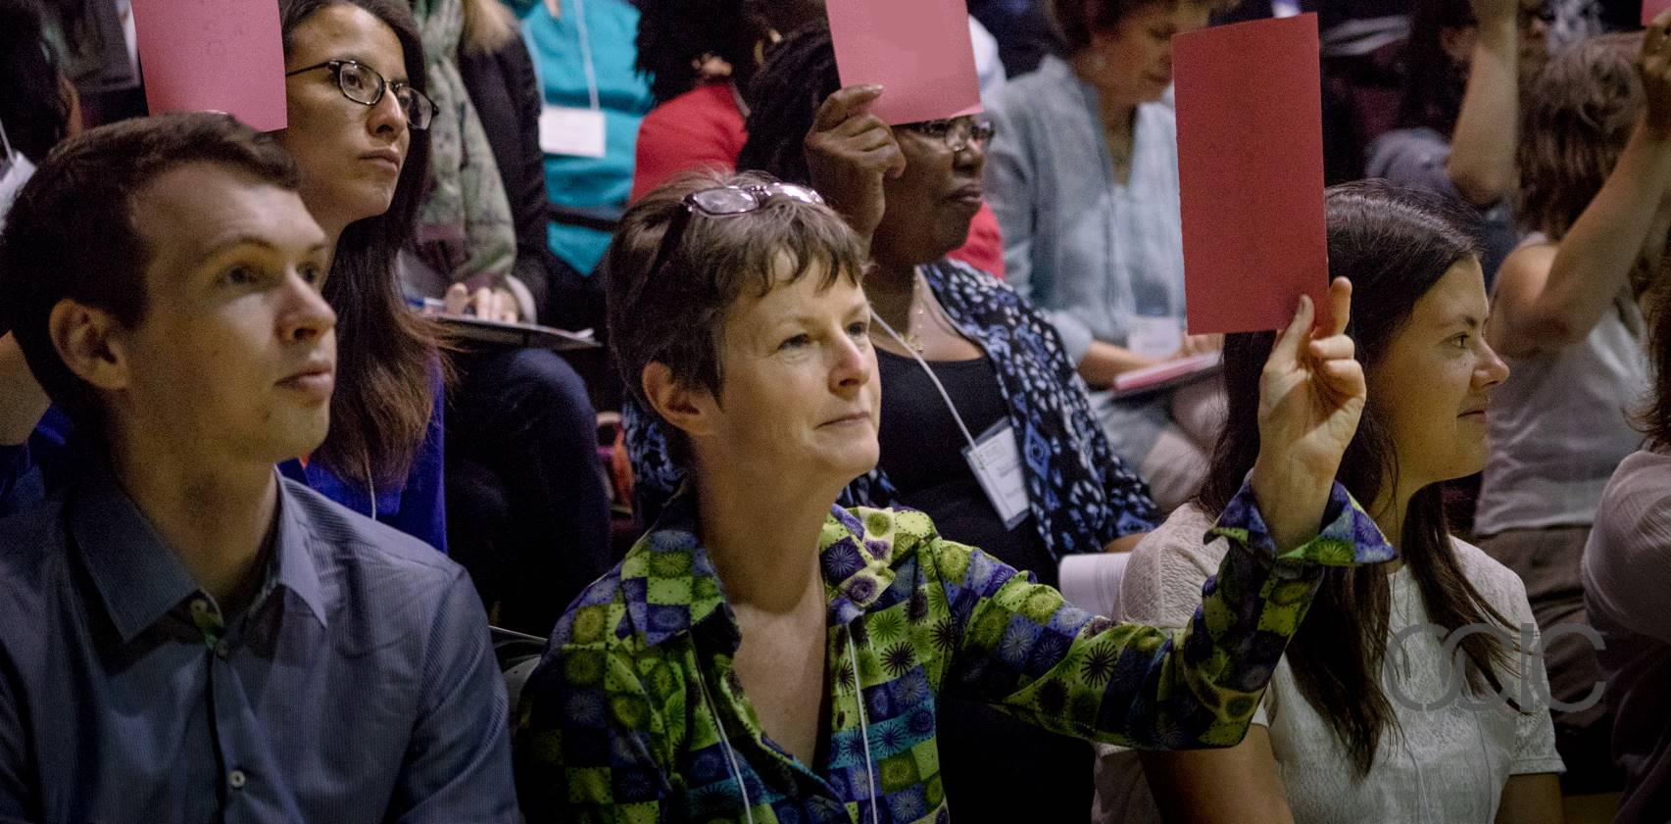
AGM RESOLUTION RE: CHANGES TO BY LAWS

Be it resolved that OCIC’s current Bylaws be amended as follows:

From:

Board of Directors

8. a) The affairs of the Council shall be managed by a Board of Directors. The Board shall be comprised of not less than six directors and not more than twelve. Members of the Board shall include representatives of international and global education organizations. Three associate members may sit on the Board of Directors. In order to reflect the broader community, the Council shall ensure that the Board has equitable gender, racial and regional representation.

To:

Board of Directors

8. a) The affairs of the Council shall be managed by a Board of Directors. The Board shall be comprised of not less than six directors and not more than twelve. Members of the Board shall include representatives of international and global education organizations. Four associate members may sit on the Board of Directors. In order to reflect the broader community, the Council shall ensure that the Board has equitable gender, racial and regional representation.

Rationale

The OCIC Board of Directors has undertaken a review of the Bylaws related to Board structure and composition, and has noted that there are an increasing numbers of associate members in the Council, many of whom express interest, upon application, to serving in a governance function. Given that the Board may currently be comprised of twelve directors, the Board puts forward this resolution as a means to allow up to one third of its Directors to represent this constituency within the Council.
DISTINGUISHED SPEAKER BIOS

The Honourable Elizabeth Dowdeswell Lieutenant Governor of Ontario

The Honourable Elizabeth Dowdeswell was invested as Ontario’s 29th Lieutenant Governor on September 23, 2014. Her eclectic public service career has spanned provincial, federal, and international borders, and has transcended disciplinary and sectoral lines.

Ms. Dowdeswell began her professional career as a teacher and university lecturer. After serving as the Deputy Minister of Culture and Youth for the Government of Saskatchewan, she held increasingly senior positions in the Canadian public service, most notably as head of the Atmospheric Environment Service. Throughout this period, she managed several public inquiries and royal commissions.

Her international negotiating experiences prefaced her election in 1992 as Executive Director of the United Nations Environment Programme and Under-Secretary-General of the United Nations, headquartered in Nairobi, Kenya. Upon returning to Canada in 1998, she established an international consulting practice and became the founding President and CEO of the Nuclear Waste Management Organization. Immediately prior to her appointment as Lieutenant Governor, Ms. Dowdeswell was the President and CEO of the Council of Canadian Academies. She has also served on numerous boards of corporate and non-profit organizations.

Ms. Dowdeswell was born in Northern Ireland and immigrated to rural Saskatchewan with her parents in 1947. She earned a Bachelor of Science in home economics and teaching certificate from the University of Saskatchewan (1966) and a Master of Science in behavioural sciences from Utah State University (1972). An Officer of the Order of Canada, Ms. Dowdeswell holds 11 honorary degrees.
Elissa Golberg Assistant Deputy Minister, Global Affairs Canada

Elissa Golberg was named Assistant Deputy Minister - Partnerships for Development Innovation at the Canadian Department of Foreign Affairs, Trade and Development in February 2015. As a career foreign service officer, Ms. Golberg has successfully pioneered complex policy initiatives and led multi-disciplinary teams working on significant international peace and security, human rights, and emergency management challenges. From 2011 to 2015, Ms. Golberg served as Canada’s Ambassador and Permanent Representative to the United Nations in Geneva and to the Conference on Disarmament (2011-2015). Some of her recent previous roles have included Director-General of the Canadian Government’s Stabilization and Reconstruction Task Force (2009-2011); Representative of Canada in Kandahar, Afghanistan (2008-2009); Executive Director of the Independent Panel on Canada’s Future Role in Afghanistan (“the Manley Panel”) at the Privy Council Office (2007-2008); and Director - Humanitarian Affairs and Disaster Response Division (2005-2007).

Born in Montreal, Ms. Golberg holds a Master’s degree in International Relations, and a Bachelor of Arts in Political Science and History. She is a recipient of the NATO ISAF General Service medal, the Queen’s Jubilee Medal, the Public Service Award of Excellence, and 3 Ministers’ Awards for Foreign Policy Excellence. She has been named a World Economic Forum Young Global Leader, and is a member of the Forum’s Global Agenda Council on Violence and Fragility. She has published articles on humanitarian and fragile state-related matters.

Margaret Biggs Skelton-Clark Fellow, School of Policy Studies, Queens University

Margaret Biggs served as President of the Canadian International Development Research Agency (CIDA) from 2008 to 2013, overseeing Canada's international development and humanitarian assistance efforts worldwide. Ms. Biggs played a lead role in Canada’s G8 Muskoka Initiative on maternal, newborn and child health and spearheaded Canadian priorities in the areas of fragile states, sustainable economic growth, food security and governance. She served as Deputy Secretary to the Cabinet and Assistant Secretary, Priorities and Planning, in the Privy Council Office from 2002-2008. From 2014-2016 Ms. Biggs was the Skelton-Clark Fellow in the School of Policy Studies, Queen’s University. In 2015 she co-led with John W McArthur “Towards 2030: Building Canada’s Engagement on Global Sustainable Development” (Centre for International Policy Studies). Ms. Biggs has represented Canada in numerous international fora and served on various Boards and Advisory Committees, including the Board of Governors for the International Development Research Centre and Alternate Governor to the World Bank. She is a graduate of the University of British Columbia and the Norman Patterson School of International Affairs, Carleton University.

Helle Bank Jorgensen President, Global Compact Network Canada

Building on a background as a Business Lawyer and a State Authorized Public Accountant, Helle brings 25 years of experience advising global companies and investors within Corporate Responsibility and Reporting.

Helle has extensive experience providing strategic and operational guidance to all functions within an organization, including advising at the C-suite and board level. Helle was the creator of the world's first LCA-based environmental account, the world's first integrated report, and is the principal organizer for the CEO/Investor-network for Business Ethics and Non-Financial Reporting. She has led the CDP-report of the S&P 500 and Improvement of DJSI ranking and investor communication for global and US companies.

She has led PricewaterhouseCoopers’s Sustainability and Climate Change practices in Europe and the US, hereof 11 years as a partner. Since 2012 she has run an independent consulting practice B. Accountability advising global business leaders in Sustainability and Climate Change. In 2013, she was also asked to build and lead the Global Compact Network Canada, and has over 1.5 years grown the number of signatories by 30% to nearly 100 Canadian companies. In 2014, Helle was chosen as one of 12 Global Facilitators for UN Global Compact Board Programme. She is a speaker and author of thought-leading articles and books and has served on multiple boards. Helle is also one of the seven people in the world and the first in North America to have passed the GRI G4 Exam.

Dr. Alexandra Conliffe VP Operations, Engineers Without Borders Canada

Dr. Alexandra Conliffe is VP Operations at Engineers Without Borders Canada (EWB), a movement of 40,000 Canadian and African leaders working together to end poverty and inequality through innovations in targeted sectors, including Global Engineering Education in Canada, Small and Growing Businesses in Africa, and Responsible Mining globally.

Between 2010-2013, Alex was a Senior Policy Analyst at Agriculture and Agri-Food Canada, and Canada's agriculture negotiator at the United Nations climate change negotiations. This work built on five years leading teams of reporters to United Nations negotiations on environment and development for the International Institute for Sustainable Development.

Alex holds a doctorate in Geography and a master's in Environmental Management from the University of Oxford, where she studied as a Rhodes Scholar. She earned a bachelor's in Mechanical Engineering from McGill University, where she was a Loran Scholar. She is a member of the McGill Faculty of Engineering Advisory Board and the Board of Directors of the Institute on Governance.

Shannon Kindornay Adjunct Research Professor, Norman Paterson School of International Affairs, Carleton University

Shannon Kindornay is an Adjunct Research Professor at the Norman Paterson School of International Affairs at Carleton University. Her research focuses on development cooperation, global governance, and aid and the private sector. Prior to joining Carleton University, Ms. Kindornay was a researcher at the North-South Institute for nearly five years where she produced numerous reports, peer reviewed publications and commentaries on a range of policy issues, including multilateral development cooperation, Canada's development cooperation program and the role of the private sector in development. She holds degrees from Carleton University and Wilfrid Laurier University.

Anne Demirjian Director, Glendon School of Public & International Affairs, York University

Anne Demirjian is a multilingual, results-oriented consensus builder that began her career at CUSO, and now has more than 30 years senior management experience in policy and programming with the Government of Canada, the World Bank, and the United Nations.

From 2014-2015 Ms. Demirjian was the Director of the Political Affairs & Mediation Group at the UN Mission in Somalia (UNSOM), responsible for the peace building and state building portfolio. From 2004-2013, working with the UN Missions in the field, she headed the UNDP’s Democratic Governance portfolio in Iraq, Libya, Somalia, Eastern European countries, and Central Asia. At UNDP-Iraq (2004-2007), Somalia (2008-2009) and Libya (2011-2012) she was responsible for transitional administration, the constitution drafting process, elections, institutional development and capacity building, public administration reform, local governance, and civil society development. In 2010 she was seconded to Haiti to lead the Post Disaster Needs Assessment for the UNDP/World Bank, after the earthquake. She has also worked in Jordan, Egypt, Tunisia, Palestine, Zimbabwe, South Africa and Nigeria.

Ms. Demirjian has taught courses on Canada’s role in conflict countries: Middle East & Africa, at Ryerson University; Transitional governance and comparative experiences with the EU accession process and the Arab Spring countries; Peace-keeping & state-building in conflict/post conflict countries and the challenges facing the UN Missions, at Almaty University and the Public Administration Academy in Astana, Kazakhstan; Mathias Corvinus Collegium, Budapest, Hungary; the University of Tripoli, Libya; and the American University of Armenia, Yerevan. She hold an Master of Science from the Universite du Quebec a Montreal, a Bachelor of Arts from Glendon College, York University, and a Diploma in Alternative Dispute Resolution.

FACILITATOR / MODERATOR BIOS

Elder Dr. Bob Phillips

Elder Dr. Bob Phillips is an urban non-status Micmac that works with the Toronto District School Board (TDSB) Aboriginal Community Advisory Committee, KAIROS, through their Blanket Exercise education program, and the Royal Conservatory of Music Learning Through The Arts program. Dr. Phillips has a doctorate in Indigenous Studies from Trent University, and an MA in Fine Art History from York University. Strongly connected to the education sector, he advocates for equal access, inclusion, and mutual respect for all.

Kimberly Gibbons Executive Director, Ontario Council for International Cooperation

Kimberly Gibbons has been the Executive Director of the Ontario Council for International Cooperation (OCIC) since 2005. During this time she has helped to lead OCIC through a period of expansion and growth in its sector-representation, networking, capacity building and public engagement roles in Ontario and Canada. As a Council, OCIC’s priorities are to strengthen members’ capacity in being leaders of good development and adapting to change; to increase multi-stakeholder dialogue to better understand and leverage perspectives, expertise and resources; and to influence by informing, amplifying the voice of Council members.

Kimberly has worked in many formal and non-formal education settings with youth and adults of diverse backgrounds in Asia, Central America, Europe and Canada and cares deeply about increasing collaborative spaces and cooperation as a means to end global poverty and inequality. She holds a Masters of Education in Adult Education and Transformative Learning from OISE, University of Toronto, and studied human rights at the graduate level at the Commonwealth Institute, University of London, England. Kimberly also has a Bachelor of Arts in International Development and Rural Extension Studies from the University of Guelph and completed her final undergraduate year of study at SNDT Women’s University, Mumbai, India.

Mitra Manouchehrian President, Ontario Council for International Cooperation

Mitra Manouchehrian is an international development professional specializing in international public health and health promotion initiatives. Mitra first became involved in international development through a volunteer placement with Canadian Crossroads International (now Crossroads International) and their partner organization in Togo, a community micro-finance organization interested in expanding their HIV/AIDS prevention activities. Upon returning to Toronto, she worked in programming at Crossroads, followed by working in Cameroon with VSO (now CUSO) to identify the training needs of PLHIV associations. Mitra then pursued a Master's degree in International Public Health at the University of Sydney, Australia, and has since specialized in managing projects focusing on prevention and treatment of vector-borne and infectious diseases.

Mitra is currently a Program Manager with Plan International Canada, working to create enabling environments where complex partnerships between key stakeholders, such as local communities, community leaders, and local and national governmental bodies can flourish. She has developed extensive experience fostering effective NGO governance through volunteering with OCIC. Mitra has been an OCIC Board Director since 2010, serving in a variety of leadership roles. She is currently President of the Board and Chair of the Personnel Committee, and has contributed to the vision and organizational direction of the Council, actively encouraging the development of the Ontario international cooperation and global education sector.

Julia Anderson Board Director, Ontario Council for International Cooperation

Julia Anderson is currently the Operations Manager for the Canadian Network for Maternal Newborn and Child Health. Previous to Can-MNCH, Julia worked as the Director of Human Rights at Trent University. Julia recently completed her term as President of Jamaican Self-Help, a small international development agency located in Peterborough, Ontario. For 30 years JSH received partnership-based funding from CIDA to deliver innovative education and anti-violence programing with partners in Jamaica. As President, Julia supported Jamaican Self-Help through the difficult transition of losing this funding and transitioning to a volunteer-based organization.

Julia has also served on the Canadian Council for International Cooperation (CCIC) Board of Directors with key Executive Committee roles, and as the Chair of the Evaluation Reference Group, a think-tank of M&E experts who worked with CIDA to improve civil society effectiveness through innovations to M&E practices in the sector. Julia currently serves on the OCIC Board of Directors where she works with staff and members to effectively promote sustainable, people-centred development in a peaceful and healthy environment.

Roshelle Filart, RESULTS Canada

Roshelle Filart was elected to the OCIC Board of Directors in 2015, and currently serves on the Membership & Nominations Committee. She brings more than 20 years experience in public education, communication and engagement, voluntary service and life-long interests in issues of social justice, international development and anti-oppressive analysis. Since returning to Canada in 2006 after volunteering with WUSC in Botswana, and VSO Canada in Guinea-Bissau, she has been an active champion of collaborative efforts to end extreme poverty everywhere. As a co-leader of the Toronto volunteer chapter of RESULTS Canada, she has led citizen advocacy efforts to engage parliamentarians, policymakers, media and community groups, for which she was officially recognized by Hélène Lavardière, MP and NDP Critic for Foreign Affairs in 2016 and awarded a Queen Elizabeth II Diamond Jubilee Medal in 2012.

Prior to serving on the Board Roshelle has been actively engaged in OCIC activities, as a volunteer on the editorial board of OCIC's multimedia eMagazine, iAM, Vol. 4, a workshop presenter at the 2013 Global Citizen's Forum, and as a frequent attendee of Toronto Development Drinks. Roshelle graduated from the University of Toronto with B.A. in anthropology and art history and a B.Ed in primary education, and has a Master's degree in International Education from New York University and a certificate in Staff Training and Adult Education from Seneca College. She currently works as a science presenter at the Ontario Science Centre where she was also a lead researcher and exhibit developer for A Question of Truth, a permanent exhibition about bias and discrimination in science.
PARALLEL ROUNDTABLE DISCUSSIONS

Background: Parallel roundtable sessions will offer an opportunity for Symposium participants to provide input on Global Affairs Canada’s review of international assistance, as well as OCIC initiatives aimed at deepening engagement of Ontarians in international cooperation by better understanding and collaborating with diaspora communities, municipalities, colleges and universities. Participants will participate in two of eight 40-minute discussion sessions of most interest to you.
Global Affairs Canada Review of International Assistance Consultation topics include:
- the health and rights of women and children
- clean economic growth and climate change
- governance, pluralism, diversity and human rights
- peace and security
- responding to humanitarian crises and the needs of displaced populations
- delivering results by improving effectiveness and transparency, innovation and partnerships
OCIC Consultation topics include:
- diaspora communities in Ontario
- Ontario municipalities, colleges and universities
Key objectives of these Consultation sessions include:
- to solicit inputs from participants that will inform OCIC’s submission to the Global Affairs Canada International Assistance Review
- to solicit inputs from participants that will inform OCIC’s research and potential for deepened engagement with diaspora communities, municipalities, colleges and universities in Ontario
Structure: Thematic rapporteurs and table moderators will lead participants through a structured 40-minute discussion, based on the questions provided. Participants will then move to their next theme, receive an overview of the key points raised, and then have the opportunity to build on the previous groups’ contributions.

Following the two roundtable rounds, thematic rapporteurs will synthesize participant contributions in brief summary presentations in plenary, followed by a summary of key messages by Shannon Kindornay, and closing remarks on the process by Kimberly Gibbons.
Global Affairs Canada Consultation Questions
Background: See Global Affairs Canada’s International Assistance Review Discussion Paper for details on each thematic consultation area: http://www.international.gc.ca/world-monde/assets/pdfs/iar-consultations-eai-eng.pdf.
Consultation questions include:
1) The health and rights of women and children
- Building on the Government of Canada’s commitment to a feminist approach and support for the gender equality goal of the 2030 Agenda, where should Canada focus its international assistance efforts in this area? Can Canada take advantage of specific opportunities to demonstrate new or continued leadership on women’s empowerment and gender equality?
- How can Canada’s efforts to support well-being and empowerment better benefit children and youth, including in the education sector?
- What strategic role can Canada play in advancing health-related SDGs to improve the health of women and girls, including adolescents, in particular their sexual and reproductive health and rights?
2) Clean economic growth and climate change
- Where has Canada added value in promoting clean sustainable economic growth?
- How can Canada support developing countries to mitigate and adapt to climate change?
- Are there niche areas within climate and environment (e.g. water, biodiversity, land use, agriculture, energy) where Canada could further focus its international assistance?
3) Governance, pluralism, diversity and human rights
- How can Canada best help implement Goal 16 of the 2030 Agenda—to promote peaceful and inclusive societies, provide access to justice for all, and build effective, accountable and inclusive institutions at all levels?
- How can Canada promote inclusion, advance respect for diversity and uphold human rights?
- In what areas of governance can Canada’s international assistance have the most impact?
4) Peace and security
- What specific strengths should Canada build upon to respond to peace and security challenges?
- How can Canada align its international assistance efforts in peace and security with international approaches, including the 2030 Agenda?
- What kind of international assistance partnerships should Canada pursue to achieve its peace and security goals?
5) Responding to humanitarian crises and the needs of displaced populations

- How can Canada support needs-driven, effective and timely responses to humanitarian crises with predictable yet flexible support?
- How can Canada better support the protection of vulnerable populations in crises and strengthen respect for humanitarian principles?
- How can we facilitate more comprehensive and coordinated responses to better meet the needs of populations affected by crises and optimize the impact of humanitarian, development and peace and security initiatives?

6. Delivering results by improving effectiveness and transparency, innovation and partnerships

- What concrete steps could Canada take to make its international assistance delivery approaches and mechanisms more efficient, effective and innovative? How can we promote greater coherence between our development, trade and diplomacy efforts?
- How can Canada foster development innovation?
- Which organizations, communities, coalitions or partnerships should Canada work with? How best can we work with them to deliver our international assistance objectives?
- How can we engage a wider range of partners to leverage the resources and expertise necessary to achieve the sustainable development goals?
- How can we enhance broader engagement of Canadians in our international assistance efforts?
- Are there additional tools or mechanisms that Canada should add to enable it to deliver international assistance more innovatively? How can current approaches and mechanisms be strengthened?

OCIC Consultation Questions
7. Collaborating with cultural communities (diaspora) in Ontario
Background: In 2015, OCIC held a consultation in partnership with the Global Affairs Canada (then DFATD) to build a shared understanding of the range of international cooperation activities and efforts being undertaken by and with cultural community groups; to gain insights on the interests of cultural community groups to work with others on international cooperation issues; and to identify opportunities for deeper engagement. The consultation report showed that there is significant opportunity to further engage with cultural community groups in international cooperation. See OCIC’s full report: http://ocic.on.ca/content/cultural-communities-sustainable-development-consultation
A number of principles were identified to inform further engagement. These include ensuring voice, participation and inclusivity in collaborations from the onset; transparency in engagements; working through partnership with different stakeholders; differentiation in approaches and mechanisms to engage cultural community groups, recognizing their diversity; use of cultural community knowledge and evidence-based approaches in collaborations; and the use of approaches to harness the innovation of cultural community groups in addressing sustainable development challenges.
The consultation identified ways to harness the financial, individual, and knowledge-based contributions of cultural communities. With respect to finance, the report called for the establishment of flexible, responsive, well-structured, transparent, long-term and predictable funding mechanisms; the use of tax incentives and expansion of match funding to move beyond humanitarian crises to support sustainable development efforts; provision of support to develop the capacity of smaller cultural community groups to access government funding; and develop creative funding mechanisms with different levels of government and across government departments to enable cultural community groups to better leverage finance and combine domestic and international engagements.
To support individuals’ contributions, the report called for continued support to volunteer-sending programs and use of information and communication technology to promote engagement by cultural communities, and the promotion of brain circulation by extending scholarships and promoting educational exchanges.
To harness the knowledge-based contributions of cultural community groups, the report called for the facilitation of long-term research partnerships, and inclusive consultations on development and foreign policymaking.
- Are the principles and approaches outlined in the cultural community report still relevant, particularly in light of the Global Affairs Canada consultation?
- In what ways does your organization engage with cultural community groups in international cooperation? What key lessons have you learned that should inform OCIC’s submission to Global Affairs Canada?
- What opportunities do you see for further engagement with cultural community groups, particularly in light of the Sustainable Development Goals?
- Following from above, do you see opportunities for broader collaboration in partnership with municipalities, colleges and/or universities?
8. Engaging Ontario municipalities, colleges and universities
- Are you, or are you aware of any municipalities, colleges and/or universities that are significantly engaged in international cooperation (alone or with civil society organizations) and if so, how?
- In what ways does your organization engage with municipalities, colleges and universities?
- What would you like to do more of or differently going forward, and in light of the Sustainable Development Goals?
- What opportunities exist for individual partnerships and for larger, more collective efforts?
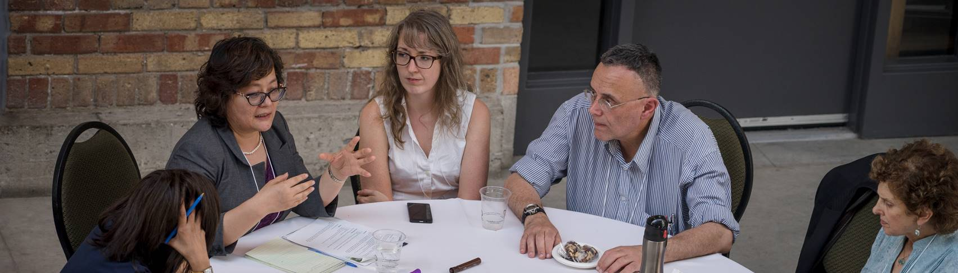
- What key points from the discussion should inform OCIC’s submission to Global Affairs Canada
PARTICIPANTS

Alpha Abebe | Mosaic Institute / University of Oxford
Jennifer Adams | White Ribbon
Nafeesa Afridi | Skills For Change
Amal Akash | Amal’s Food Solutions Inc. / Associate Member
Julia Anderson | Kawartha World Issues Centre / OCIC Board Director
Dr. Pamela Appelt | Harbourfront Centre
Jinney Arias | YMCA of Medellin, Colombia
Rajula Atherton | Atherton & Atherton
Zahra Baptiste | Ontario Council for International Cooperation
Mark Blumberg | Blumberg Segal LLP/ Associate Member
Ivy Bojmic | Free The Children
Katie Boomgaardt | Centre for Critical Development Studies, University of Toronto Scarborough
Yin Brown | OCIC Board Director / Associate Member
Analynn Bruce | ADRA Canada
Paul Bubelis | Sustainability Network
Miriam Buttu | Casa-Pueblito
Amanda Cacilhas | Canadian Catholic Organization for Development and Peace – Caritas Canada
Piyali Chakraborti | Ontario Council for International Cooperation
Gavin Charles | Canadian Council for International Cooperation
Bryan Cox | Youth Challenge International
Michelle Davis | Free The Children
Nancy Del Col  Robbyn Draimin | World Vision  RESULTS Canada
Gonzalo Duarte | Compañeros Inc
Sara Dunkley | Beautiful World Canada Foundation
Ray Dunn | Nu-Vision Ministry Canada
Tunde Fakunle | RosFlo Inc
Vicki Faul | Ontario Council for International Cooperation
Nathan Fenn  Jessica Ferne | Ryerson University  International Development and Relief Foundation
Roshelle Filart | RESULTS Canada / OCIC Board Director
Victoria Foote | The Jane Goodall Institute of Canada
Jennifer Foulds | Amref Health Africa in Canada
Shona Fulcher | Centre for Social Innovation
Kimberly Gibbons | Ontario Council for International Cooperation
Asha Gervan | Humber College
Andres Gnecco | Save A Family Plan
Carine Guidicelli | Crossroads International
John Gultig | Pitch Communications
Isabelle Hachette | World Accord
Stefan Hostetter | Centre for Social Innovation
Susan James | Consultant / Associate Member
Fatou Jammeh | Associate Member / OCIC Volunteer
Sarah Judd | Fair Trade Toronto / OCIC Global Changemaker Youth Ambassador 2016
Emily Kere | OCIC Board Director / Associate Member
Iqbal Khan  Saba Khan | Associate Member  Dignitas International
Olivia Kwiecien | Dalhousie University
Bella Lam | The Jane Goodall Institute of Canada
Brad Lester | Rooftops Canada
Tamara Levine | Tumanako Consulting
John Lewis | Humber College
Allan Lissner | Praxis Pictures
Alison MacDonald | CPAR
Susan MacGregor | Humber College
Sarah MacIndoe | Free The Children
Alex Macmillan | Humber College
Mitra Manouchehrian | OCIC Board Director / Associate Member
Kevin McGregor | Canadian Feed The Children
Paul McGuire  Fana Mekonen | SalvAide  Enheed
Dr. John Mitchell | Brescia University College
Courtney Mollenhauer | Transforming Faces
Marlen Mondaca | Save the Children
Esperanza Monsalve | YMCA of Greater Toronto
Jakub Nemec | ADRA Canada / OCIC Board Director
Alice Ng Bouwma | World Renew
Sharon Njobo | ADRA Canada
Kevin O’Neill | Amref Health Africa in Canada / OCIC Board Director
Gertrude Omoro | World Vision Canada
Krista O’Shaughnessy | Beautiful World Canada Foundation
Sikander Panag | Associate Member
Isabel Pérez-Doherty | Associate Member
Cassandra Polyzou | Ontario Council for International Cooperation
Yuliya Prodaniuk | Canadian Partnerships for International Development
Ashley Rerrie  Komila Rakhinova | Casa-Pueblito / OCIC Global Changemaker Youth Ambassador 2016  Freelance Gender Expert
Julia Rao | Presbyterian World Service & Development
Robin Rix | Office of the Lieutenant Governor of Ontario
Ann Rosenfield | Transforming Faces
Robin Sagi | Fair Trade Toronto / OCIC Global Changemaker Youth Ambassador 2016
Shubha Sandill | York University
Jay Scott | Axis Weal / Associate Member
Stephen Sillett | Aiding Dramatic Change in Development
Heather Smith | Rayjon Share Care
Luke Stocking | Canadian Catholic Organization for Development and Peace
Lisa Swainston | Ontario Council for International Cooperation
Tina Sweeney | Cuso International
Myroslava Tataryn | Handicap International / Associate Member
Christopher Warren Trottier | University of Ottawa / Associate Member
Uju Umenyi | Canadian Jesuits International
James Wilkes | Kawartha World Issues Centre
Mitchell Wilkie | cbm Canada
Ken Wyman | Humber College
Ronny Yaron | Association of Career Educators
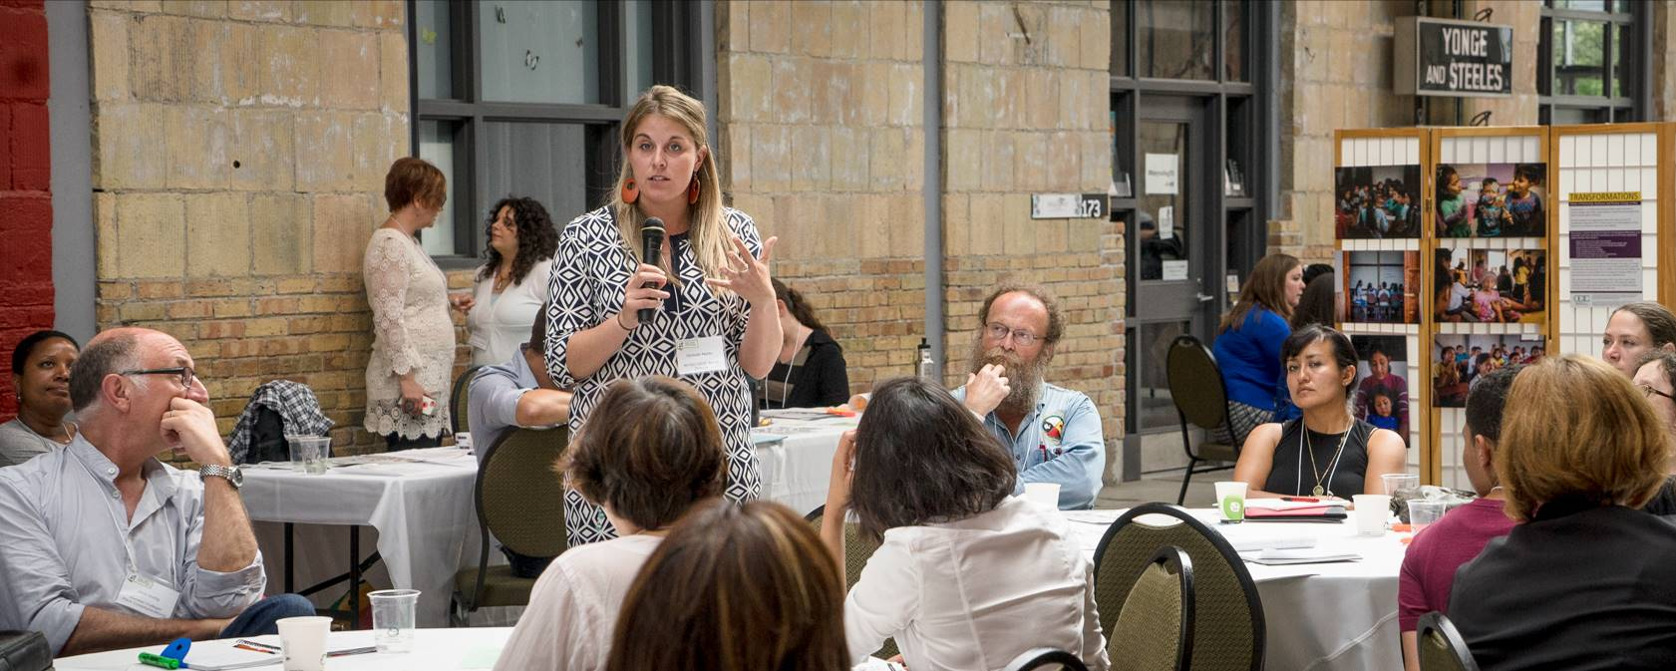

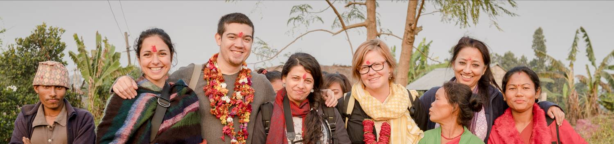

THANK YOU

Sincere thanks to our distinguished guests, participants, collaborators, funders and the following volunteers, for your contributions to Ontarians & the World: Universality Matters 2016, and the Council.

Rana Abd-El Hamid | Shreya Acharya | Charlene D’Costa
Fanta Diaby | Nadia Djinnit | Jesse Han
Madison Hopper | Katerina Ioannou | Sarah Kangudie
Ashley McIntyre | Marguerite Miailhe | Jam Muneer
Lauren Paparousis | Manal Rajan | Niyati Shah
Fidaa Shehada | Andrea Sherk | Rhea Simms
Karen Singh | Tess Soltendieck | Ken Wong




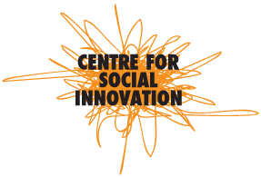




This event was undertaken with the financial support of the Government of Canada provided through Global Affairs Canada.
JOIN US

OCIC & the ICN have a number of exciting initiatives in the works in the days and weeks ahead. Be sure to let us know what you are doing and how we might collaborate or support your efforts. Take advantage of the following seminars, initiatives, collaboration opportunities, resources and consultations:

- Blumbergs & OCIC Seminar on Recent Changes to the Regulation of Charitable Activities in China: June 21, 2016

- Transformations Photojournalism Initiative Expressions of Interest: Deadline June 23, 2016

- Global Citizens Forum Leadership & Program Committee Mobilization: from June 2016

- iAM eMagazine Editorial Board & Production Team Mobilization: from June 2016

- Money Talks Launch: July 2016

- IMPACT Summer Institute: July 6-8, 2016

- OCIC & ICN Submissions to Global Affairs Canada International Assistance Review: July 2016

- ICN World Social Forum Workshop on The Rights of Indigenous Peoples in the Context of the Sustainable Development Goals, and Global Partners Consultation on Canada’s International Assistance Review: August 2016

- Global Changemaker Youth Ambassador Nominations: Deadline August 19, 2016

- IMPACT Online Training Program: August 2016 to February 2017

- ICN Online Public Engagement Course Launch: September 2016

- Transformations Photojournalism Initiative visits to partners: October 2016

- Global Citizens Forum: February 2017

- Global Changemaker Youth Ambassador Awards: February 2017

- International Development Week Program: February 2017

- IMPACT Evaluation in Practice Summit: March 2017

- iAM Volume 8 Launch: March 2017
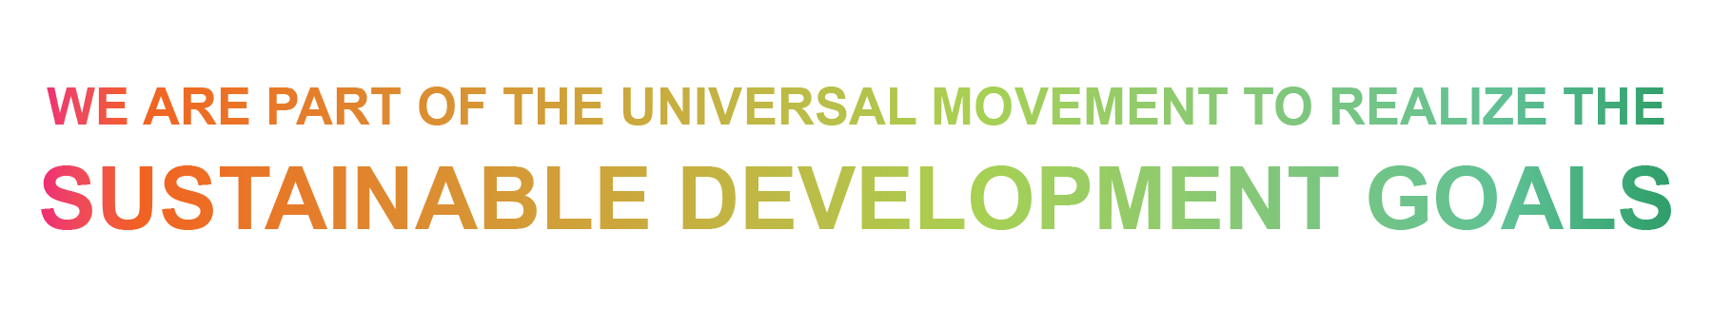

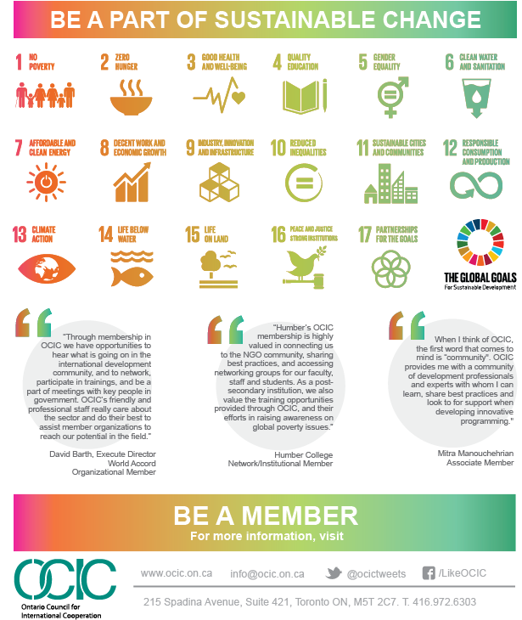
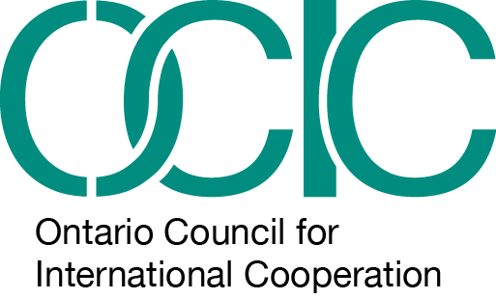
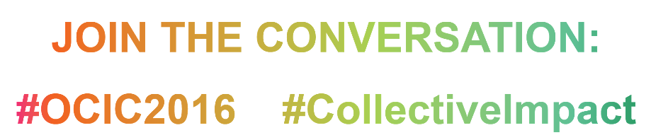

Note the following relevant consultation questions: - Which organizations, communities, coalitions or partnerships should Canada work with? How best can we work with them to deliver our international assistance objectives? - How can we engage a wider range of partners to leverage the resources and expertise necessary to achieve the sustainable development goals? - How can we enhance broader engagement of Canadians in our international assistance efforts?

