Inter-Council Network congratulates Harper and Paradis on new funding
***For Immediate Release***
November 14, 2014
The Inter-Council Network of Provincial & Regional Councils for International Cooperation voiced its approval today of the recent announcement by the Hon. Christian Paradis, Minister of International Development and La Francophonie, of a call for proposals valued at $370 million dollars dedicated to Maternal, Newborn and Child Health (MNCH). Funding for the call for proposals is part of the new $3.5 billion commitment Prime Minister Harper announced at the Saving Every Woman, Every Child Summit in May in Toronto, and will fund initiatives for up to five years that will help reduce maternal and child mortality and improve women’s and children’s health in 40 developing countries in Africa, Asia, Latin America and the Middle East.
The Inter-Council Network, representing over 400 civil society organizations from coast to coast to coast, is made up of eight provincial and regional councils that are recognized for bringing local knowledge and priorities to the federal level. “We welcome this latest announcement and are pleased that the Government of Canada recognizes the invaluable role and expertise of civil society organizations,” said Heather McPherson, Executive Director of the Alberta Council for Global Cooperation.
“The Government’s renewed commitment to spend five times more toward achieving our global goals on maternal health than the original Muskoka announcement in 2010 renews Canada’s global leadership on this issue” stated Carolyn Whiteway, Acting Executive Director of the Atlantic Council for International Cooperation. From the Yukon and B.C. through to Ontario, Quebec and the Atlantic, the Councils were unanimous in their appreciation of the technical explanations provided today by the Department of Foreign Affairs, Trade and Development Canada (DFATD).
“We are hoping that they are flooded with proposals, affirming what the Councils already know about Canadians’ interest in international development,” said Tracey Wallace, Executive Director of the Northern Council for International Cooperation, “Canadians want our government to take this kind of leadership on the international stage when it comes to the world’s poor and most vulnerable populations.”
While the Inter-Council Network was unanimous in its approval of the funding, concerns were raised regarding the parameters, “While we agree that this announcement, in spirit, is an excellent initiative, we believe more dialogue must happen on the nature of how to ensure women, children and newborns are protected and cared for and we look forward to that dialogue on reproductive rights” stated Gervais L’Heureux of l'Association québécoise des organismes de coopération internationale.
Kimberly Gibbons, Executive Director of the Ontario Council for International Cooperation added, “We hope that this and the recent call for proposals for Typhoon Haiyan Reconstruction Assistance will soon be followed by others.”
The funding is directed at Canada’s number one development priority: improving the health and survival of women and children in the developing world. The fund is seeking innovative proposals from civil society groups that have the expertise and the capacity outlined in the call.
More information on these funds and how the Councils are helping to facilitate and encourage proposals can be found by contacting:
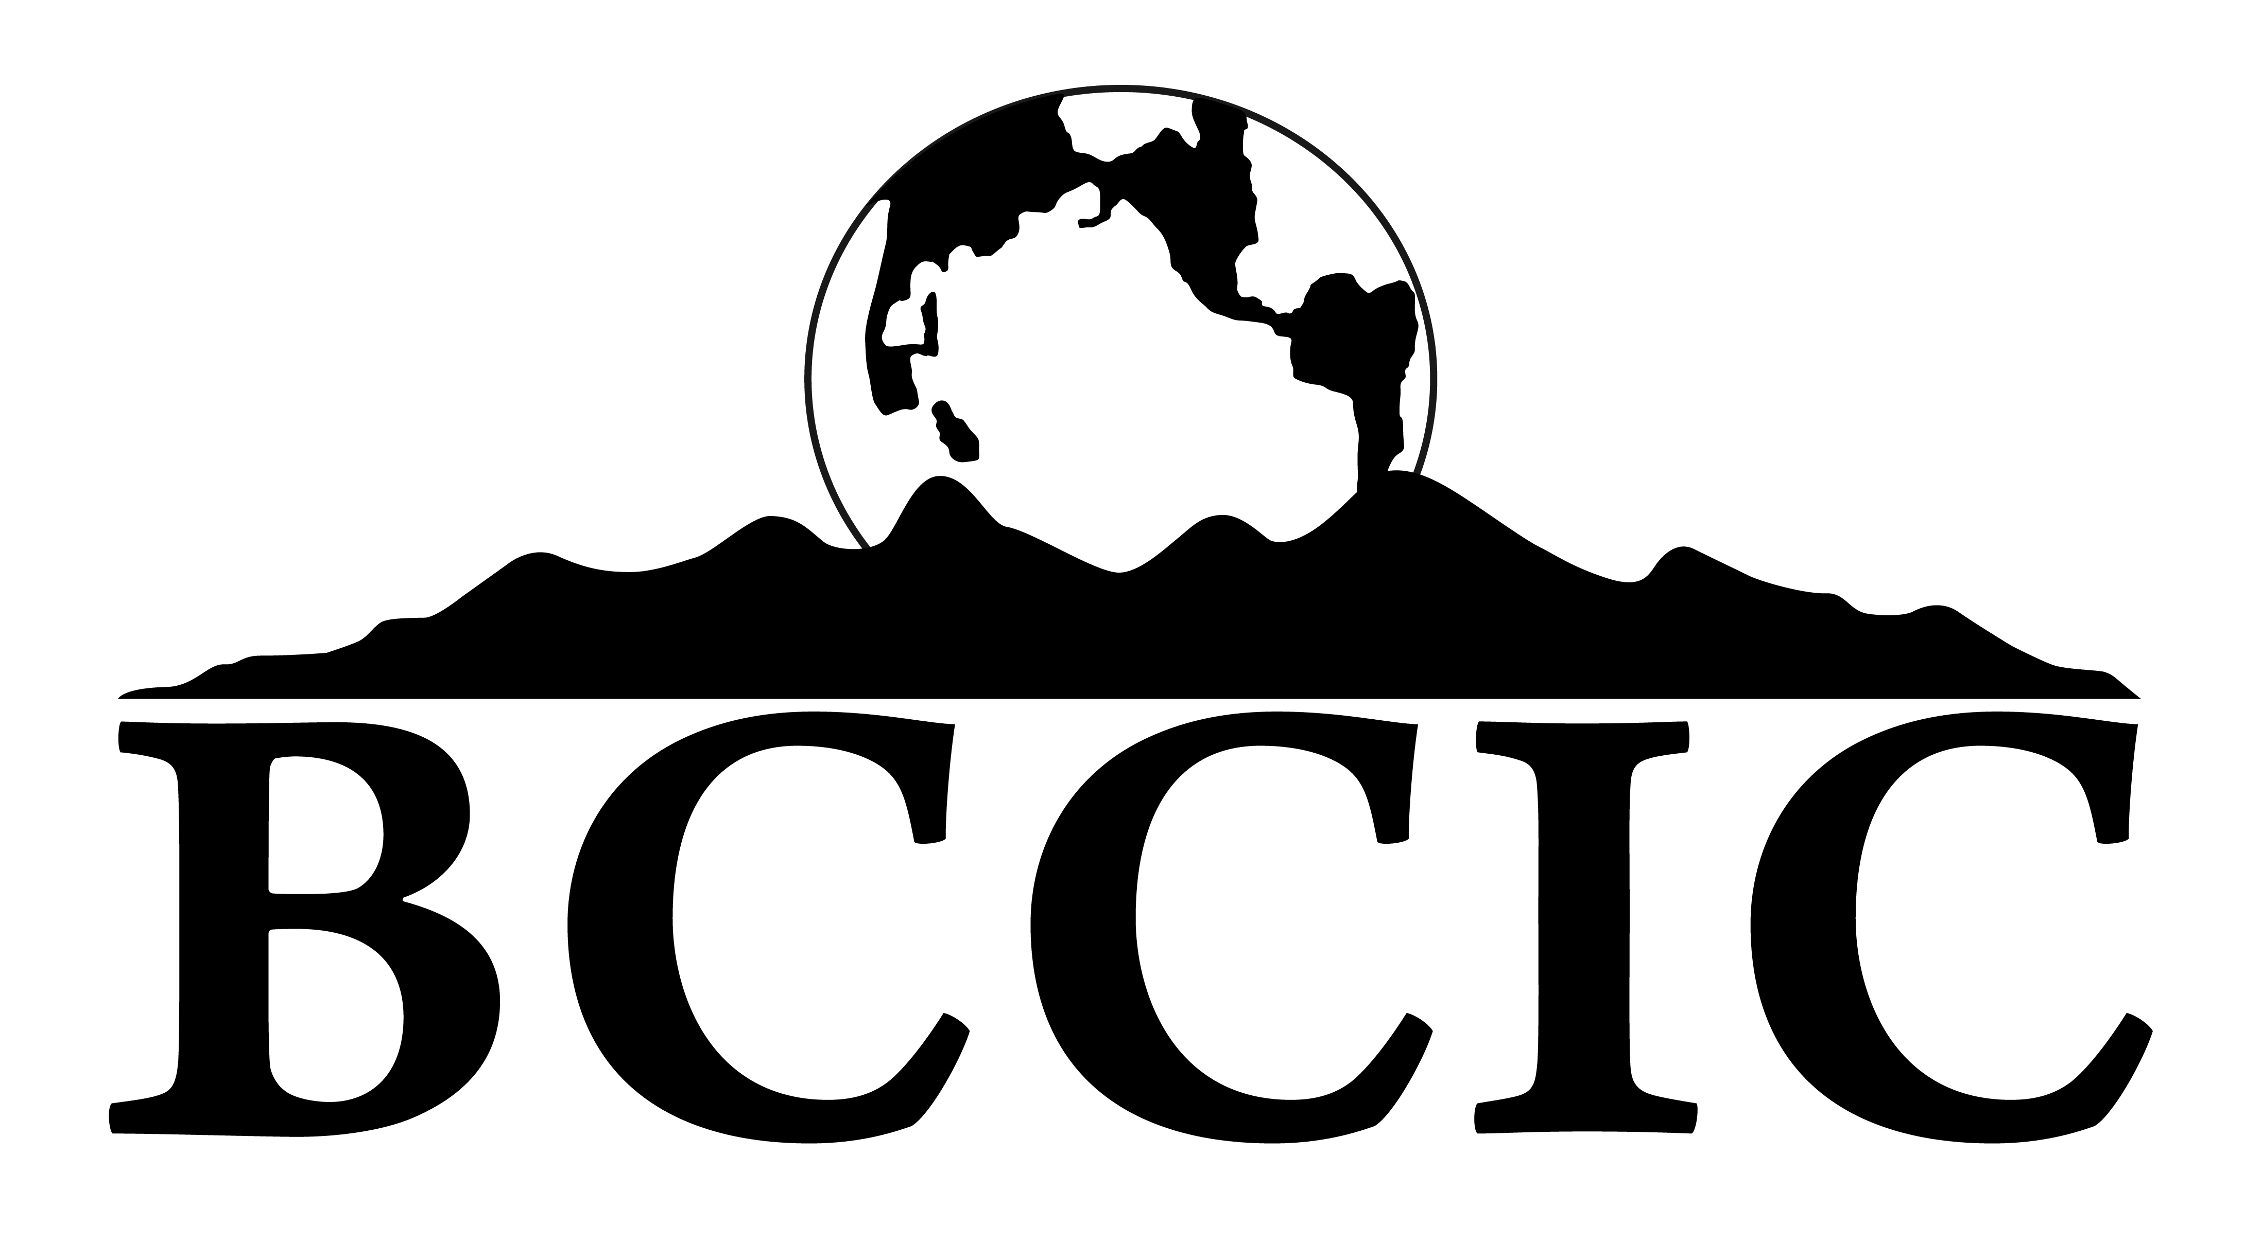  Michael Simpson  Executive Director  British Columbia Council for International Cooperation  mike@bccic.ca  604.899.4475 | Tracey Wallace  Executive Director  Northern Council for International Cooperation  tsoro@northwestel.net  867.334.9606
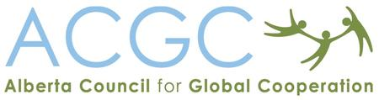  Heather McPherson  Executive Director  Alberta Council for Global Cooperation  director@acgc.ca  780.988.0200 | 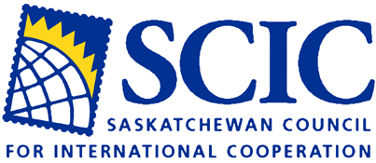  Jacqui Wasacase  Executive Director  Saskatchewan Council for International Cooperation  director@earthbeat.sk.ca  306.757.4669
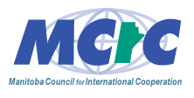  Janice Hamilton  Executive Director  Manitoba Council for International Cooperation  janice@mcic.ca  204.987.6420 | 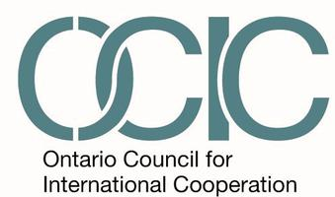  Kimberly Gibbons  Executive Director  Ontario Council for International Cooperation  kimberly@ocic.on.ca  416.972.6303
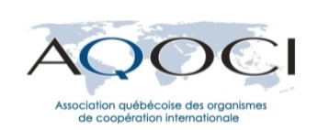  Gervais L’Heureux  Directeur général  l'Association québécoise des organismes de coopération international  glheureux@aqoci.qc.ca  514 871-1086, poste 202 | Carolyn Whiteway  Acting Executive Director  Atlantic Council for International Cooperation  projects@acic-caci.org  902.431.2311
-end-

