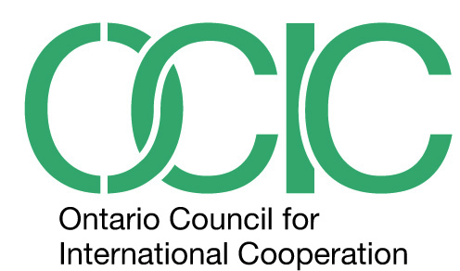

OCIC BOARD OF DIRECTORS NOMINATION FORM 2016
Nominations of candidates to serve on the OCIC Board of Directors are currently being accepted for six (6) possible seats open for a two-year term, including 5 (five) for Organizational Members, and one (1) for Associate Members (pending a possible By-Law Amendment to allow Associate Members to occupy a maximum of four (4) seats).
Eligibility:
Representatives of Organizational Members in good standing may be nominated to the Board and occupy a maximum of nine (9) seats.
Organizational nominees must be a staff member, Board member or appointed representative of an OCIC Member Organization in good standing.
Organizational nominees must be nominated by an OCIC Member Organization in good standing, and seconded by another OCIC Member Organization in good standing.
Associate Members in good standing may be nominated to the Board and occupy a maximum of three (3) seats.
Associate Member nominees must be nominated by an OCIC Member Organization or Associate Member in good standing, and seconded by another OCIC Member Organization or Associate Member in good standing.

Responsibilities and Desired Assets:
The OCIC Board of Directors is the governing body of the Council. As such, the Board is legally responsible for the operations and programs of OCIC, which are managed by staff and volunteers who are assigned to these operations and programs.
Responsibilities of Board Members include:
Becoming fully conversant with the roles and responsibilities of the Board and individual Board Members
Becoming fully conversant with the Vision, Mission, Mandate, Strategic Plan, operations, programs, challenges and opportunities facing OCIC
Attending an annual planning retreat (September), and quarterly meetings of the Board
Serving as a member of one or more Board Committees and attending Committee meetings
Being well-informed of sectoral issues and prepared to discuss or address them at Board Meetings and as needed
Working collectively to set, articulate and fulfill the OCIC Strategic Plan
Representing OCIC and the Board on occasions, as requested
Being a channel of communication with the membership of OCIC
Contributing personal experience and expertise to the work of the Board in support of the work of OCIC
Facilitating collaborative decision making by the Board
Representing the Council for duties exercised as a Board member

Assets desired on the Board include:
Experience and expertise in any of: fund diversification, financial management, policy analysis, media and government relations, membership associations, risk management, Board governance, charity law, human resource management, partnership building and brokering, advocacy, anti-oppression analysis, capacity building, communications and public engagement.
Individuals that represent the full diversity of communities in Canada, including complexities of intersecting identities such as ability, age, class, gender, race and sexual orientation.

Nomination Process:

To help us prepare Board nominee profiles for review and distribution prior to the AGM, please return the form below, along with a brief bio and statement of the nominee’s qualifications and how s/he might contribute to the OCIC Board to Lisa Swainston at admin@ocic.on.ca by June 9, 2016.
Nominees are encouraged to self-identify particular areas of experience, expertise and identity, as noted above.
Nominations will also be accepted from the floor of the AGM, June 16, 2016.

OCIC BOARD OF DIRECTORS NOMINATION FORM 2016

NOMINEE

Name of Nominee: Signature:
Organization Name:
Phone:
E-mail:

NOMINATOR

Name of Nominator: Signature:
Organization Name:
Phone:
E-mail:

SECONDER

Name of Seconder Signature
Organization Name:
Phone:
E-mail:

