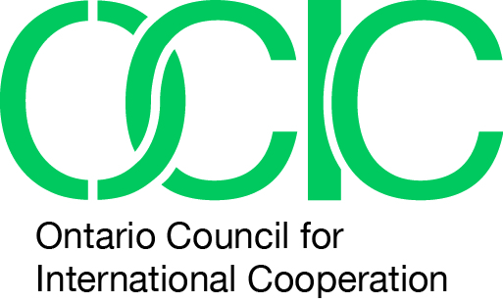

‘Transformations: Stories of Partnership, Resilience and
Positive Change in Peru’
Highlights, Key Results and Lessons Learned

During the 25th Anniversary of International Development Week, February 1-7, 2015, the Ontario Council for International Cooperation (OCIC) launched a new public engagement photojournalism initiative which in its first year is entitled ‘Transformations: Stories of Partnership, Resilience and Positive Change in Peru’. This five-year collaborative project is intended to increase dialogue and further understanding of international partnerships that address complex global challenges. In its pilot year the project profiles the partnerships between two OCIC member organizations and their partners in Peru: Transforming Faces and KusiRostros, and Save the Children Canada, Save the Children International in Peru, and the Commission on Human Rights of Ica (CODEHICA).

In late November 2014, three OCIC staff and a photojournalist traveled to Peru for ten days to visit the Peruvian partners in order to learn about and document firsthand the ways the organizations work together, and the impact of their collective efforts. The stories documented were curated and launched as a series of physical and virtual photo exhibits titled ‘Transformations: Stories of Partnership, Resilience and Positive Change in Peru’, during International Development Week 2015.

Through individual and organizational stories viewers are encouraged to actively engage in a new narrative on international cooperation and solidarity. This narrative is rooted in the Istanbul Principles for CSO Development Effectiveness, a set of mutually shared values guiding the development work of civil society organizations (CSOs) worldwide

Highlights and Key Results

- With direction and support of all partners, the OCIC team collected a variety of nuanced and personal stories that incorporate narratives from over 100 children, families, and community members.
- OCIC and our partners worked collaboratively to plan the international visit and develop the exhibition. The use of partnership agreements was piloted as a method to frame this collaboration
- In February 2015 two English-language virtual exhibits featuring 80 photos and accompanying narratives were published online on Exposure.co.
- A corresponding physical exhibit featuring 40 photos was launched at the outset of International Development Week, and micro exhibits of four to eight photos each were presented in six locations across Toronto.
- Spanish-language versions of the two virtual exhibits were published online in March 2015 and launched simultaneously in Canada and Peru.
- The four virtual exhibits will remain online and continue to be promoted by OCIC and our partners throughout the year.
- Physical exhibits during the month of February reached over 46,910 impressions and virtual exhibits have been view 3,848 times (in English and Spanish) by May 21, 2015.

Key Lessons Learned

- A partnership approach to public engagement can effectively access relationships of trust, and provide an effective means to share powerful and meaningful narratives

- Support, understanding and engagement from all partners were critical factors to the success of this pilot initiative, enabling a deep connection with individuals in a short period of time.
- Building on existing and mature relationships of trust provides a unique point of engagement with stakeholders. With a high level of respect and transparency on the intended use of images and stories, numerous people wished to share their experiences, to be photographed, and to be heard.
- In this context, individuals are willing to share deeply personal stories in order to develop a more nuanced narrative about individual’s lives, situations, agency and active involvement.
- Through a collaborative feedback process of developing a written and visual narrative, all partners were able to play a critical role in the final framing of the exhibition and increase the transparency and accountability to the individuals who shared their stories

- Using photojournalism as a medium and providing access on multiple platforms is an effective strategy to bridge geographical and language gaps and is a compelling way to share narratives (in a partnership context)

- High quality exhibit images attract viewers’ attention and are an effective entry point to engage with a narrative.
- Photojournalism provides an opportunity to share multiple individualized stories contributing to a more nuanced understanding
- Virtual exhibits in both the English and Spanish languages increase reach to a broader online audience and to those who shared their story to see and engage with the resulting narrative.
- Developing a comprehensive communications and engagement strategy would make the exhibit more impactful. A strategy that leads to a specific action and links stories more closely to global agenda is needed.

- In project based partnerships, developing a mutual set of objectives from the outset strengthens and deepens the potential of impact and provides more clarity about desired outcomes

- Providing a clearer picture of the scope of the project and exploring expectations and objectives of all partners from the very beginning of the selection process will contribute to increasing ownership and accountability of partners.
- Developing a comprehensive public engagement strategy for the duration of the initiative, including clear specifications and target audiences and desired actions with and by these audiences, are necessary to move towards deeper levels of engagement.

Note

- As a pilot, the first iteration of this initiative was centred in Toronto as a means to streamline the learning process for the OCIC team. Moving forward, we hope to significantly expand our public reach across the province of Ontario.

