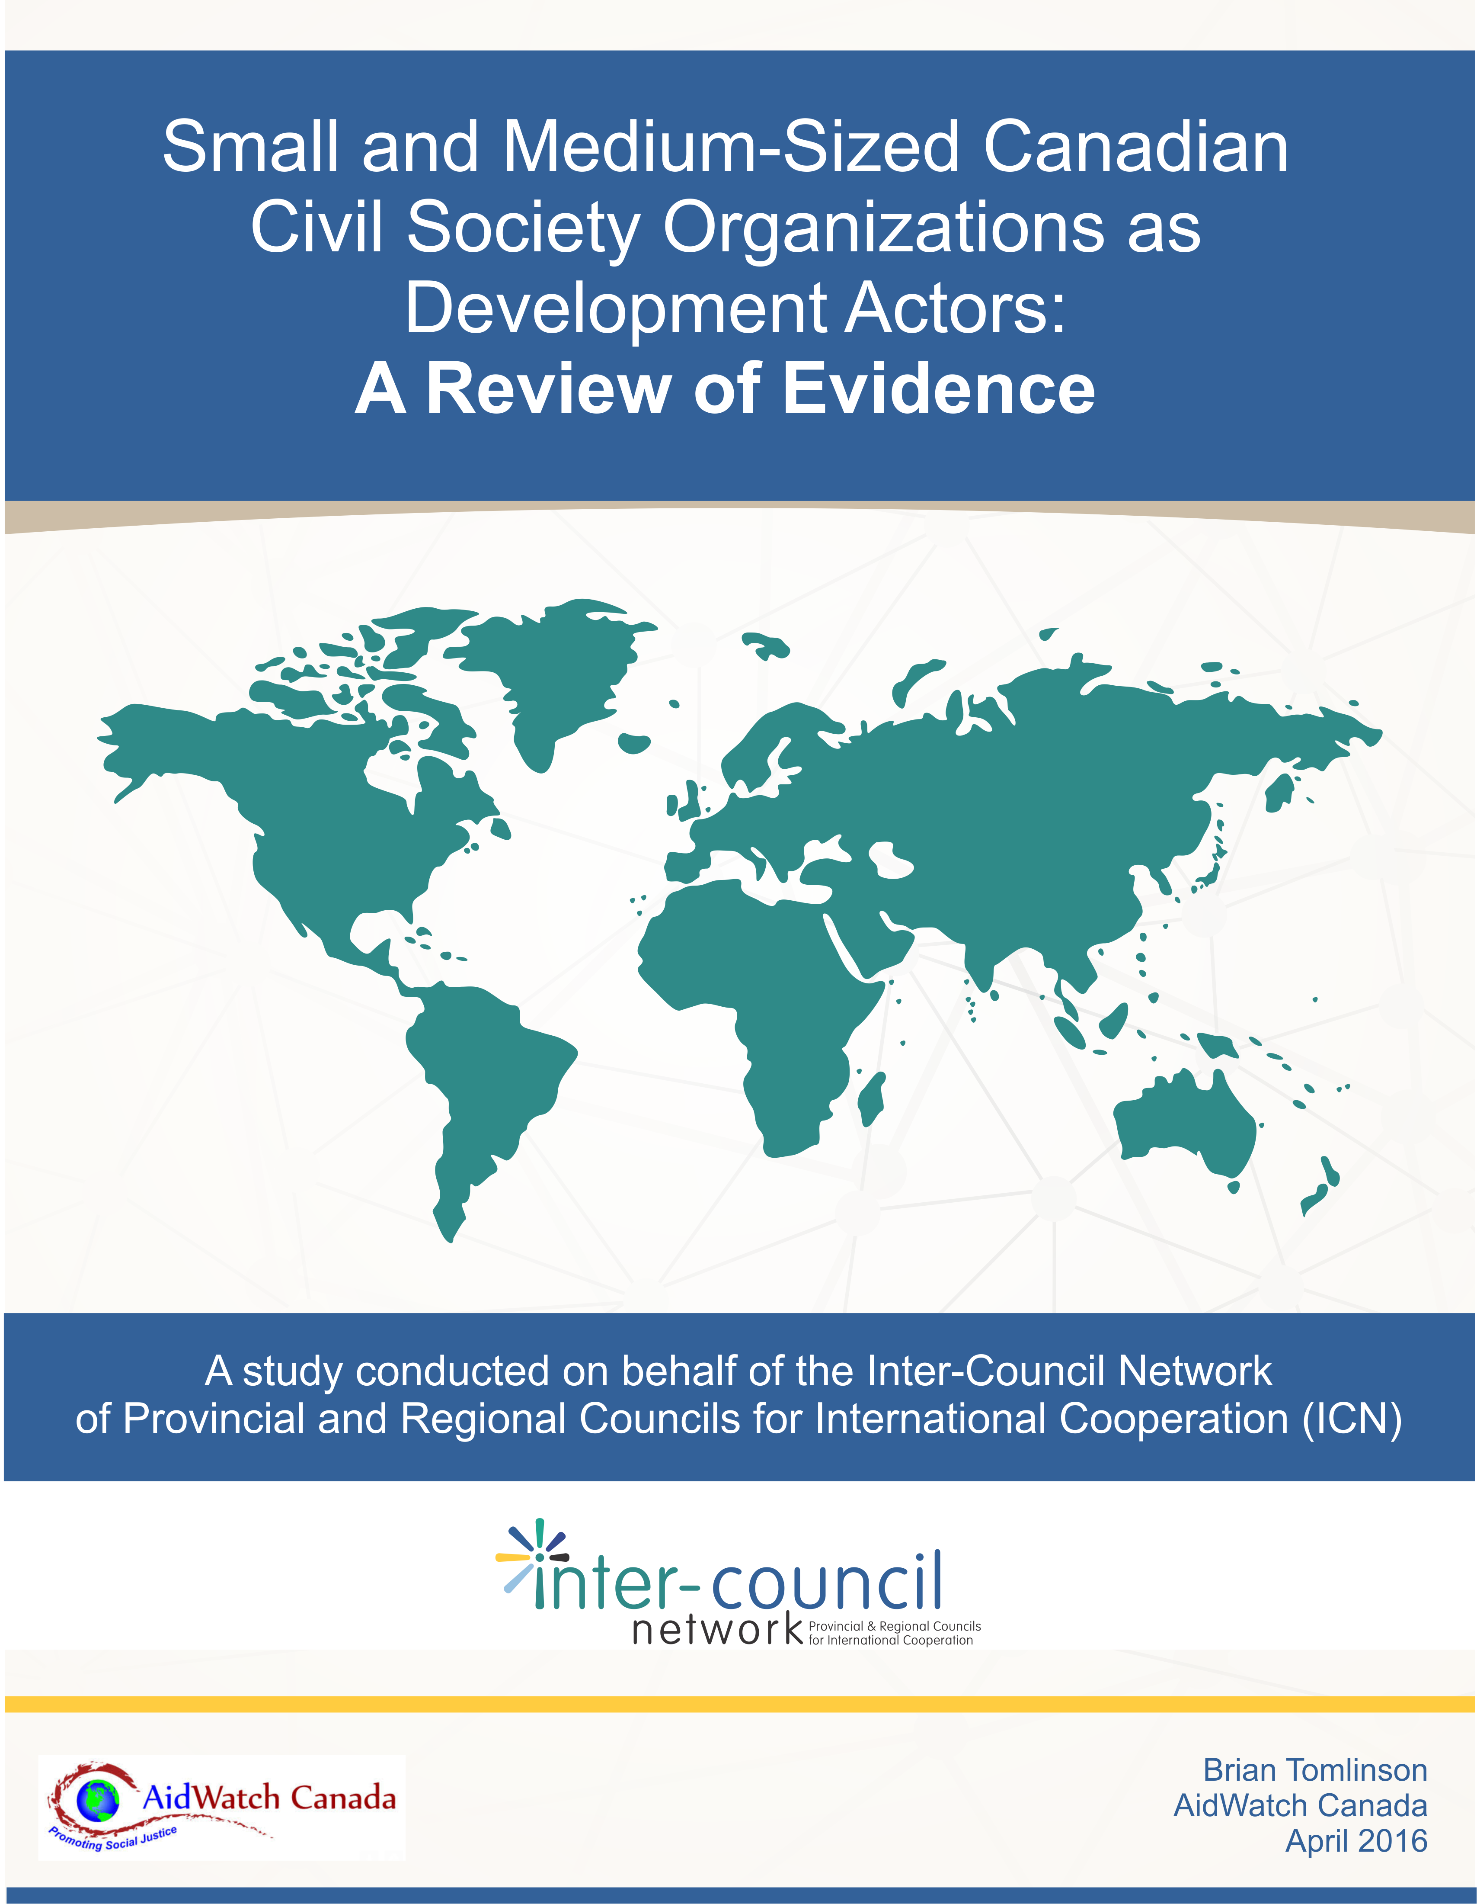

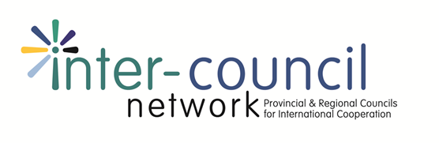

Michael Simpson, Executive Director  British Columbia Council for International Cooperation | 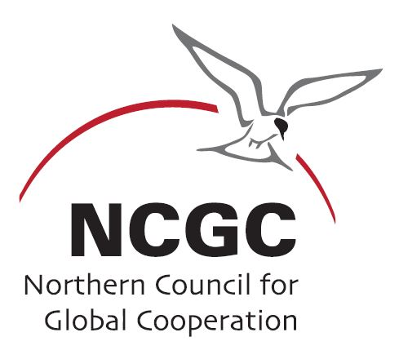  Tracey Wallace, Executive Director  Northern Council for Global Cooperation
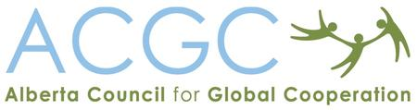  Heather McPherson, Executive Director  Alberta Council for Global Cooperation | 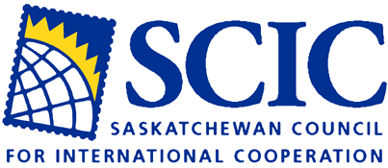  Jacqui Wasacase, Executive Director  Saskatchewan Council for International Cooperation
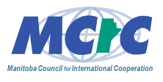  Janice Hamilton, Executive Director  Manitoba Council for International Cooperation | 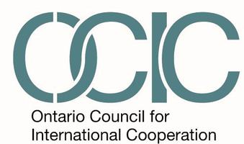  Kimberly Gibbons, Executive Director  Ontario Council for International Cooperation
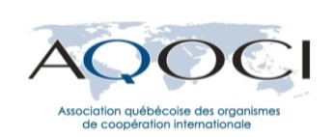  Michèle Asselin, Directrice générale  l'Association québécoise des organismes de coopération internationale | 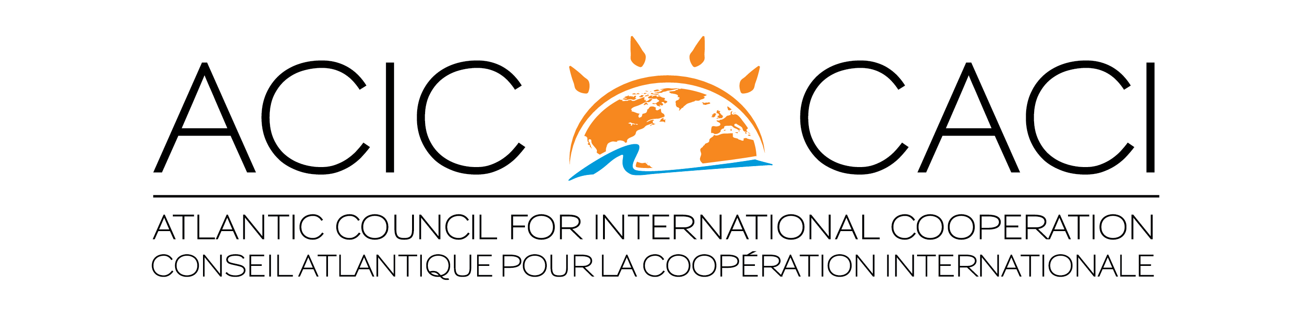  Carolyn Whiteway, Acting Executive Director  Jennifer Sloot, Executive Director  Atlantic Council for International Cooperation

This initiative was undertaken with the financial support of the Government of Canada, provided through Global Affairs Canada.

Small and Medium-Sized Canadian Civil Society Organizations as
Development Actors: A Review of Evidence

An Executive Summary

Canadian small and medium sized organizations (SMOs) are significant development actors, engaging in diverse and innovative development programming and connecting with Canadians across the country as global citizens. In the past five years, many SMOs have been marginalized as the government implemented Canada’s aid priorities, despite their record of effective programming. This paper presents a case for new initiatives to re-engage SMOs in Canada’s development efforts based on this record and core competencies. In doing so, it reviews current evidence on the value, roles and contributions of SMOs as development actors.

The paper develops a profile of Canadian SMOs involved in development cooperation, the impact of changing funding modalities on SMOs since 2010, and the characteristics of SMOs as development actors, as evidenced by third party evaluations. The Executive Summary highlights the main indicative trends and findings in each of these areas.

1. A Profile of Canadian SMOs as Development Actors

The study examined 807 charities in Revenue Canada’s database, with more than 30% of their revenue devoted to overseas expenditures. Of these charities, three-quarters (75%) were small organizations (610), 17% were medium sized organizations (134), and 8% were large organizations (63).

What are some of the main trends within this Revenue Canada dataset?
- SMOs are more likely to devote more than 30% of their revenue to overseas activities – 93% of small organizations, 64% of medium organizations, compared to just over 40% of large organizations, in the revised list of charities involved in development cooperation, devote more than 30% of their revenue to overseas expenditures.
- SMOs raise significant resources for development cooperation, a fact that is obscured by the dominance of a few very large international NGOs in Canada. If revenue from the four largest CSOs among the 807 charities studied is excluded, SMOs account for approximately 25% of the total revenue for these 807 CSOs involved in development cooperation. Including the four organizations reduces the SMO share to 15%. While no data exists, it is commonly understood that many SMOs rely on non-cash contributions in addition to this revenue, perhaps more so than large CSOs.
- SMOs are the main avenue to reach Canadians with an SMO direct presence in many cities and communities across Canada. More than 85% of large organizations have their headquarters in Ontario or Québec. While location is not the only determinant for engagement with Canadians, it is notable that close to 40% of small organizations are based in provinces west of Ontario. Similarly a third of medium sized CSOs (33%) are located in these provinces. With a correspondingly smaller share of the Canadian population, Atlantic Canada has fewer organizations from all classes of CSOs, with less than 5% of small organizations based in these provinces.
- In Ontario and Québec, SMOs are also present in cities and communities beyond the Toronto, Ottawa, and Montreal metropolitan areas. Among the 54 large organizations based in Ontario and Québec, 46 have headquarters in Toronto, Ottawa or Montreal. Again SMOs are a primary resource in reaching Canadians in these provinces, with 50% of small organizations and 43% of medium organizations located in cities and towns in Ontario and Québec outside the Montreal, Ottawa and Toronto metropolitan areas.
- SMOs are more likely to depend on direct donations from Canadians to support their programs. SMOs account for 30% of all revenue from individual Canadian donations, this revenue source is much more important in sustaining their activities than large organizations. Private individual donations make up 67% of the revenue for small organizations, 44% for medium sized organizations, but only 22% for large organizations.

2. Trends in SMO Funding from CIDA/DFATD

There is a major bias in funding from CIDA/DFATD towards large CSOs. This trend has been exacerbated by the impact of the dramatic changes in funding modalities by CIDA’s Partnerships for Development Innovations Branch, beginning in 2010.
- Large organizations dominate in accessing CIDA/DFATD funding. Among the 807 charities examined in the Revenue Canada dataset, 60% of large organizations received CIDA/DFATD funding in 2014. By contrast only 1.8% of small organizations (11 out of 610 organizations) and 17% of medium sized organizations (23 out of 134 organizations) received funding from CIDA/DFATD in 2014.

- Small and medium organizations were dramatically affected by the change towards an exclusive call-for-proposal funding mechanism in CIDA in 2010. Among organizations funded by the Partnerships for Development Innovations Branch in 2010/11, 93 organizations were no longer funded in 2013/14, mainly as a result of the changes in funding mechanisms. Of these 93 organizations, close to 70% (64 organizations) could be considered small organizations (receiving less than $100,000 per year from CIDA, and 22% (20 organizations) could be considered medium sized organizations (receiving between $100,000 and $500,000 per year from CIDA).
- SMO members of Provincial and Regional Councils were also affected by these trends. SMO Council members received 37% less revenue from CIDA between 2010/11 and 2013/14, declining from $17.2 million for 41 organizations in 2010 to $10.8 million for 28 organizations in 2013.

3. SMOs in CIDA’s Development Cooperation

The reduction in numbers of SMOs receiving CIDA funding since 2010 belie the actual positive trends in the historical performance of SMOs in Canadian development cooperation. Comparing SMOs receiving funding in 2010/11 from the Partnership for Development Innovations Branch, with all CSOs receiving funding from this Branch, the following trends are apparent:
- SMOs are more directly engaged in programming in Sub-Saharan Africa, where poverty is deep and endemic, than for CSOs in the Branch as a whole (50% of disbursements for SMOs, compared to 47% for all Branch disbursements to CSOs).
- SMOs are strongly represented in the 25 priority countries for Canadian ODA. More than 47% of disbursements by SMOs were made in 2010 to these 25 countries, compared to 46% for the Branch as a whole.
- SMOs devoted significantly more CIDA resources towards MDG priority areas, human rights and civil society strengthening. Using a proxy set of indicators for MDG priorities, in 2010 SMOs allocated close to half of their CIDA disbursements (48%) to these priorities, compared to only 35% for the Branch as a whole. When areas of programming for human rights, civil society strengthening and development awareness are also included, this proportion of disbursements increases to 72% (compared to 66%).
- On gender equality, both SMOs and all CSOs funded by the Branch lack focus. Only 2.6% of disbursements for SMOs were allocated to activities where gender equality is the principal objective (compared to 0.9% for all CSOs funded by the Branch).

4. SMOs as Development Actors: Contributions and Characteristics

Global Affairs Canada’s recent CSO Policy states,
“The great diversity within civil society in Canada is also a significant strength that helps respond in innovative ways to the needs of those living in poverty. DFATD recognizes this strength and is committed to supporting CSOs of diverse sizes and scale, sector and region.” [Government of Canada, 2015]

SMOs clearly represent this diversity, and in particular are almost the exclusive means through which many Canadians can be directly involved with a CSO in communities and regions across Canada.

The review of independent evaluations for 20 SMOs highlight the roles of SMOs in raising the voices of poor and marginalized people (often through community to community linkages), pilot and motivate innovation through sector specialization, coalesce research and Canadian expertise, often work with this expertise in multi-stakeholder approaches to development, create sustainable results through long term partnerships, and engage Canadians directly in development cooperation, not only as donors, but often as volunteers in their communities.

More specifically, the review of the evaluations suggests ten important characteristics and key competencies of SMOs as development actors.
- Focus and specialization SMOs are highly specialized, perhaps more so than larger organizations involved in different aspects of development cooperation. At least half the evaluations pointed to the importance of specialization in terms of mandate, sector or geographic local.
- Access to sector expertise Many SMOs, through their specialization, have well developed institutional connections in Canada, from which they can draw (often voluntary) contributions of Canadian expertise for programs overseas, where the expertise needed is determined by conditions and counterparts in developing countries.
- Transfer of knowledge and capacity development Close to half the evaluations commented on the increasing roles of SMOs in capacity and knowledge development with counterparts in developing countries. They note the effectiveness of such programs, particularly where the SMO has been able to indigenized capacities with sustained support for long-term partners, sometimes spanning decades of development cooperation.

- Public engagement with Canadians Given their presence in all provinces and regions of Canada, SMOs are uniquely positioned to implement Global Affairs Canada’s policy commitment to work with CSOs “as a principal mechanism to engage individual Canadians and raise awareness of and involvement in international development.” [Government of Canada, 2015] While among the 20 evaluations there are examples of effective programming in public engagement, an overall observation is that these programs are often marginal to the work of these SMOs. A much more deliberate approach to, and financing for, public engagement is called for if SMOs are to take full advantage of their strategic location and connection with communities across the country.
- Reflection of aid effectiveness principles Consistent with the ODA Accountability Act and Canada’s commitment to international aid effectiveness principles, SMOs
- are strongly focused with their programming on the 25 priority countries for Canadian aid,
- have wide experience in country ownership through partner-led multi-faceted relationships with their counterparts in developing countries, and
- have improved their approach in ways that strengthen the use of results-based management tools.
While formal participation in transparency and accountability initiatives can be a challenge for many SMOs with few resources, many are members of Provincial, Regional and National Councils where they must adhere to well elaborated codes of conduct.
- Long term engagement with partners Canadian CSOs have long standing experience working in partnership, and SMOs are no exception. All 20 evaluations highlight the importance of long-term sustained partnerships for effective development cooperation on the part of SMOs, including the use of flexible core institutional support in the case of one SMO.
- Multi-stakeholder engagement and partnerships Given their size, SMOs are often strongly motivated to foster multi-stakeholder approaches in their development cooperation initiatives, which is an increasingly important goal for Global Affairs Canada and the international community. More than half the evaluations highlighted the contribution of particular multi-stakeholder initiatives in deepening the impact and leveraging modest SMO resources. Equally important is a deliberate approach to developing trust and commitment in these initiatives, built on sustaining of programming and competencies over years.
- Sustainability and results All CSOs are concerned that their initiatives have sustained outcomes and impacts over the longer term, and for SMOs, while perhaps sometimes more challenging, these goals are no less important. The evaluations identify particular SMO strategies for sustainability – multi-stakeholder partnerships, capacity development to reach out to new donors, organizational strengthening through core support, sustained presence with partners and communities, limiting episodic engagements, etc.
- Flexible and adaptable to changing local conditions The evaluations provide some evidence that SMOs may be more nimble than larger organizations, given their size, with decision-making and responsiveness to changing conditions on the ground.

- Cost effectiveness and voluntary efforts Evaluators for the 20 SMOs were consistent in their praise for these organizations as cost effective actors in development cooperation. They point to a “multiplier effect” from volunteer efforts combined with a small amount of financial resources, the importance of focus and access to volunteer expertise, perhaps unavailable to larger organizations. They also highlight the impact of volunteering on the individuals concerned, which not only deepens a global perspective, but has sometimes contributed to life-changing directions involving a future career or volunteer effort in development organizations.
While these characteristics may not always be unique to SMOs, they are important drivers in determining SMO effectiveness and development impact. The scale of an organization often allows for more variation in adapting to the needs of specific partnerships, very much directly engaging people in their communities, in both Canada and overseas.
Given this SMO history in Canadian development cooperation, and the obvious competencies involved in SMOs, Global Affairs Canada should honour its CSO Policy to create “merit based, predictable funding opportunities through equitable, flexible and transparent modalities that will support the diverse roles and types of CSOs in Canada and in developing countries.”
Responsive mechanisms accessible to this diversity of CSOs “can provide the impetus for innovative approaches” and the renewal of Global Affairs partnerships with the Canadian CSO community. [Government of Canada, 2015]

- Introduction

The Inter-Council Network of Provincial and Regional Councils for International Cooperation (ICN) has commissioned a short research paper on the value, roles and contributions of small and medium-sized Canadian civil society organizations (SMOs) as development actors. The paper will explore this theme through three questions:
- What is the profile of Canadian SMOs involved in development cooperation, relative to large civil society organizations (CSOs)?
- What has been the impact of recent changes in funding modalities on funding for SMO development activities by CIDA/DFATD?
- What are some of the key characteristics and contributions of SMOs as development actors, as evidenced by third party evaluations?

B. SMO Metrics
A study of small and medium sized organizations is methodologically challenging, requiring a number of adaptations to several data sources. The study relies on 1) a Revenue Canada database for 2014 financial information on revenue and overseas expenditures for all charities registered in Canada, 2) Global Affairs Canada historical project dataset, and 3) evaluations and institutional assessments for a select number of Canadian CSOs (See the Bibliography in Annex Two). Each source comes with unique challenges. A Methodological Note in Annex One provides the rationale for the adaptations and assumptions regarding each source.

While different assumptions and approaches could be made, giving different specific outcomes, the author is confident that the chosen methodologies for each data source provide a reliable overview of the main trends regarding Canadian SMOs. However, given these challenges with data, care should be exercised in quoting specific data as an absolute measure of the SMO community in Canada.

1. Revenue Canada Data

a) Developing a sample of SMO charities

For 2014, Revenue Canada lists more than 5,450 charities with expenditures outside of Canada. This study, however, concentrates on 985 of these organizations, as determined by the criteria and rationale set out the Methodological Note found in Annex One.

Expenditures on foreign activities, as a proportion of total revenue, varied considerably across these 985 organizations: 178 charities (18% of the 985) registered foreign expenditures at less than 30% of their total revenue for 2014. For many of these 178 organizations, foreign assistance may be a legitimate part of, but is not their primary mandate.

Large organizations are more likely to program less than 30% of their revenue in overseas activities (with 41% of the 107 large organizations falling below the 30% threshold). SMOs are more concentrated on overseas activities. More than 93% of small organizations and 64% of medium-sized organizations focused on foreign activities (i.e. with more than 30% of revenue devoted to these activities).

The analysis below concentrates on those organizations with more than 30% of revenue devoted to foreign activities (adjusting for very large institutions that have significant development activities). While acknowledging a somewhat arbitrary cut-off, the resulting sample of 807 organizations with more than 30% of revenue devoted to foreign activities tend to be those with a more exclusive mandate and focus on development cooperation.

b) Distribution of CSOs by size and total revenue

Within this sample of 807 organizations:
- 610 are small organizations (75.6%)
- 134 are medium sized organizations (16.6%)
- 63 are large organizations (7.8%)

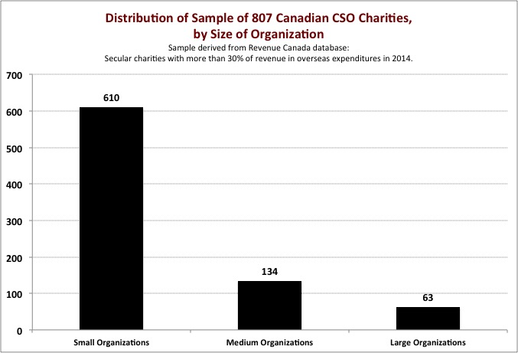

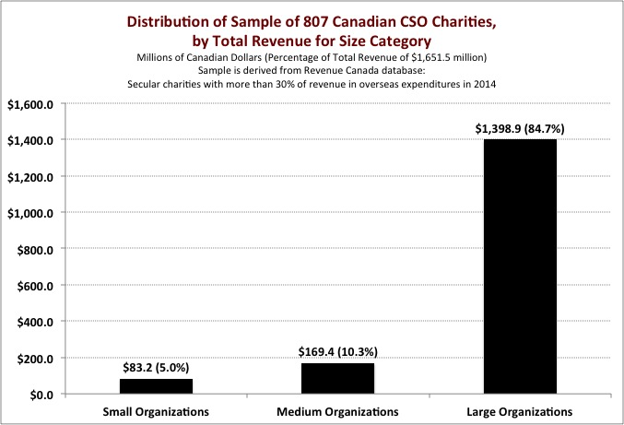

Together SMOs accounted for 15% of the $1.7 billion in revenue for the organizations with more than 30% of their expenditures on foreign activities. But four large organizations account for more than $628.2 million of the $1.7 billion. If these four organizations are excluded from the calculation, the share of SMOs in total revenue for the remaining 803 organizations increases to 25%. It should be highlighted that small and medium sized organizations rely on additional voluntary and in-kind contributions, perhaps more so than large organizations. While it is difficult to calculate, the value of these contributions from Canadians would significantly augment this financial share.

c) Geographic distribution of CSOs by size

The following table demonstrates the geographic distribution across the country of the 807 organizations that focus at least 30% of their revenue on overseas development cooperation expenditures.

Table 1: Provincial/Territorial Distribution of CSOs by Size of Organization

 | Small Orgs | Percentage  of Total | Medium Orgs | Percentage of Total | Large Orgs | Percentage of Total
British Columbia | 131 | 21.5% | 23 | 17.2% | 4 | 6.3%
Alberta | 80 | 13.1% | 15 | 11.1% | 2 | 3.2%
Saskatchewan | 13 | 2.1%
Manitoba | 15 | 2.5% | 6 | 4.5% | 2 | 3.2%
New Brunswick | 11 | 1.8%
Nova Scotia | 8 | 1.3% | 1 | 0.7%
Prince Edward Island | 4 | 0.7%
Newfoundland | 3 | 0.5% | 1 | 0.7%
Ontario | 254 | 41.6% | 73 | 54.4% | 41 | 65.1%
Québec | 89 | 14.6% | 15 | 11.2% | 13 | 20.6%
Other / None | 2 | 0.3%
Total | 610 |  | 134 |  | 63

Source: Revenue Canada T3010, Charities with Activities outside of Canada; Author’s calculations

Outside of Ontario and Quebec, small organizations are concentrated in the western provinces (Manitoba to BC), with 238 (39%) of the 610 organizations located in these provinces. Still 56% of small organizations are located in Ontario and Québec. At the other end of the spectrum, 85.7% of large organizations are concentrated in Ontario and Québec. For medium sized organizations, slightly less (65.7%)is concentrated in these two provinces. For the Atlantic Provinces, the predominance is small organizations.

d) Geographic concentration in Montreal, Ottawa and Toronto

Large organizations are highly concentrated in Ontario and Quebec, and within the Toronto, Ottawa, Montreal regions, with only 8 of the 63 large organizations located in western provinces. For those large organizations in Ontario and Québec, 46 of them, or 85%, are even more concentrated in Montreal, Ottawa and Toronto. These organizations have total revenue of $1.2 billion.

Small and medium sized organizations are not only distributed in cities and communities across the country, they are less concentrated in Ontario and Québec. Within these provinces only 50% of small organizations and 57% of medium organizations have headquarters located in Montreal, Ottawa and Toronto.

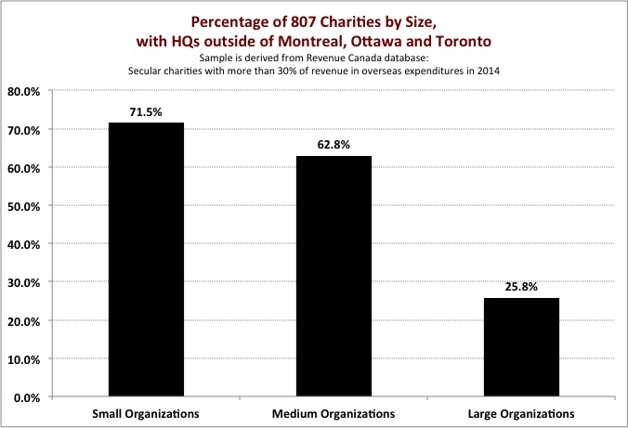
e) Contributions to Charities from Individual Canadian Donations

Revenue Canada identifies tax-receipted income for charities from individual Canadian donations. The 807 charities focusing on development cooperation receipted $441.8 million in total tax receipted income. Distributed by size of organization,

- 610 small organizations receipted $55.8 million (or 12.6% of total tax receipted income);
- 134 medium sized organizations receipted $74.1 million (or 16.8% of total tax receipted income); and
- 62 large organizations receipted $311.9 million (or 70.6% of total tax receipted income).

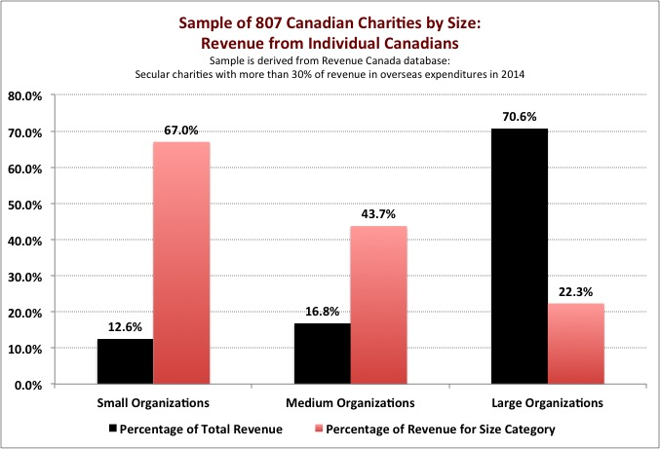

SMOs, as a whole, account for just under 30% of receipted revenue from Canadians. But as a share in their total revenue, individual Canadian donations are very important for SMOs:

- Small organizations, private donations make up 67% of their total revenue;
- Medium size organizations, private donations make up 44% of their total revenue; and
- Large organizations, private donations make up only 22% of their total revenue.
While large organizations raise significant resources from Canadians, SMOs, and particularly small organizations, are much more engaged with Canadians as the primary source of their revenue.

The 705 organizations collectively transferred $1.1 billion to counterparts in ODA eligible countries. Since the selection of these charities is based on the degree of concentration of expenditures in foreign activities, it is not surprising that the proportion of their revenue devoted to these activities is consistently high across the different sizes of organizations:

- Small organizations: 84.3% of revenue devoted to foreign activities;
- Medium size organizations: 64.2% of revenue devoted to foreign activities; and
- Large organizations: 66.0% of revenue devoted to foreign activities.

Revenue Canada also records the amount charities have received from CIDA/DFATD in 2014. For the 705 organizations with a focus on international cooperation, there is a strong bias toward financing large organizations through DFATD:
- The 610 small organizations took in $762,000 from CIDA/DFATD, which was received by only 11 organizations, representing 1.8% of all small organizations. This amount represented 0.9% of the total revenue for these 610 organizations;
- The 134 medium sized organizations took in $12.3 million, which was received by 23 organizations, representing 17% of all medium sized organizations. This revenue amounted to 7.3% of total revenue for these 134 organizations; and
- The 62 large organizations took in $322.4 million, which was received by 38 organizations, representing 60% of the 62 large organizations. This revenue represented 23% of the revenue of the 62 large organizations.

2. SMOs and Members of Provincial and Regional Councils for International Cooperation

Of the 320 organization members of the Provincial and Regional Councils for International Cooperation, 195 (or just over 60%) can be considered SMOs. It should also be noted that only just over 50% of the membership of the Provincial and Regional Councils (excluding universities and colleges) are registered charities. Those SMO members that are not registered charities are therefore not part of the analysis in the previous section. However, it is likely that the overall trends still apply to SMO not-for-profits.

Among the 195 organizations, 93 SMOs (48%) can be found in British Columbia, Alberta, Saskatchewan, and Manitoba, 38 (20%) in Ontario (of which 21 are headquartered in Toronto or Ottawa), 40 (20.5%) in Québec (of which 18 are headquartered in Montreal), 16 (8.2%) are based in New Brunswick, Nova Scotia, PEI and Newfoundland, and 4.1% in the Yukon. There are 156 Council-member SMOs outside the Toronto / Ottawa / Montreal hub, or 80% of all SMOs that are Council members. (See Chart, next page)

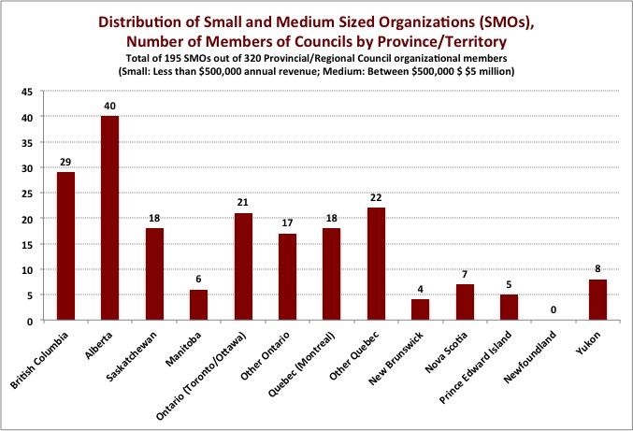
3. CIDA/DFATD and SMOs

Revenue Canada data clearly demonstrates the bias in funding from CIDA/DFATD towards large organizations, and to a lesser degree, medium-sized organizations. This finding has likely been exacerbated by the impact of the 2010 change in funding modalities by CIDA’s Partnership for Development Innovation Branch. This analysis therefore uses the 2010/11 fiscal year as the reference year for changes in funding patterns.

a) Impact of changing funding modalities in 2010

A study by AidWatch Canada highlights the highly disproportionate impacts on former CIDA partners, between 2010/11 and 2013/14, resulting from the exclusive use of calls-for-proposals by Partnerships for Development Innovation Branch. An analysis of CIDA/DFATD’s historical project database found that 93 (42%) out of 221 organizations that received funding in 2010/11 received no disbursements in 2013/14, many of whom were SMOs. Only 9 of the 93 organizations no longer receiving funding in 2013/14 received more than $500,000 in funding in 2010/11.

On the other hand, 64 of the 93 organizations, or 69%, were small organizations, receiving less than $100,000 from CIDA in 2010/11. And the remaining were 20 medium-sized organizations receiving between $100,000 and $500,000 in funding in 2010/11.

A total of 100 of the 221 organizations funded by Partnerships for Development Innovation Branch in 2010/11 could be considered SMOs. They received $32.9 million in funding or 18.4% of Branch funding for Canadian CSOs in that year. Of these SMOs, the top 20 organizations received more than 60% of this $32.9 million. Thirteen (13) of these 20 were members of Provincial and Regional Councils. Overall, however, funding for SMO Council members declined significantly by 37%, from $17.2 million for 41 organizations in 2010/11, to $10.8 million for 28 organizations in 2013/14.

b) A profile of SMOs in CIDA’s development cooperation in 2010

To understand better the significant role that SMOs have played historically in CIDA’s development cooperation, a further analysis of the 2010/11 historical project dataset was undertaken for this ICN study.
- As demonstrated in the following two tables, SMOs compare favourable to the Branch allocations to geographic regions and priority countries in 2010/11. The priority countries are the list of 25 countries as revised in 2014.

Table 2: Geographic Distribution

Regional Disbursements  (2010/11) | SMOs Percentage of Total | Branch, All CSOs Percentage of Total
Africa | 49.7% | 47.1%
Americas | 33.8% | 36.3%
Asia | 15.6% | 15.4%
Europe | 0.9% | 1.2%

Source: CIDA Historical Project Dataset, 2010/11

Table 3: Disbursements to Priority Countries

Priority Countries Disbursements,  2010/11 FY using the  2014 list of 25 | SMOs  Percentage to Priority Countries | Branch, All CSOs  Percentage to Priority Countries
Priority Countries | 47.2% | 45.5%
Other Countries | 43.3% | 38.2%
Regional | 5.7% | 5.4%
Canada | 3.8% | 10.9%

Source: CIDA Historical Project Dataset, 2010/11

- Using OECD DAC sector codes as a proxy for allocations towards MDG priorities, in 2010/11 SMOs funded by CIDA allocated almost half of their CIDA disbursement (48%) towards these priorities (compared to 35% for the Branch as a whole). When codes for human rights, civil society strengthening and development awareness are included, the proportion for SMOs increases to 72% (compared to 66% for the Branch as a whole).
- On gender equality, both SMOs and all CSOs funded by the Branch, lack focus. Only 2.6% of disbursements for SMOs were allocated to activities where gender equality is the principal objective (compared to 0.9% for all CSOs funded by the Branch). The principal objective marker is a good proxy for the degree to which organizations focus on gender equality. On the other end, 30% of SMO activities, and 14% for Branch CSOs as a whole, indicate no gender results. Greater attention to gender equality and women’s empowerment in CSO programming should be a higher priority for the sector.

C. SMOs as Development Actors: Contributions and Characteristics

Hundreds of Canadian SMOs that focus their efforts in development cooperation have varied mandates, roles and contributions as development actors, which belie easy summarization. Very little academic literature has been written with a focus on small and medium-sized development organizations. However, as noted in the previous sections, SMOs are very numerous, rooted across the country, and are seemingly playing important roles in development cooperation, more often than not, with significant volunteer community support.

How then to assess SMOs in particular? One possible source of independent assessment of SMO roles and contributions are third-party evaluations and institutional assessments. These were undertaken, largely before 2010, as part of CSO project or program support by CIDA. Annex One lists 20 SMOs for which evaluations, assessments and academic articles were consulted, and from which this paper draws a number of conclusions.

On what basis should SMOs be assessed? Many of the Provincial and Regional Councils have charters and codes of ethics for good practice to which all members including SMOs must adhere, or are encouraged to integrate into their work. Globally, CSOs have set out a framework for adhering to eight Istanbul Principles for CSO Development Effectiveness, which has been the basis for internal training with members by Provincial and Regional Councils. [Open Forum, 2011] More specifically, Global Affairs Canada adopted in 2015 an “International Development and Humanitarian Assistance Civil Society Partnership Policy,” which includes reference to the Istanbul Principles. [Government of Canada, 2015] This Policy will frame this discussion of roles and characteristics of SMOs in Canadian development cooperation.

The Global Affairs CSO Policy notes,
“The great diversity within civil society in Canada is also a significant strength that helps respond in innovative ways to the needs of those living in poverty. DFATD recognizes this strength and is committed to supporting CSOs of diverse sizes and scale, sector and region.

As noted in earlier sections, SMOs represent this diversity, and in particular are almost the exclusive means through which many Canadians can be directly involved with a CSO in most communities and regions across Canada. As shall be demonstrated from the review of evaluations, SMOs raise the voices of poor and marginalized people (often through community to community linkages), pilot and motivate innovation through sector specialization, coalesce research and Canadian expertise, often work with this expertise in multi-stakeholder approaches to development, create sustainable results through long term partnerships, and engage Canadians directly in development cooperation, not only as donors, but often as volunteers in their communities.

Through the review of evaluations and assessments, 10 key areas of SMO competences can be identified, which may not be unique to SMOs, but which characterize their roles and the strength of their contributions to Canadian development cooperation.

1. Focus and Specialization

At least half of the 20 organizations in the evaluation/assessment sample are organizations that evaluators highlight a long experience with a particular focus and/or specialization in their mandate, sector or geographic locale. Specialization ranges from strengthen civil society through human rights training (Equitas), innovation in low-cost housing (Rooftops Canada), innovative reading/learning approach tested in a district in Tanzania to demonstrate impact (CODE), strategic research and coalition building (MiningWatch), alternative sustainable agricultural practices (SUCO), or youth engagement (Jamaica Self Help).

With respect to Jamaica Self Help, the evaluator commented that the organization was very effective in creating deliberate space for youth to take direct responsibility to learn and act in all aspects of a CSO. Importantly this engagement created opportunity in a medium-sized city (Peterborough). At the rate of 15 to 20 per year, over the long life of the organization since 1978, hundreds of youth became not only more aware as people and citizens, but thoughtfully involved in meaningful change in both Jamaica and Peterborough.

Similarly, the Nova Scotia Gambia Association has evolved over 25 years from a small high school project to a respected small Atlantic region organization, with revenue less than $500,000, but which has made a large impact in the Gambia. Evaluations highlight this impact through innovative use of theatre/drama in health education, engagement of youth, and access to primary and secondary schools across the country. Geographic focus in this case, alongside respect for culture and the direct involvement of Gambians in the organization, has given NSGA, over time, “established trust … to have easy access through many indigenous networks, and provides the organization with a degree of credibility with target audiences at the outset of any initiative.” [NSGA, 2002]

Farm Radio International, focusing on the use of radio to fill gaps in local farmers’ knowledge, created innovative approaches to engaging poor farmers voices and concerns directly in the design of programs, as well as Community Listening Groups, “contributed to the success of the radio programs and the project in general,” embedding it within local institutional contexts and gaining necessary community support. [Farm Radio International, 2014]

Inter Pares has developed a different form of specialization, described by its evaluator as “organizational accompaniment,” which involves making available resources for core counterpart support, concentrating on building expertise in a small staff team, facilitating reciprocal south-north learning between organizations, and mobilizing Canadian supporters around knowledge, global solidarity and civic engagement for alternative people-centered development paths. In the words of its evaluation, “from its counterparts viewpoint, [Inter Pares’] value lies in the quality of its relationships (human resources) which they say are based on mutual trust and respect, reciprocity, vigour and solidarity of a friendly critic.” [Inter Pares, 2009] A medium-sized organization at the time of the evaluation, Inter Pares demonstrates the strengths and contributions that can be made, resulting from a deliberate focus on long-term, engaged and reciprocal partner relations within a small manageable organizational space. These strengths (identified by evaluators) are also characteristic of other specialized SMOs in the sample of 20 organizations.

2. Access to Sector Expertise

Closely related to sector focus, many SMOs have access to and are able to deliver specific Canadian sector expertise in response to needs that are determined by conditions and counterparts in developing countries. They do so often through well-developed institutional connections in Canada. A highly developed example of this role is Rooftops Canada. The organization brought considerable value added to CIDA “by mobilizing the expertise of the Canadian social and cooperative housing sector.” The evaluator notes that “there is significant synergy between [Rooftop Canada’s] efforts in Canadian public engagement and its programming overseas given that most technical assistance provided to overseas partners is made through the support of Canadian members through voluntary and in-kind contributions.” [Rooftops Canada, 2010]

Similarly, the Canadian Network for International Surgery, a small CSO head-quartered in Vancouver, is according to its 2008 evaluators, “the only organization in Africa providing large scale obstetrical surgery skills training to health care professionals, and injury control training for the reduction of child mortality.” Despite its modest size, it has involved more than 6,000 health workers in training workshops over a 12-year period [up to 2007]. The evaluation notes that it had not only created a strong student base, but a human resource for “training the trainers,” which resulted in extending its training through south-south cross-country training programs. [Canadian Network for International Surgery, 2008]

Access to Canadian expertise takes many forms. An important resource, sometimes noted by evaluators, is the skill resource found among long-time committed staff and associates of Canadian SMOs. Counterparts can benefit from well-developed expertise in research (MiningWatch), sensitive organizational development skills (Inter Pares and ACORD in Africa), access to skills in book publishing (CODE in Tanzania), or promotion of sustainable agricultural practices (SUCO in Mali).

3. Transfer of Knowledge and Capacity Development

Global Affairs’ CSO Policy highlights important roles for CSOs in developing countries, among them, “enhancing the capacity of individuals and groups to realize their rights.” [Government of Canada, 2015] Nine of the 20 evaluations/assessments commented on the roles of Canadian SMOs in capacity and knowledge development with counterparts in developing countries. Effectiveness in capacity development for several SMOs, particularly where programs have been built upon years of experience with counterparts, is noteworthy in these evaluation reports.

The evaluation of Equitas, for example, notes that while training in human rights promotion is at the level of the individual, Equitas has structured this program deliberately to ensure that knowledge, skills, abilities and techniques is effectively transferred and used by their organizations. They point to “evidence that direct beneficiaries [organizations] have incorporated knowledge and skills into their operations [and] are undertaking significant number of human rights education initiatives [with indirect beneficiaries].” [Equitas, 2013]

Effectiveness can arise as a result of shared experiences as NGOs. An assessment of One Sky’s work with environment organizations in Nigeria pointed to the importance of capacity building organized by a small Environmental NGO [One Sky] that intuitively understands its coalition partners.

Indigenization of capacity development is an important strategy by many SMOs with limited resources. For example, an evaluation of the Nova Scotia Gambia Association noted that a capacity development program in the use of theatre for community education successfully resulted in drama coaches for all theatre troupes involved in education work, who were members of the original troupe trained by the NSGA. The experience of the Canadian Network for International Surgery has already been noted in the previous section with respect to extending capacities through south-south cooperation in training.

SMOs are often uniquely situated within communities in Canada to draw upon particular resources for their capacity development work. Farmers Helping Farmers in PEI, for example, are able to draw on FHF volunteers at the University of PEI, and particularly the Atlantic Veterinarian College, in capacity work with women dairy farmers in Kenya, for more than four years. An academic article on this experience notes, “these [positive] results are strongly linked to the fact that … efforts were made throughout the Wakulima Dairy / NGO partnership to train women farmers and keep dairy income in their control.” [Waltona, et al, 2012]

4. Public Engagement with Canadians

The Global Affairs Policy sees CSOs as “a principal mechanism to engage individual Canadians and raise awareness of and involvement in international development.” [Government of Canada, 2015] Given the presence of SMOs in all provinces and regions of Canada, and in many small cities and communities, SMOs are uniquely place to fulfill this mandate in a deeply rooted way, where (larger) organizations headquartered in Montreal/Toronto/Ottawa may find more difficult to sustain.

The YMCA, with its individual community Ys across the country, is seen to be effective in integrating an international program supported by the various Canadian YMCAs together, with youth exchanges and community involvement across the country. According to the evaluation, “in Canada, the fact that the international programs are managed locally creates a large and diversified pool of potential participants.” [YMCA, 2008] The Marquis Project, based in Brandon, Manitoba, was seen to be able to effectively take advantage of long-standing community relationships with churches, youth groups and schools to promote interest in its overseas work with HIV/AIDS.

Others are adept at connecting with their particular constituency. World Accord, “given its small size, … has had a relatively large impact in development education, particularly in the church community across Canada.” [World Accord, 2007] Similarly, the evaluation of the Canadian Network for International Surgery noted that 40% of University of Toronto surgery students were aware of CNIS, as a result of extensive use of workshops, public meetings and African handicraft markets conducted with its direct constituency in Canada.

These and others among the 20 organizations reviewed are excellent examples of the capacities and opportunities for development education by SMOs. Nevertheless, an overall observation on the 20 evaluations and assessments suggests that much more deliberate development education and public engagement initiatives is called for if SMOs are to more fully take advantage of their locations, strategic advantage and success stories in communities across the country.

5. Reflection of Aid Effectiveness Principles

Consistent with the guidance of the ODA Accountability Act, Canada is committed to an international agenda for aid effectiveness, which focuses on four principles agreed in Busan in 2011: 1) Ownership of development priorities by developing countries; 2) Focus on results; 3) Inclusive development partnerships; and 4) Transparency and accountability to each other. Several of the SMO evaluations and assessments demonstrate ways in which SMOs are working consistently with these principles.

Like many donors, Canada has also agreed to focus its bilateral development cooperation; in Canada’s case there is a focus on 25 countries. As noted in Section C above, Canadian SMOs are strongly represented in these countries. Several evaluations remark that the organization has also concentrated their programs in terms of either the number of partners (Jamaica Self Help and Inter Pares) or geographically (SUCO in four countries and Rooftops Canada, concentrated locales where greater synergies in activities supported is possible).

Ownership: While most SMOs work closely with counterparts in developing countries (see #6 below), several evaluators took particular note of the organization’s commitment to local ownership. For example, Rooftops Canada “effectively promotes local ownership through comprehensive capacity development of local partners, the leverage of local resources from the private sector, and the development, replication, and scaling up of locally tested models in housing micro-finance.” [Rooftops Canada, 2010] Similar comments were made about the programs of the Agricultural Institute of Canada, the Nova Scotia Gambia Association, In the case of the Canadian Network for International Surgery, “by facilitating the creation of independent African organizations, CNIS promotes ownership and principles of

sustainability right from the outset.” [Canadian Network for International Surgery, 2008] The evaluation of Equitas strongly endorsed the organization’s approach to design its training and human rights education programs to support needs identified by communities where partner organizations were engaged.

Results The evaluation for Jamaica Self Help commented that “JSH’s demands for greater focus on results had led to [partners] look at and managing their activities in a different way,” which it discusses systematically with these partners. [Jamaica Self Help, 2009] Most SMOs indicated that they have improved their use of results-based management tools. Evaluators took particular note of the Agriculture Institute of Canada and its comprehensive documentation of results, Equitas for its documentation of results in its global program in a complex area of human rights training, and the initiatives in ongoing monitoring and assessment by the Nova Scotia Gambia Association.

Inclusive partnerships See section # 7 below for a discussion of inclusive partnerships and SMOs.

Transparency and accountability While formal participation in transparency initiatives is a challenge for many SMOs given their size, those that are members of provincial/regional councils or CCIC adhere to well elaborated codes of conduct. Most have well developed web sites where it is common for annual reports and financial statements to be available.

6. Long Term Engagement with Partners

All of the 20 SMOs reviewed worked through long-term partnerships, with various modalities of support, including in one instance flexible core institutional support. The following are only some examples among many.

Jamaica Self Help was noted for the strength of its partnerships with schools and community centers in a particular community in Kingston, which were able to develop as a result of long term stable funding. By focusing partnerships within a locale, there was also increased cooperation among partners. The evaluation suggests that results were the product of “JSH’s awareness of the length of time taken for effective community development and its willingness to fund a partner over an extended period of time.” [Jamaica Self Help, 2008] A similar observation was made of Inter Pares, pointing to the importance of long-term relationships that are dynamic, not static, and that are renegotiated as both organizations change.

The Marquis Project evaluation highlighted that long-term relationships created trust, which opened space for the organizations to tackle controversial issues such as sex education related to an HIV/AID prevention program in a highly conservative rural district of Tanzania. Community support for the program was described as “exceptional.” [Marquis Project, 2003]

The evaluation of Youth Challenge International commented on a unique and innovative initiative in partner relationship building. An Alliance Council brought together around one table YCI and its three partners in three different countries as a forum for discussion of common issues. It was noted that the Council “has been an important factor in the growing independence of YCG and Reto [YCI partners] and the growing equality among the four partner organizations.” [Youth Challenge International, 2002]

7. Multi-stakeholder Engagement and Partnerships

Given their size, SMOs are often strongly motivated to foster multi-stakeholder approaches in their development cooperation initiatives, which is an increasingly important goal for official donors such as Global Affairs Canada in their support for CSOs. Evaluators in 11 of the 20 organizations reviewed highlighted the importance of multi-stakeholder engagement and partnerships as a key factor in their success in deepening their impact as modestly resourced organizations.

Many Canadian development organizations, large and small, increasingly collaborate on policy research and advocacy, often through coalitions and working groups, coordinated by the CCIC. A recent study of such coalitions noted increased membership among organizations that lacked policy capacity, including “organizations – and in particular smaller organizations – that saw coalitions as an opportunity for ‘internal learning’ on policy issues.” [CCIC, 2015] Inter Pares and MiningWatch are noted for working closely with CSO colleagues through various coalitions and working groups, multiplying modest resources, to affect national government and multilateral organizations’ policies.

A number of organizations leverage university connections to access expertise, but also extend their reach among government actors in developing countries. Good examples are Farmers Helping Farmers and the Canadian Network for International Surgery noted earlier. The evaluation of the Nova Scotia Gambia Association documents how the organization has worked closely with the Department of Medicine and the School of Nursing at Dalhousie University, as well as St Mary’s and Mount St. Vincent universities, in multiple partnerships in the Gambia, with relationships also extending into the government of the Gambia.

The evaluation of the Marquis Project remarked on the importance of partnering with the Sexual Education Resource Center (SERC) in Brandon, bringing in their expertise in working with youth, but who had not worked outside of Canada. They also collaborated with the national Inter Agency Coalition for AIDS and Development, in implementing a health promotion project with partners in Tanzania. Jamaica Self Help and Horizons of Friendship (in nearby Cobourg, focusing programming in Honduras) were able to join together in a youth policy learning and action dialogue on “making poverty history.” The evaluation noted that “both organizations were able to take advantage of long standing partner relations to deepen inter-cultural contact over three years, combined with deeper learning on key development issues, but linking with more established policy oriented organizations is Ottawa”, such as Inter Pares, ETC., and CCIC. [Jamaica Self Help, 2008]

8. Sustainability and Results

All CSOs are concerned that their initiatives have sustainable outcomes and impacts over the longer term, and for SMOs, while perhaps sometimes more challenging, these goals are no different. SMOs respond in different ways to their challenges for sustainability.

Diverse and multi-stakeholder partnerships, described above, have been identified by some evaluations as an important ingredient in sustainability for SMOs. Other organizations have learned and adapted their programs to improve the sustainability of outcomes. Youth Challenge International, for example, “shifted their emphasis from short term interventions by challenger groups to longer term involvement with communities and groups,” which allowed for YCI to focus more on building local capacities to sustain and complete community initiatives. [Youth Challenge International, 2002] Similarly, it was noted that Equitas has structured its program to ensure that training of individuals translates into strong organizational capacities to manage and extend human rights training initiatives locally.

The evaluator of Inter Pares suggested that its programmatic approach of “organizational accompaniment” creates ‘social capital’ in its long-term relationships with counterparts, which can be drawn upon in developing high risk / high impact programs, often leveraging larger sources of revenue from other donors for southern organizations such as ACORD. Similarly, Rooftops Canada leverages its support, effectively creating more sustainable programs through opening access to local commercial financing markets and attracting larger official donors to scale up its initiatives. Most of the SMOs examined worked through long-term relationships with counterparts in developing countries, whose programs in turn were also supported by a diversity of sources beyond the SMO.

Sometimes key individuals in a partner organization, where there is recognized innovation, move into government or a related public institution, where they are able to scale-up pilot projects and innovation. An example is the case of Jamaica Self Help’s schools program where the principal was seconded to government to implement a program to improve inner city schools. In the case of SUCO the evaluation noted that the organization’s approach to socio-economic development of rural communities and agro-ecology is getting increased recognition as it is adopted directly into training programs supported by official donors – Canada in Nicaragua and by the EU in Haiti.

9. Flexible and Adaptable to Changing Local Conditions

Evaluators provided several examples of SMO flexibility and adaptation of programs to local conditions. SMOs may be more nimble due in part to their scale and more direct decision-making. Jamaica Self Help was noted for the ways it absorbed lessons from a newly created Innovation Fund for new partners. One year after launching the Fund JSH decided to abandon this approach after an assessment and concentrate and deepen existing partner relationships. Small organizations, such as Hope for Malawi, are able to concentrate efforts building strong relationships in communities where they work, thereby able to change according to changing local circumstance, with guidance from local partners.

Rooftops Canada was able to not only test new approaches to creating access to low cost housing in Africa, it was noted for an iterative management style, “able to respond quickly to the priorities of its partners as they arise and seize opportunities when they present themselves.” [Rooftops Canada, 2010] Larger organizations, with more bureaucratic and cumbersome management decision-making processes, may be less nimble.

10. Cost Effectiveness and Voluntary Efforts

Canadians look to CSOs to be cost-effective development actors, minimizing overhead costs, while also managing high quality development initiatives in challenging areas of the world. Evaluators for the 20 SMOs reviewed were consistent in their praise for these organizations as cost-effective actors in development cooperation.

Several evaluations spoke to the multiplier effect of investment of small amounts of resources by a given SMO and its wider impact. For the YMCA, “the benefits produced from limited funds are multiplied due to the contribution of valuable unbudgeted resources such as volunteer time, staff management and physical resources.” [YMCA, 2008] Focus, specialization, access to expertise, small numbers of highly skilled staff and multi-stakeholder engagements by SMOs described above all contribute to cost effective use of resources. For the Nova Scotia Gambia Association, for example, success was attributed to NSGA’s ability to work with other organizations and exploit pre-existing resources. This pooling of resources has contributed to the program producing results at significant grander proportions than could have been achieved by working in isolation.” [Nova Scotia Gambia Association, 2002]

Reliance on volunteers is often a defining characteristic of SMOs. The rootedness of many SMOs in communities across Canada means that many can rely on skilled volunteers to reduce overhead costs, participate and manage their programs (Help for Malawi, Jamaica Self Help, YMCA, Farmers Helping Farmers). Volunteers contribute directly to development cooperation efforts, but they also reap benefits in expanding horizons as more people are engaged as active global citizens in communities and organizations across Canada.

The evaluation of SUCO highlighted the centrality of the SUCO volunteer for cost-effective targeted interventions through which he/she is able to provide important competencies working with a partner organization. But the volunteer often impacts the wider community, where the project is realized through contributions of all stakeholders, including SUCO, the volunteer, and the partner organization, but often also public institutions, other community grassroots organizations and local authorities.

Engagement in development cooperation has strong impact on many volunteers and their future directions. For Youth Challenge International volunteers, “participation in YCI had caused them to either change career directions drastically, usually into a development-related or more people-oriented field, or had caused them to change how they were going to apply their professional knowledge.” (Youth Challenge International, 2002] In Jamaica Self Help, the reliance on youth volunteers was central to the organization’s mandate. The evaluator commented, “Several youth spoke to this idea of becoming not only more aware, but also more involved, more thoughtful and more appreciative. They indicate that they feel impacted, even changed, by their involvement.” [Jamaica Self Help, 2011]

E. Conclusions

This review has documented the breadth of SMO engagement in development cooperation from all regions of the country. Unlike larger CSOs involved in development cooperation, more than 430 small organizations and 80 medium-sized organizations in the Revenue Canada sample of 807 organizations are located outside the major metropolis of Toronto, Ottawa and Montreal. An even higher concentration of Provincial and Regional Councils’ SMO members is similarly situated, representing 90% of the 195 SMO members.

As development partners with CIDA, SMOs were disproportionately affected by the move to an exclusive call-for-proposal modality of determining CIDA funding in 2010 by Partnerships for Development Innovations Branch. This impact ignored evidence that SMOs had a development track record in 2010 in terms of CIDA’s aid effectiveness priorities (focus, results for the MDGs, gender equality) similar or better than CSO Branch partners as a whole.

What do SMOs bring to Canadian development cooperation? The SMOs under review have been described by evaluators as
“highly relevant and innovative” (Rooftops Canada),
achieving “impressive results” (Agricultural Institute of Canada),
working with partners “demonstrating strong ownership and capacities” (Equitas),
“pivotal in evolution of the [Cross River Environmental] coalition” (One Sky),
“played a huge role in the development of Gambia’s human resources” (Nova Scotia Gambia Association),
demonstrating proof of a development strategy for change “based on the reliance on the involvement of women in agro-ecology production” (SUCO), and
creating positive partnerships with women’s self-help groups which “laid the groundwork for an effective nutrition and agricultural project” (Farmers Helping Farmers).

Aware that attribution of results and impact may be even more problematic for smaller development interventions, the review of the third party evaluations and assessments for 20 small and medium-sized organizations reveals important characteristics that define SMOs as development actors. While these characteristics may not be exclusive to SMOs, they are important drivers in determining their effectiveness and development impacts.

Scale of an organization allows for important variations in adapting the structure of an organization to sustain specific partnerships, very much directly affecting people in their community, over the long term for significant (if sometimes unpredictable) impact. While some evaluators point out that resources matter with limits to “small” for organizations involved in development cooperation, a study for One Sky makes an important observation that despite its size, “many of One Sky’s tangible successes are linked to several “intangibles” such as the culture of the organization, the intention behind its actions, and the vision and foresight that guides organizational dynamics, policies and projects.” [One Sky, no date]

These aspects are difficult to measure in an evaluation, but several evaluators do mention their importance (for example Inter Pares, Rooftops Canada, CODE, Jamaica Self Help, MiningWatch).

While SMOs may be focused geographically or sectorally to enable effective programmatic approaches, they are also highly visible in communities and sectors (not-for-profit housing, community health, education and literacy, publishing etc.) across the country. Many are able to draw expertise from these constituencies (planning, scientific, surgical, research, network-building, micro-finance, engaging youth, etc.), where larger organizations with broader development mandates may not have access. These constituencies also provide significant cash and in-kind contributions.

SMOs more than larger organizations depend on donations from individuals and community organizations.

SMOs extend the value and impact of their initiatives through various means. SMOs have been working with partners to leverage and diversify the scale of their funding base, mainly through engagement with other donors. Multi-stakeholder initiatives involving different development actors, from official donors, to private sector or local government, also characterize and leverage many long-standing initiatives of SMOs.

SMOs are able to tell the story of Canadian development cooperation to a diverse audience. Engaging Canadians in a sustained way requires organizational strategies beyond fundraising connections. SMOs are well situated in hundreds of Canadian communities not only to talk to and include individuals from these communities as volunteers, but also to take advantage of a wide range of community based organizations and institutions (churches, schools, service organizations, local media, etc.) to engage and communicate the immediacy of linkages and solidarity between communities through people-to-people contact and exchanges.

Given this SMO history in Canadian development cooperation, the obvious competencies involved in small and medium sized organizations, Global Affairs Canada should honour its policy to create “merit based, predictable funding opportunities through equitable, flexible and transparent modalities that will support the diverse roles and types of CSOs in Canada and in developing countries.” Responsive mechanisms accessible to this diversity of CSOs “can provide the impetus for innovative approaches” and the renewal of Global Affairs partnerships with the Canadian CSO community. [Government of Canada, 2015]

Annex One: Methodological Notes

Given the significant challenges in identifying data and information that relates to the characteristics of SMOs as development actors, some specific methodologies used to adapt the various data sets and qualitative information for Canadian SMOs in development cooperation.

1. Revenue Canada Dataset on Canadian Charities with Overseas Expenditures

For 2014, Revenue Canada lists more than 5,450 charities with expenditures outside of Canada. Through a manual review of this database, the author narrowed a focus on 985 of these organizations. Why were certain categories of organizations excluded?

- At least half the organizations in the database are churches, other faith-based organizations, or organizations that explicitly identify religion as a significant part of their mandate. Such organizations make up at least a third of the Revenue Canada dataset of 5,450 charities. There are many Canadian faith-based organizations that are legitimate development actors undertaking excellent development activities overseas and in Canada. This exclusion in no way implies a judgement on their work. Unfortunately, in the database, it is often not possible to distinguish between those charities with an evangelical mandate in their overseas work, and those with a primary development mandate. The only option was to exclude all faith-based organizations in order to ensure the remaining organizations are those with a focus on development.

- All universities and colleges are excluded. Again there are many universities and colleges undertaking important activities for effective development cooperation. However, these efforts are a very small part of the institution’s revenue, and the nature of programming by universities and colleges is often unique to these institutions.

- All organizations were excluded where the level of overseas expenditures was less than $20,000. While this level of expenditure is an arbitrary cut-off, it is intended to acknowledge that there is minimum threshold for overseas expenditures to be effective as a development actor. Of the 5,450 organizations, 2,240 had foreign expenditures of less than $20,000.

- The criterion for determining a small organization in the Revenue Canada dataset is organizations with less than $500,000 in overseas expenditures. A medium sized organization is one with overseas expenditures between $500,000 and $2 million. These criteria focus on overseas expenditures as the emphasis is on organizations with a priority to development cooperation. Total revenue for the organizations selected by these criteria may be different.

- Organizations were included only if the charity’s main work overseas was directed to countries eligible to receive ODA, according to a list prepared by the OECD Development Assistance Committee, to which all donors subscribe, including Canada. This DAC list is different from a list of 25 priority countries for Canadian ODA. A number of charities in the dataset directed their activities to the United States, Israel, or European countries not eligible to receive ODA.

- Among the 985 organizations that remained in the database after these exclusions, a significant proportion allocated a very small share of their total revenue to overseas programming. In some instances there are good reasons for such allocations, including those organizations that focus on development education and public engagement in Canada. However, there are also many institutions among the 985, whose primary mandate is not development cooperation, but rather their foreign expenditures represent support for a small or unique project. While again arbitrary, this study excludes organizations that devote less than 30% of their revenue to overseas programming. The rationale is to concentrate on trends for organizations for whom development cooperation is a primary mandate.

The result is a sample of 807 Canadian charities whose primary focus is development cooperation. The author is reasonably confident that this sample is representative of a larger sample from the 5,450 organizations, which, were it possible, would include all legitimate development actors that have been excluded by reason of the methodology using the above criteria.

The implementation of this particular methodology relates solely to the limits of the Revenue Canada database and is unrelated to any reflection on the membership of the Councils that form the ICN. This membership includes faith-based organizations, universities and colleges, and other institutions undertaking work in development cooperation. There are also many members of the Councils that are not registered as charities, but are not-for-profit organizations working in development. There is no corresponding database for such organizations.

2. Global Affairs Canada’s Historical Project Dataset

An historical project dataset maintained by Global Affairs Canada (formerly CIDA and DAFTD) is another avenue through which to understand trends that characterize Canadian SMOs and that have affected their effectiveness as development actors.

The dataset provides project-by-project information for all organizations that received funding from CIDA/DFATD from 2005/06 to 2013/14. Unfortunately there is no easy way to identify small and medium organizations among the organizations receiving funding from Global Affairs Canada. In this study the following assumptions are made to identify small and medium organizations among those that received funding from Canadian Partnerships Branch / Partnerships for Development Innovations Branch:

a) A small organization is one that receives less than $100,000 in funding in a given fiscal year.

b) A medium sized organization is one that received between $100,000 and $500,000 in funding in a given fiscal year.

Again these criteria are arbitrary delineations relating to level of government funding. They take account of the fact that small and medium organizations were less likely to receive larger institutional program funding from CIDA/DFATD, and would more often rely on small project funds. It is also important to note that any funding from CIDA/DFATD Partnerships Branch requires matching contributions by the organization.

3. Evaluations and Institutional Assessments

A major challenge for this study has been qualitative information on the nature and effectiveness of development programming by SMOs, developed and validated by third party analysts. A partial solution to this lack of information, with third-party validation, was to seek out independent evaluations and institutional assessments for some Council members. Many such assessments were undertaken with CIDA/DFATD support for organizations receiving sustained funding from the government. Unfortunately very small organizations, receiving project funding, were seldom subject to evaluations, and do not normally have the resources to undertake such evaluations themselves.

For the purposes of this study, therefore, the author sought evaluations completed between 2000 and the present, from selected members of the ICN Councils. In order to ensure a large enough sample, the definition of a medium sized organization was broadened to include organizations with total revenue between $500,000 and $5 million. More often the cut-off for such organizations is $2 million.

The result is a sample of 20 evaluations and assessments, of which seven are from organizations with total revenue between $2 million and $5 million. The author is reasonably confident that the results of these latter evaluations are still representative of medium sized organizations. Several were completed in the early 2000s when the organization was smaller in size. As well, the organizations involved for the most part have an institutional strategy focusing on a particular objective in development cooperation, and not institutional growth involving many sectors of development, with the former a common characteristic of medium sized organizations.

The paper identifies particular organizations, whose evaluation(s) are listed in the bibliography, for specific points made in the text. This referencing in no way implies that other organizations among the 20, or within the broad membership of the Council, do not reflect a particular characteristic. Referencing is done only to document that particular evaluations have pointed to the characteristic. Together they build an overall profile of SMO as a whole. While the sample of 20 organizations is reasonably broad to capture different characteristics of SMOs, it is not intended to be representative of the membership of the Councils, or particularly regions or provinces, which make up the ICN.

The main limitation of this approach through evaluations is that coverage of small organizations is weak. One can assume that small organizations operating with revenue near the arbitrary cut-off of $500,000 likely share similar characteristics in their programming. However, any substantive assessment of small organizations as development actors will require dedicated resources for a third party evaluation, perhaps considering a representative sample of organizations among small Canadian CSO development actors. Such an exercise is beyond the scope of this paper.

Annex Two: Bibliography

1. Evaluations/Assessments Consulted

1. Agricultural Institute of Canada, 2011. International Twinning Partnership Program, 2006‐2011, End of Program Report, 2011.

2. Canadian Network for International Surgery, 2008. Institutional Assessment, March 2008.

3. Carrefour Solidarité Internationale (CSI), Évaluation du Programme du Carrefour Solidarité Internationale (CSI) au Mali, 2004 -2007

4. CODE, 2015. Reading CODE: Assessing a Comprehensive Readership Initiative in Tanzania, 2015. By Charles Temple, Ph. D.

5. Equitas, 2013. Global Human Rights Education Program, 2008 – 2013, Final Evaluation Report, 2013.

6. Farmer Helping Farmers (PEI): A series of recent academic papers from UPEI documenting the impact of Farmer Helping Farmers programs in Kenya.
Carolyn Dohoo, Judith Read Guernsey, Kimberley Critchley, and John VanLeeuwen, 2012. “Pilot Study on the Impact of Biogas as a Fuel Source on Respiratory Health of Women on Rural Kenyan Smallholder Dairy Farms.” Journal of Environmental and Public Health, Volume 2012.
Walton, C., VanLeeuwen, J., Yeudall, F., & Taylor, J. (2012). Association between duration of community-based group membership and sustainable livelihoods for Kenyan women dairy farmers. Journal of Agriculture, Food Systems, and Community Development. Advance online publication. http://dx.doi.org/10.5304/jafscd.2012.031.002.
Walton, Colleen, 2012. Sustainable Livelihoods and Food and Nutrition Security of Kenyan Smallholder Farm Women. A thesis Submitted to the Graduate Faculty in Partial Fulfillment of the Requirements for the Degree of Doctor of Philosophy, Department of Health Management, Faculty of Veterinary Medicine. University of Prince Edward Island.
Linyuan Guo-Brennan, Carolyn Francis, Elizabeth Townsend, Michael Guo-Brennan, forthcoming. Empowering Pre-service Teachers to Become Change Agents: The Impact of International Teaching Practicum on School Development in Kenya, Journal of Teacher Education, forthcoming.
Janet Gamble, with Samantha Smith, Fergie Wallwin,Sydney Abells, Alicia MacDonald, Harrison Blizzard, Amy Rawlinson, 2013. Food Security and Diet Diversity: A Three Year Comparison Study Between Women’s’ Groups in Rural Kenya, Prepared by UPEI Students for Development Interns, Submitted to Farmers Helping Farmers, November 10, 2013
John A. VanLeeuwen, Teresa Mellish, Colleen Walton, Ayub Kaniaru, Regina Gitau, Ken Mellish, Bernard Maina, & Jeff Wichtel, 2012. Management, productivity and livelihood effects on Kenyan smallholder dairy farms from interventions addressing animal health and nutrition and milk quality. Tropical Animal Health Production, (2012) 44:231–238.

7. Farm Radio International
Marketing information service (MIS) and radio Marketing on the airwaves, African Farm Radio Research Initiative 2011.
Participatory Radio Campaigns and Food Security, How radios can help farmers made informed decisions, African Farm Radio Research Initiative 2011.

The New Age of Radio: How ITCs are changing rural radio in Africa, African Farm Radio Research Initiative 2011.
Irish Aid, Outcome evaluation report: Innovations to Practice through Demand-Driven Participatory Farm Radio Campaigns, 2014.
Karen Hampson, Chris Huggins, Askebir Gebru, Lynn Nakabugo and Mark Leclair, “There is no program without farmers”: Interactive Radio for Forest Landscape Restoration in Mt Elgon region, Uganda, forthcoming.

8. Hope for Malawi, 2015. Report on Children’s Hope, 2015. By Werner van Sprang, Wageningen University.

9. Inter Pares, 2009. Evaluation of Inter Pares Program, 2005 – 2010, Submitted June 2009.

10. Jamaica Self Help,
Evaluation of Jamaica Self Help Program, 2005 – 2009.
Evaluation of JSH Youth Programme, 2011.

11. Marquis Project, 2003. Capacity Building for HIV/AIDS Education in Tanzania and Manitoba, An Evaluation, 2003.

12. MiningWatch Canada, 2005. Impact Evaluation, 2005.

13. Nova Scotia Gambia Association, 2002. Nova Scotia Gambia Association: Peer Health Program, 2001-2004, Mid-Term Evaluation.

14. One Sky
Cross-River Environmental Non-Governmental Organization Capacity Building Project, 2004.
Report on the Mid-Term Review of the Cross River State Environmental NGO Capacity Development Project, (John Saxby, CIDA), 2004.
G. Hochachka and S. Thomson, Integral Organizational Assessment: One Sky, No Date.

15. Rooftops Canada, 2010. Mid-Term Evaluation of the Rooftops Canada / Abri International Program: Urban Poverty, Housing and HIV/AIDS, 2010.

16. SHARE Agricultural Foundation, 2002. Institutional Assessment, 2002.

17. SUCO, 2014. Évaluation sommative du PCV 2009-2014 de SUCO, Sommaire, 2014.

18. World Accord, 2007. Evaluation of World Accord Program, 2007.

19. YMCA, 2008. Performance review of the YMCA Overseas Partnership Projects, Overseas Youth Exchanges and Canadian Public Engagement Program, 2005-2008 program, Executive Summary.

20. Youth Challenge International,
Evaluation of Program, 2000-2002.
Summative Evaluation: Volunteer Cooperation Program, Youth Challenge International, Technical Report, 2014.

2. Other Documents:

1. Ayer, S. 2013. “Strength in Numbers: Metrics on the international development community in Canada,” accessed January 2016, at http://www.ccic.ca/flash/flash_2013-10_e.html (behind CCIC members firewall).

2. Canadian Council for International Cooperation (CCIC), 2015. The Coalition Landscape: A mapping and analysis of current priorities, key issues, gaps and areas of overlap, and implications for Canadian international development and humanitarian coalitions. Jared Klassen, with Jean Christie, January 2015, accessed January 2016 at http://www.ccic.ca/_files/en/2015_01_CCIC_Coalition_Report_FINAL.pdf

3. Government of Canada, 2015. DFATD’s International Development and Humanitarian Assistance Civil Society Partnership Policy, Global Affairs Canada, accessible at http://www.international.gc.ca/development-developpement/cs-policy-politique-sc.aspx?lang=eng

4. Lavergne, R. (former CIDA), 2011. A Review of Evidence of the Effectiveness of CIDA’s Grants and Contributions (Nov. 2011): Key Findings for PWCB

5. Open Forum for CSO Development Effectiveness, 2011. The Siem Reap Consensus on the International Framework for CSO Development Effectiveness, accessed January 2016 at http://cso-effectiveness.org/InternationalFramework

6. Plewes, B. 2013. Digging Deeper, Towards Greater Action on Global Rights for Women and Girls, 2013, accessed January 2016 at http://www.ccic.ca/_files/en/DiggingDeeperEnglish_Web.pdf

7. Survey of 48 Canadian CSO International Support to Women and Girls, 2013.

The author is very grateful to the Inter Council Network (ICN) and its constituent Provincial and Regional Councils for the opportunity to review development trends relating to small and medium sized organizations as development actors. An ICN reference group has significantly improved with detailed comments on an earlier draft of this paper. The author however is solely responsible for the methodologies used to determine these trends, and the analysis and conclusions reached in the paper.
Please see Annex One for a Methodological Note for the assumptions made in using data sources to develop this analysis and Annex Two for a list of evaluations examined. Given the limits of the data sources, while overall trends are accurate, care should be exercised in quoting specific data as an absolute measure of SMOs in Canadian development cooperation.
It is important to note that close to 50% of the membership of Provincial and Regional Councils are not registered charities. However, it is likely that the overall trends below also apply to SMO not-for-profits, with the possible exception of charitable donations from individual Canadians. SMO not-for-profits are more likely reliant on in-kind and voluntary contributions.
These characteristics are drawn from a review of the 20 evaluations of SMOs (see the Methodological Note in Annex One). The 10 areas were developed where a number of evaluations pointed to a particularly role or characteristic in the approach of SMOs. Given the limited number of evaluations consulted, it is assumed, but cannot be verified, that a particular characteristic may be reflected across a broader range of SMOs if it is reflected in a number of these evaluations. While the focus here is on SMOs, there is no claim that these ten areas of SMO competencies are unique to SMOs, as they may also apply to a wider range of Canadian CSOs beyond those under review.
The main issue has been the inability to distinguish development and humanitarian focused CSOs within the Revenue Canada database within the many charities with a religiously based mandate. The decision to exclude all of the latter distorts the total revenue picture for development and humanitarian CSOs, and in particular the exclusion of $413.5 million in revenue by World Vision Canada, one of the largest humanitarian and development organization in Canada.
The author is grateful to Mark Blumberg for providing 2014 data from Revenue Canada for charities with overseas expenditures.
These four organizations are CARE Canada, Aga Khan, Plan International and Mastercard. As noted above (footnote 5), if World Vision Canada were to be included, the top five would have total revenue of slightly over $1 billion.
For an example of methodologies to calculate some of these contributions see the work of Jack Quarter at OISE, accessed at http://www.oise.utoronto.ca/lhae/Faculty_Staff/688/Jack_Quarter.html.
The Department of Foreign Affairs, Trade and Development (DFATD) was renamed Global Affairs Canada in late 2015.
As determined by 2014 organizational revenue data. Organizations that are part of a larger INGO family would not be included as a SMO even if they meet the revenue criteria as they must be considered in their larger organizational context.
Ayer, op. cit., page 11.
Brian Tomlinson, “Calls-for-proposals for CSOs by DFATD’s Partnerships for Development Innovation Branch: Impacts on CSOs since 2010,” accessed January 2016, at http://aidwatchcanada.ca/csos-in-development/overview-of-dfatd-support-for-csos/
The AidWatch study uses total CIDA/DFATD disbursements as a proxy to distinguish the size of organizations and not annual total revenue, as is the case in this study. Organizations receiving less than $100,000 are considered small organizations and organizations receiving between $100,000 and $500,000 annually are considered medium sized organizations. See Annex One for the Methodological Note for a further explanation.
The proxy is adapted from Reality of Aid reports and includes the DAC codes for basic education, basic health (including basic nutrition, infectious diseases, malaria and TB control, and health education), population and reproductive health, HIV/AIDS, water and sanitation, agriculture, environment, and food aid and disaster prevention.
These codes include democratic participation and civil society, elections, legislation and political parties, media, and human rights.
These evaluations/assessments have been provided by member organizations of the Provincial and Regional Councils. They are used with permission of the organizations concerned. While the author references various documents to better understand the development roles of SMOs, this paper should not be considered a systematic assessment of these 20 organizations. Small organizations with very modest budgets and no history of support from government/CIDA will be under-represented in this sample of 20 organizations. They do not have resources for third-party evaluations. While scale may affect effectiveness, it can be assumed that among the many SMOs, it is possible to identify those that share the roles and characteristics described in this section. For further methodological considerations see the Methodology Note in Annex One.
References to individual organizations vis-à-vis findings in their evaluations or assessments do not imply any judgment on other organizations among the 20 or among the many SMO members of the Councils. These references are meant only to confirm that these characteristics have been raised in an organizational evaluation and may be applicable to the wider community of SMOs.
The author is grateful to Mark Blumberg for providing 2014 data from Revenue Canada for Canadian charities with foreign expenditures.
There can be other reasons for some organizations, whose focus is development cooperation, to expend less than 30% of their revenue overseas. For example, some organizations may pay volunteer costs in Canada. Other organizations, such as the Red Cross, have a diverse program that includes Canadian programming. For a discussion of methodology in a similar 2013 study by CCIC (but with a different sub-set of the Revenue Canada charities see Steven Ayer, “Strength in Numbers: Metrics on the international development community in Canada,” accessed January 2016, at http://www.ccic.ca/flash/flash_2013-10_e.html (behind CCIC members firewall).
The analysis excludes funds received from other Branches of CIDA/DFATD for development programming by Canadian CSOs. These Branches (Bilateral and Multilateral) historically have provide very little funding to SMOs.

